VISOKA ŠKOLA STRUKOVNIH STUDIJA ZA INFORMACIONE I KOMUNIKACIONE TEHNOLOGIJE

­­­­­

DOKUMENTACIJA

https://baggage-shop.000webhostapp.com/index.p

Web programiranje PHP1

Student: Aleksandar kandic

Broj indeksa: 10/21

Smer: Internet tehnologije

Modul: Web programiranje

Sadrzaj:

Uvod 2

Korišćene tehnologije: 2

Template: 2

Opis funkcionalnosti: 2

Organizacija 3

Dizajn baze podataka: 3

Struktura projekta 4

Sitemap 6

Opis funkcionalnosti na stranicama 7

Kodovi 21

CSS 21

JavaScript 66

PHP 91

footer.php 91

footerAdmin.php 94

headAdmin.php 95

header.php 95

headerAdmin.php 99

admin.php 101

author.php 102

contact.php 103

home.php 105

login.php 108

register.php 109

shop.php 110

single.php 111

survey.php 113

addBrand.php 114

addCategory.php 115

addColor.php 116

addImage.php 118

addMorePool.php 120

addNavigation.php 121

addProducts.php 122

addPromotion.php 129

addSurvay.php 130

answers.php 131

gallery.php 132

manageBrands.php 133

manageCategories.php 134

manageColors.php 135

manageNavigation.php 136

managePromotions.php 137

messages.php 138

newsletter.php 139

orders.php 140

products.php 142

removeColor.php 143

survay.php 144

updateBrand.php 146

updateCategory.php 147

updateColor.php 149

updateGallery.php 150

updateNavigation.php 153

updatePool.php 155

updateProduct.php 156

updatePromotion.php 163

users.php 165

index.php 166

addMorePool.php 167

addSurvay.php 168

anketaOdgovor.php 169

artikliZaKorpu.php 170

blockUser.php 170

filteri.php 171

functionAdmin.php 173

functions.php 173

islogIn.php 175

kontakt.php 175

logout.php 176

logovanje.php 176

narudzbina.php 177

newsletter.php 178

registracija.php 179

removeAnswer.php 180

removeBrand.php 181

removeCategory.php 181

removeContact.php 182

removeNavigation.php 182

remoweNewsletter.php 183

removeOrder.php 183

removePicture.php 184

removePool.php 184

removeProduct.php 185

removePromotion.php 186

removeSurvey.php 186

unblockUser.php 187

updatePool.php 188

# Uvod

## Korišćene tehnologije:

• HTML

• CSS

• Bootstrap

• JAVASCRIPT + JQUERY+AJAX

• PHP

## Template:

Za izradu sajta korišćen je template, preuzet sa:

https://w3layouts.com/template/baggage-an-ecommerce-category-bootstrap-responsive-web-template/

## Opis funkcionalnosti:

* Sav kljucan sadrzaj se generise iz optimizovane baze podataka
* Dinamicka galerija koja se generise sa slikama unetim preko admin panela
* Dinamicki meni koji se generise iz baze podataka, moguce menjati linkove i naziv stranica na admin panelu
* Registracija i prijava korisnika realizovana preko AJAX-a sa klijentskom i serserskom proverom
* Upotreba AJAX-a na svim bitnim mestima
* Kontakt stranica i kontakt forma sa klijentskom i serverskom validacijom, poruka se unosi u bazu i ispisuje se na admin panelu u odeljku za poruke
* Anketa koju postavlja administrator, svaki registrovani korisnik moze samo jednom da odgovori na jednu anketu, administrator moze da dodaje, menja i brise ankete, da dodaje nova pitanje za postojecu anketu i da ih brise, sve je realizovano preko AJAX-a
* Zastita od neovlascenog pristupa za potrebne stranice kao sto su admin sekcija
* Promena izgleda sajta u odnosu na projavljenog korisnika, odnosno po ulozi korisnika. Dok se korisnik ne prijavi, u navigacionom baru mu pise Sign in i Sign up, kada se korisnik prijavi ili se registruje, na tom mestu mu pise ime i opcija da se odjavi – logout. Prijavom administratora u navigaciji se pojavljuje link ka admin panelu.
* Prijava na newsletter sa krijentskom i serverskom proverom, prijavljeni korisnici se ispisuju u admin panelu administratoru, ukoliko mejl nije u ispravnom formatu, korisnik se obavestava da je negde pogresio, u suprotnom obavestava se da je uspesno prijavljen
* Na stranici shop, ispis proizvoda iz baze podataka, moguce filtriranje i sortiranje proizvoda, pretraga po imenu proizvoda
* Klikom na proizvod otvara se single stranica o kliknutom proizvodu sa dodatnik opisom
* Klikom na add to cart, proizvod se dodaje u korpu, klikom na checkout, proizvodi se narucuju i ta narudzbina se upisuje u bazu i prikazuje administratoru na admin panelu
* Admin panel za upravljanje celokupnim sadrzajem sajta, za unosenje novih boja, kategorija, marki, promocija, linkova...
* Unos proizvoda, izmena i brisanje preko admin panela, bira se vrsta promocije i u odnosu na nju, pa promocija se prikazuje na ispisu proizvoda
* Postavljanje, brisanje i izmena anketa, dodavanje novih odgovora na postojecu anketu kao i brisanje i izmena odgovora, na stranici za ankete se prikazuje samo POSLEDNJA uneta anketa
* Administrator moze videti odgovore na ankete, moguce videti i odgovore obrisanih anketa
* Prikaz poruka, narudzbina i prijavljenih na newsletter sa mogucnosti brisanja
* celokupni CRUD za proizvode, novigaciju, boje, kategorije, brendove, promocije
* Unos slika i nazivom slike u galeriju, koje se dinamicki ispisuju na pocetnoj strani
* Prikaz registrovanih korisnika sa mogucnoscu blokiranja i odblokiranja korisnika, blokiran korisnik ne moze da se prijavi na sajt, ispisuje mu se poruka prilikom prijave da je blokiran

# Organizacija

## Dizajn baze podataka:

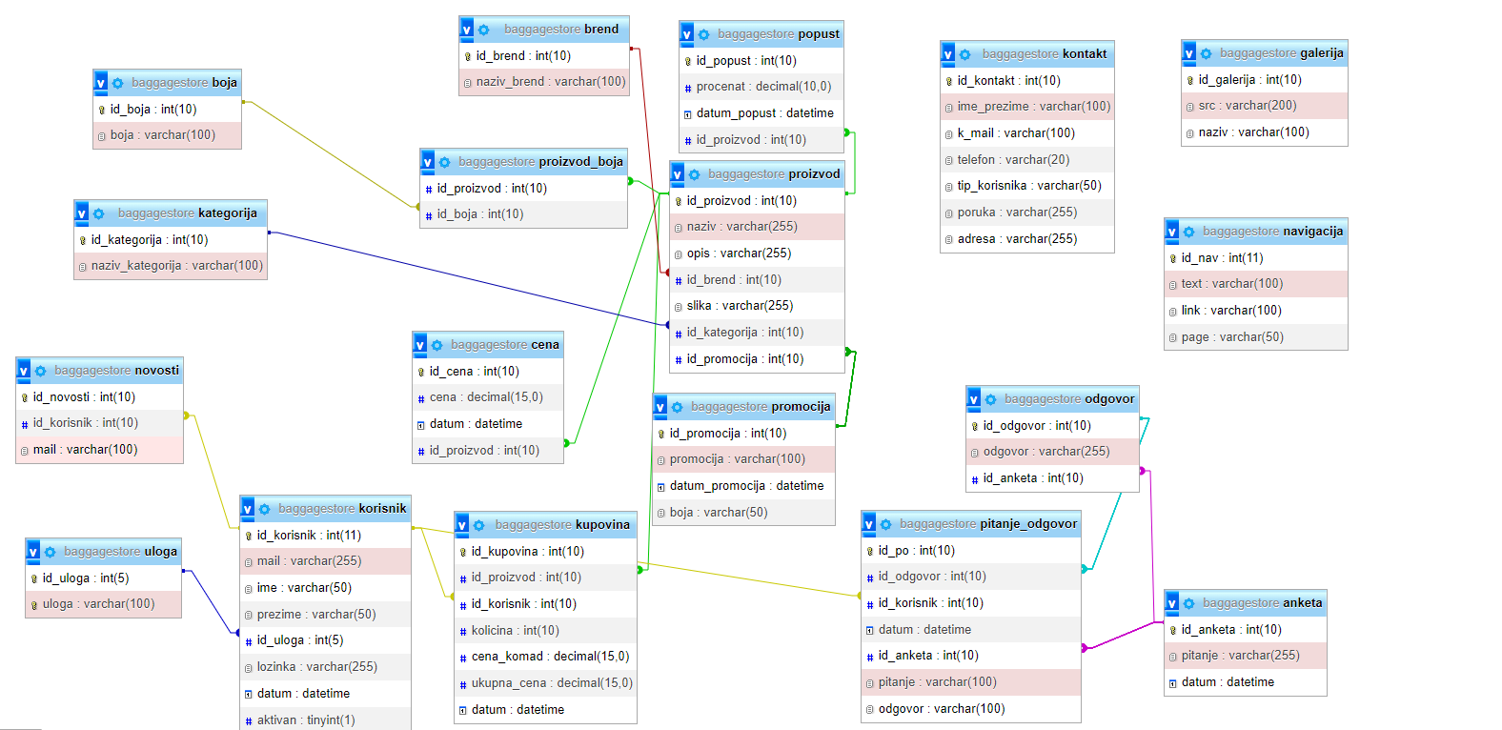

## Struktura projekta

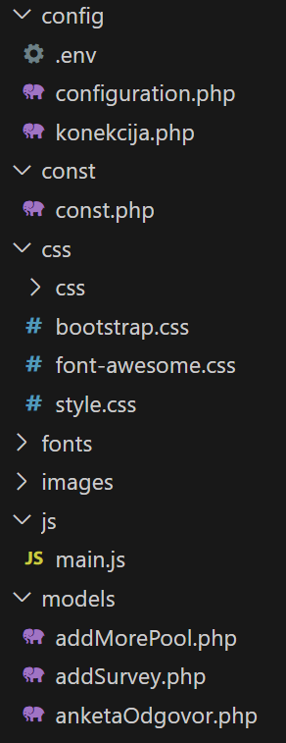 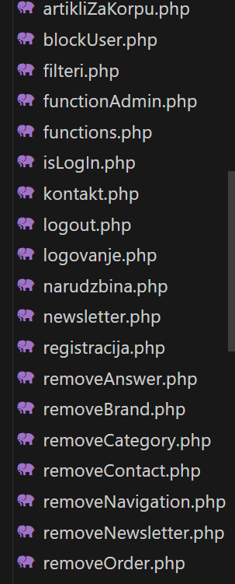

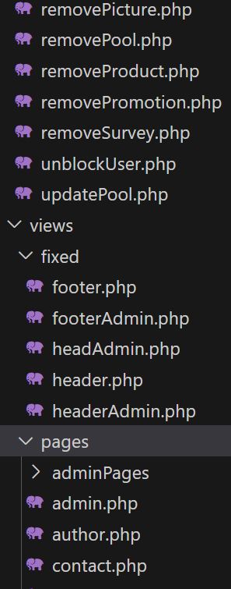 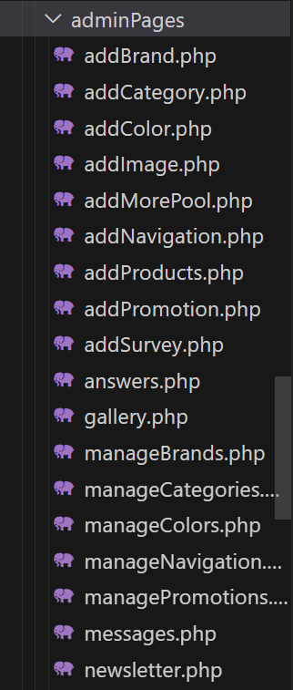

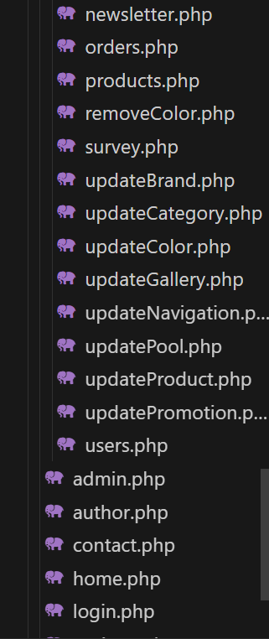 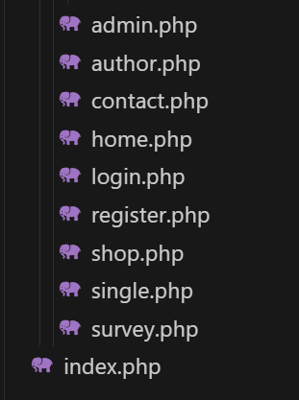

## Sitemap

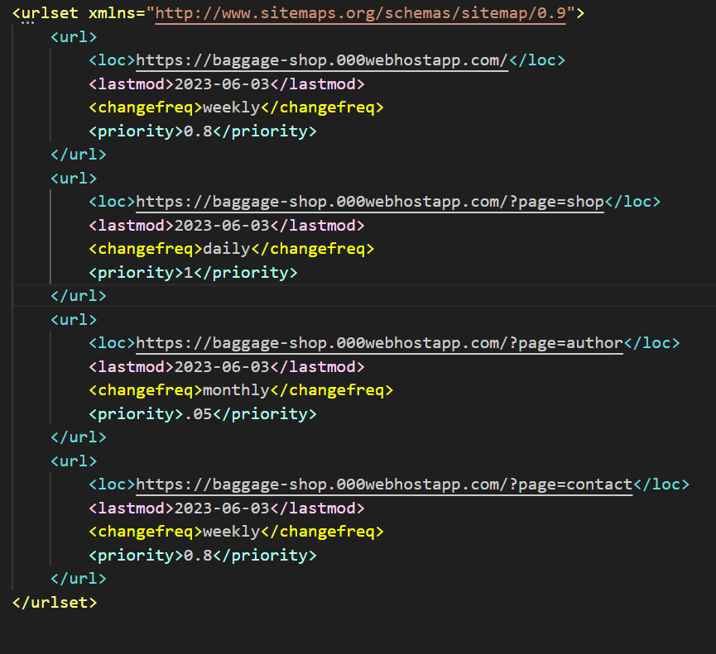

## Opis funkcionalnosti na stranicama



Na pocetku svake stranice nalazi se dinamicki navigacioni meni koji se generise iz baze, linkovi sign in i sign up koji se menjaju sa logout prilikom prijave ili registracije korisnika. U zavisnosti od uloge korisnika u navigacionom meniju se dodaju linkovi kao sto su admin panel, anketa, shop, kontakt

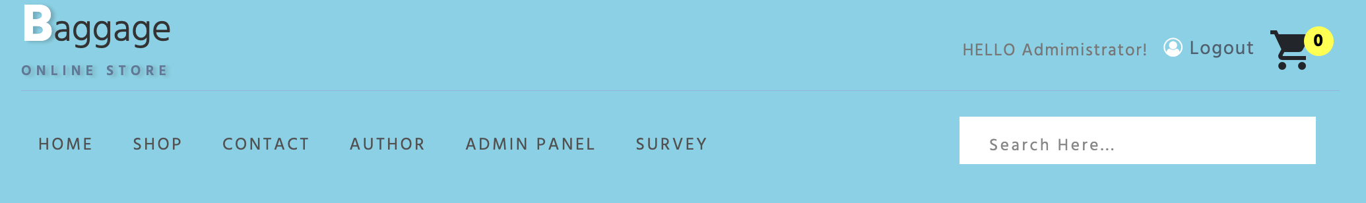

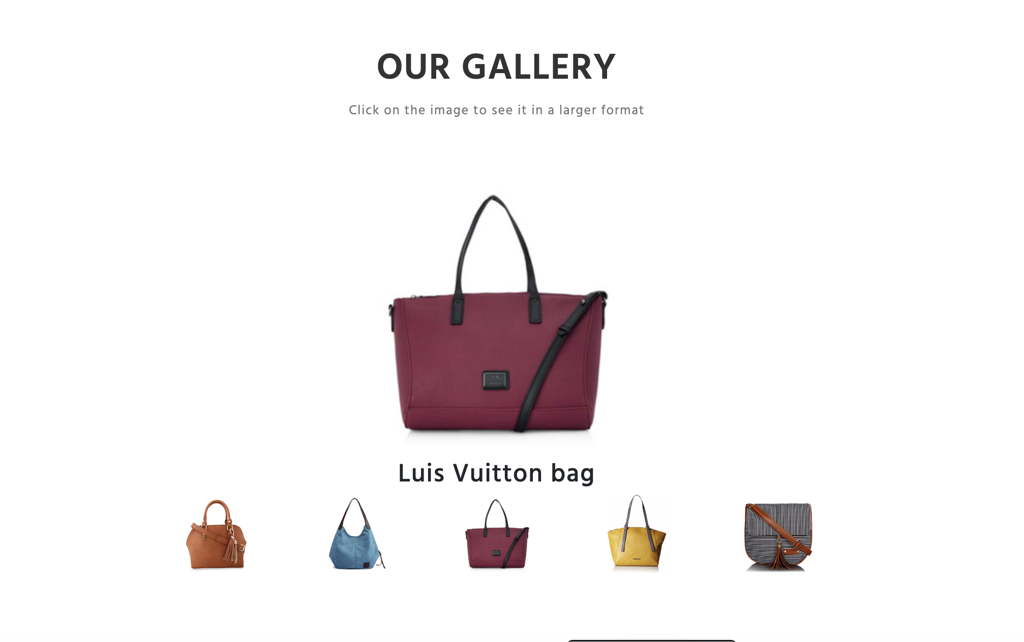

Na pocetnoj stanici nalazi se dinamicka galerija, koja se generise sa slikama unetim u admin panelu.



Prijava za newsletter, klikom na subscribe korisnik se obavestava da se prijavio, ukoliko nije napravio gresku.

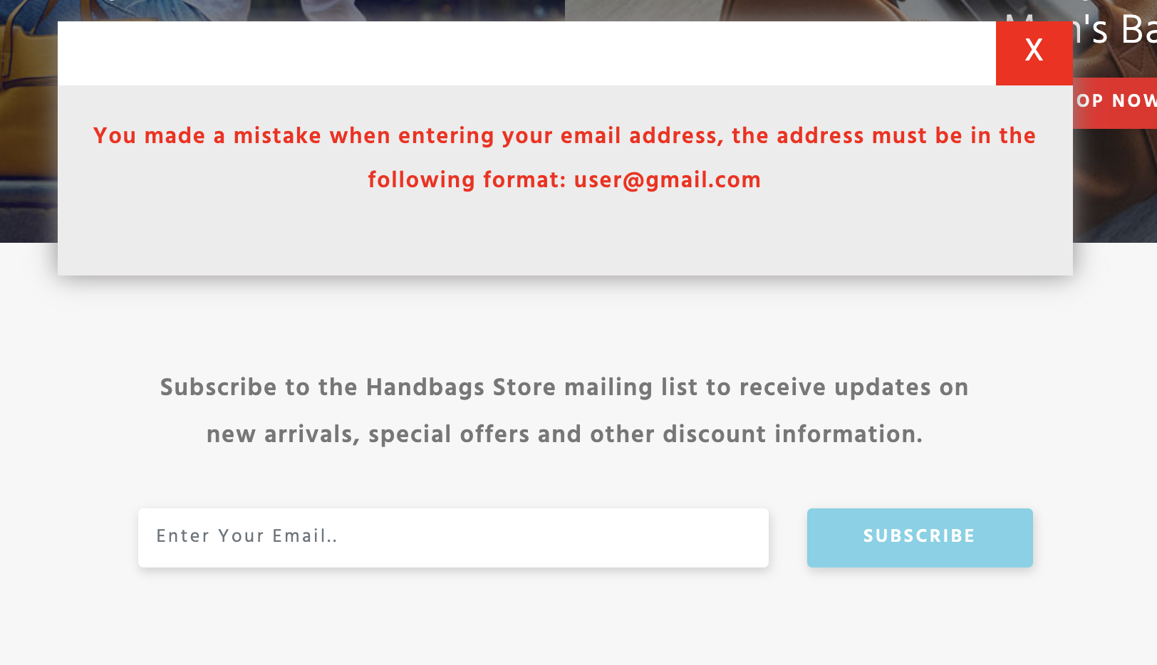

Ispis poruke prilikom unosa neispravnog mejla, mejl se salje putem ajaxa, klijentska i serverska provera, zatim unos u bazu i ispis prijavljenih na admin panel.

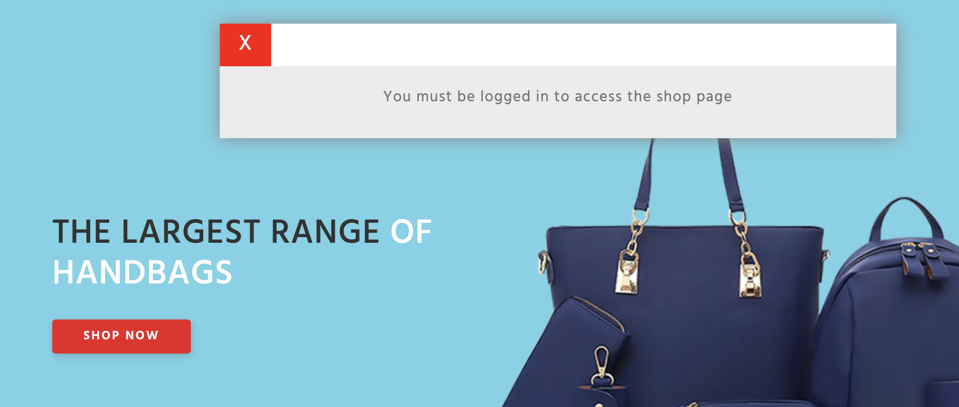

Ukoliko kliknemo na dugme shop now, ukoliko niste prijavljeni izaci ce Vam odgovarajuca poruka, u suprotnom vodi Vas na stranicu shop.

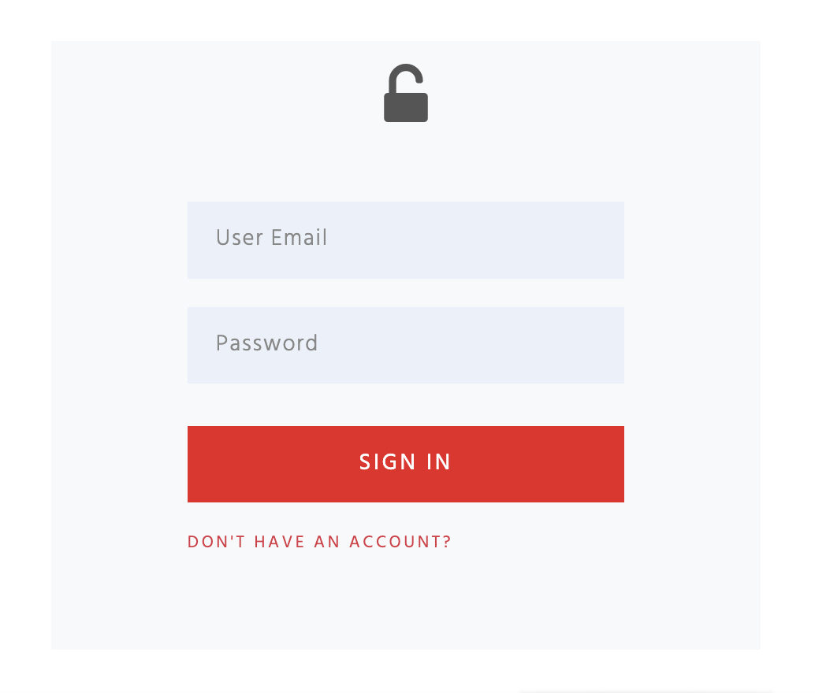

Stranica za prijavu registrovanog korisnika, podaci se salju putem ajax-a, klijentska i serverska provera, ukoliko dodje do greske, greske se ispisuju korisniku.

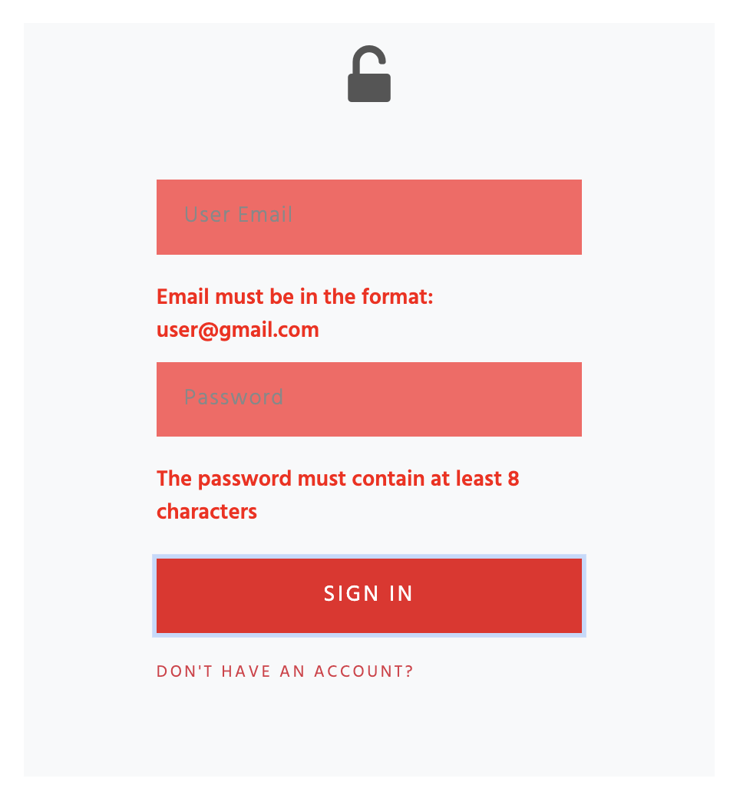

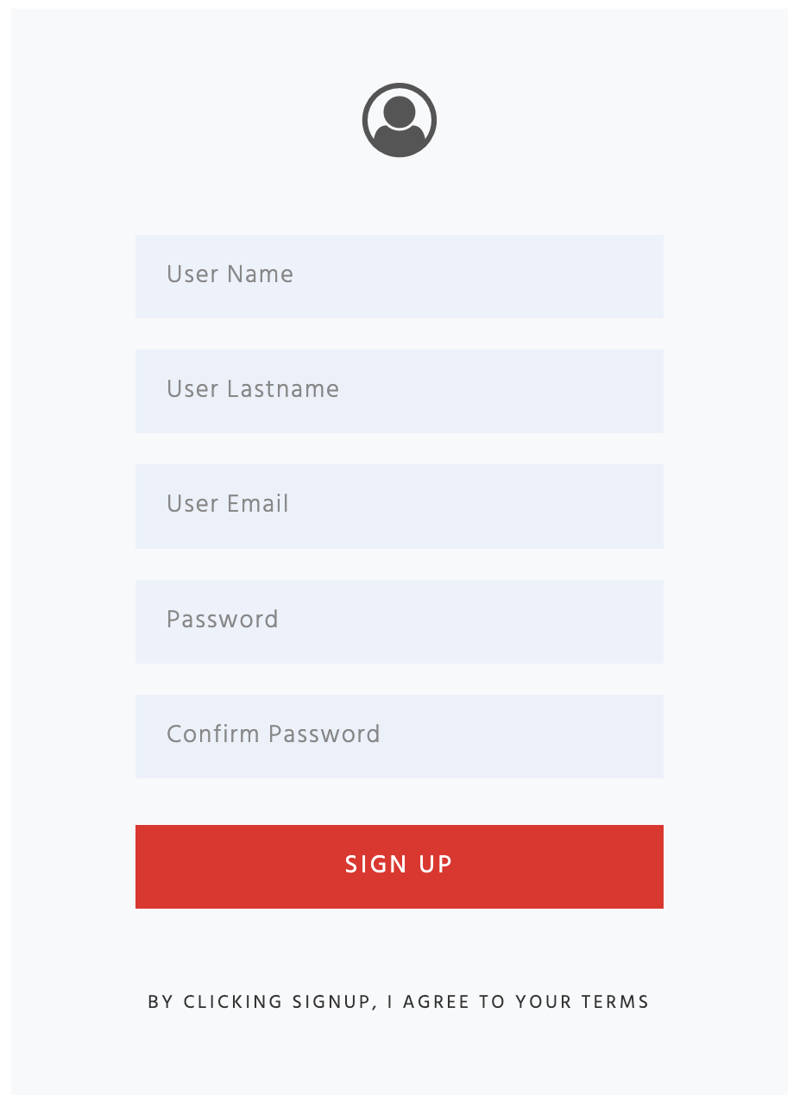

Stranica za registraciju, unos imena, prezimena, mejla i lozinke. Klijentska i serverska provera, slanje podataka putem mejla, unos korisnika u bazu i ispis u admin panel.

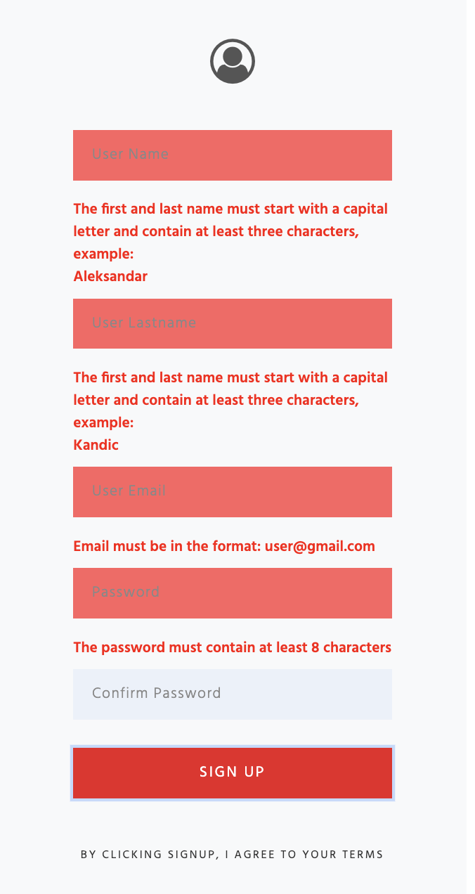

Ispis gresaka ukoliko do njih dodje.

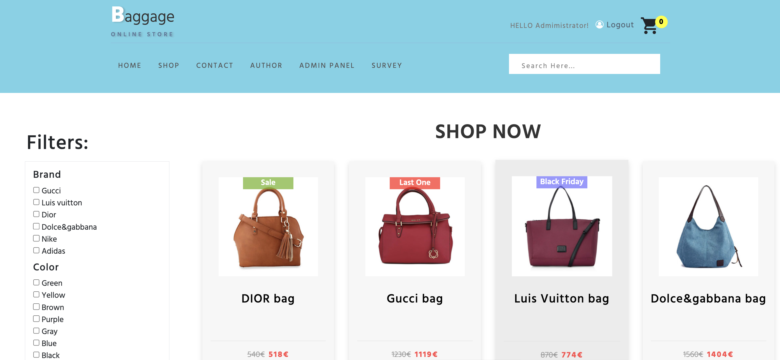

Stranica shop na kojoj se ispisuju svi proizvodi, sa mogucnoscu filtriranja, sortiranja i pretrage po imenu

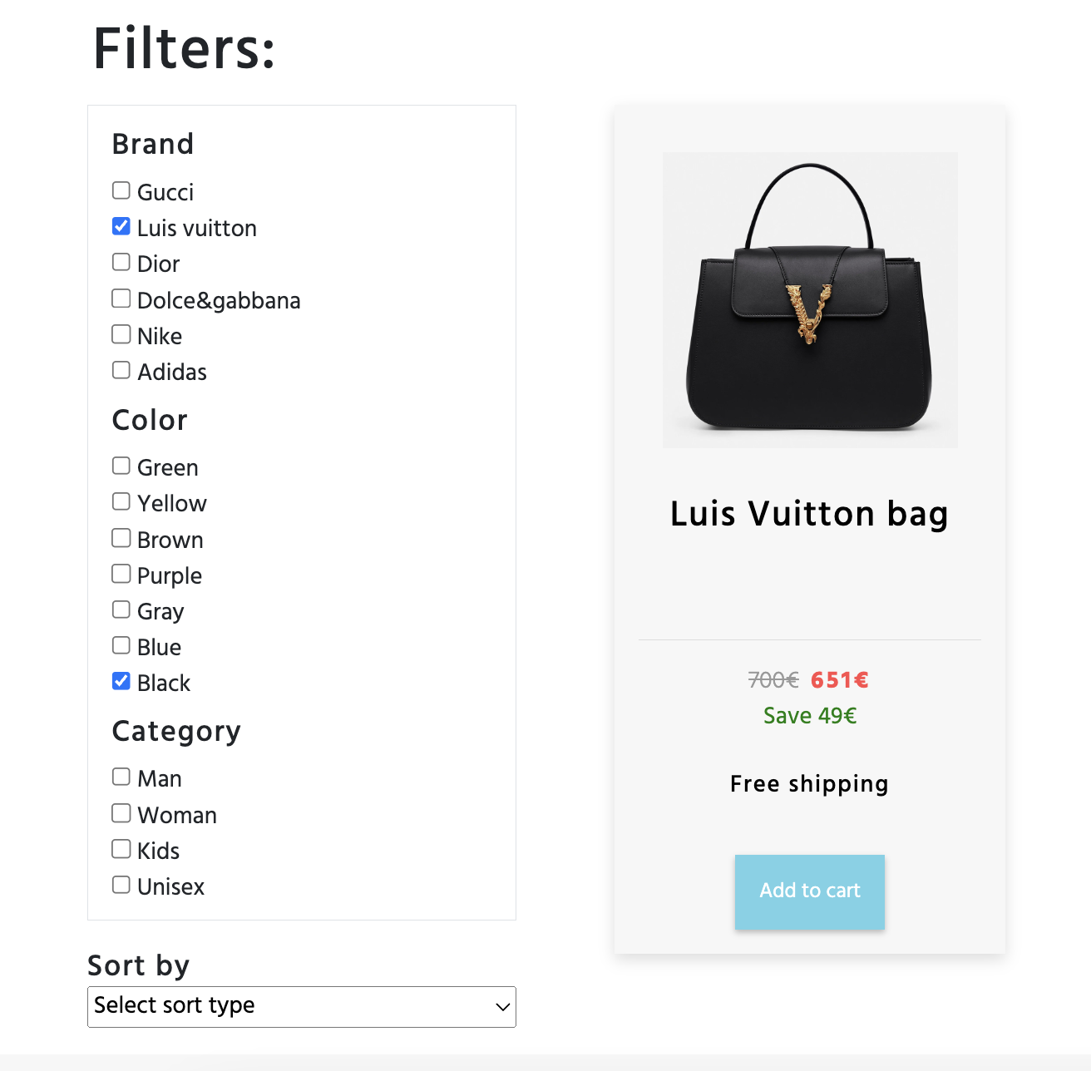

Filtriranje, sortiranje i pretraga po imenu za proizvode.

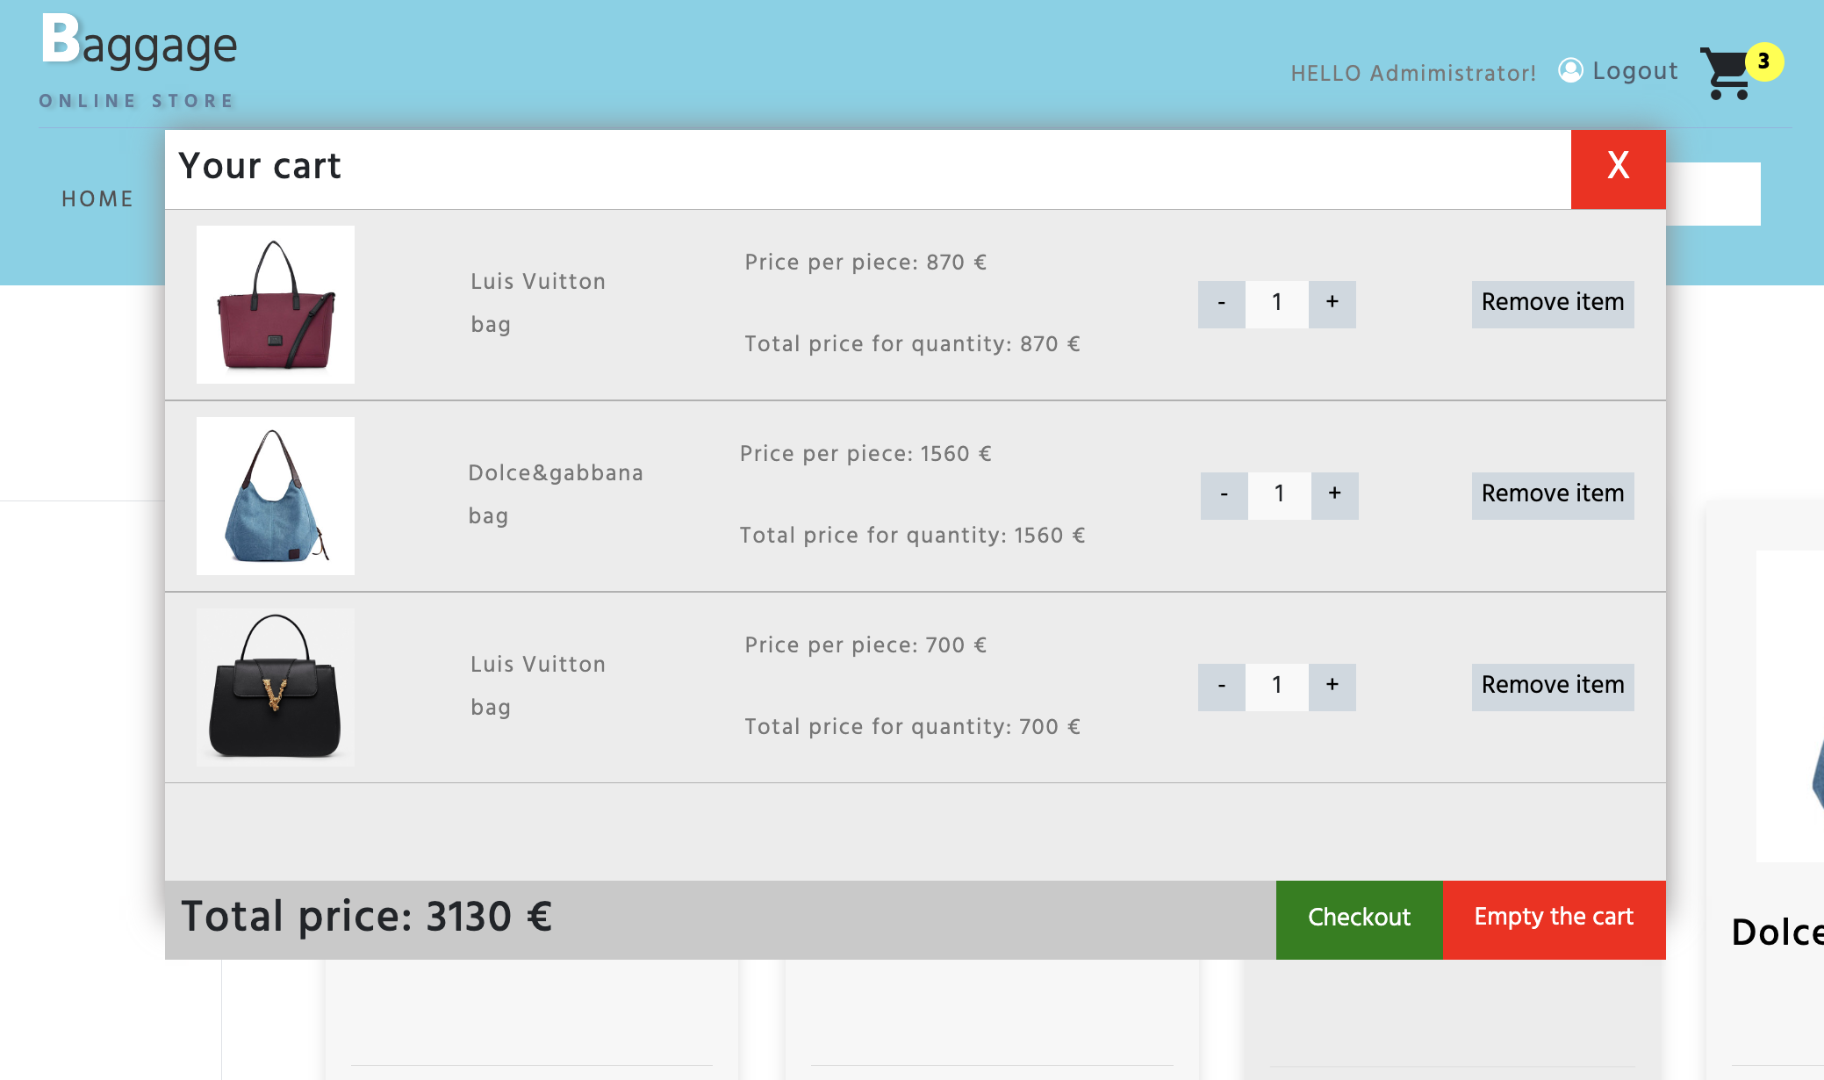

Korpa u vidu modala, omogucava povecavanj i smanjenje kolicine proizvoda, brisanje pojedinacno ili svih proizvoda, kao i kupovina proizvoda, koja se unosi u bazu i prikazuje na admin panelu.

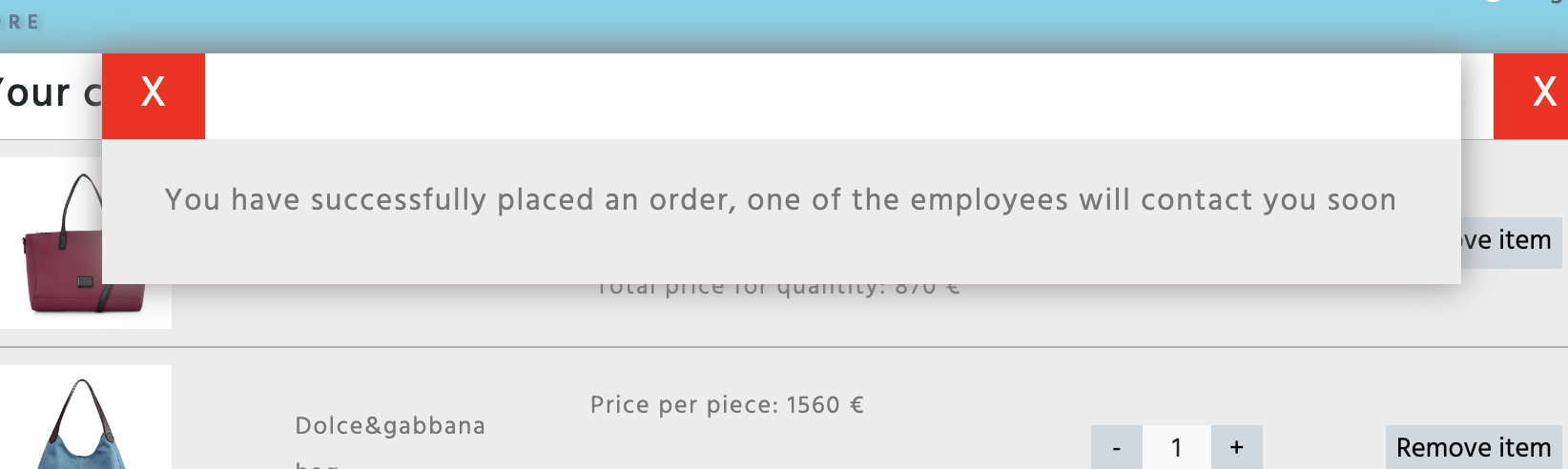

Prikaz uspesne kupovine.

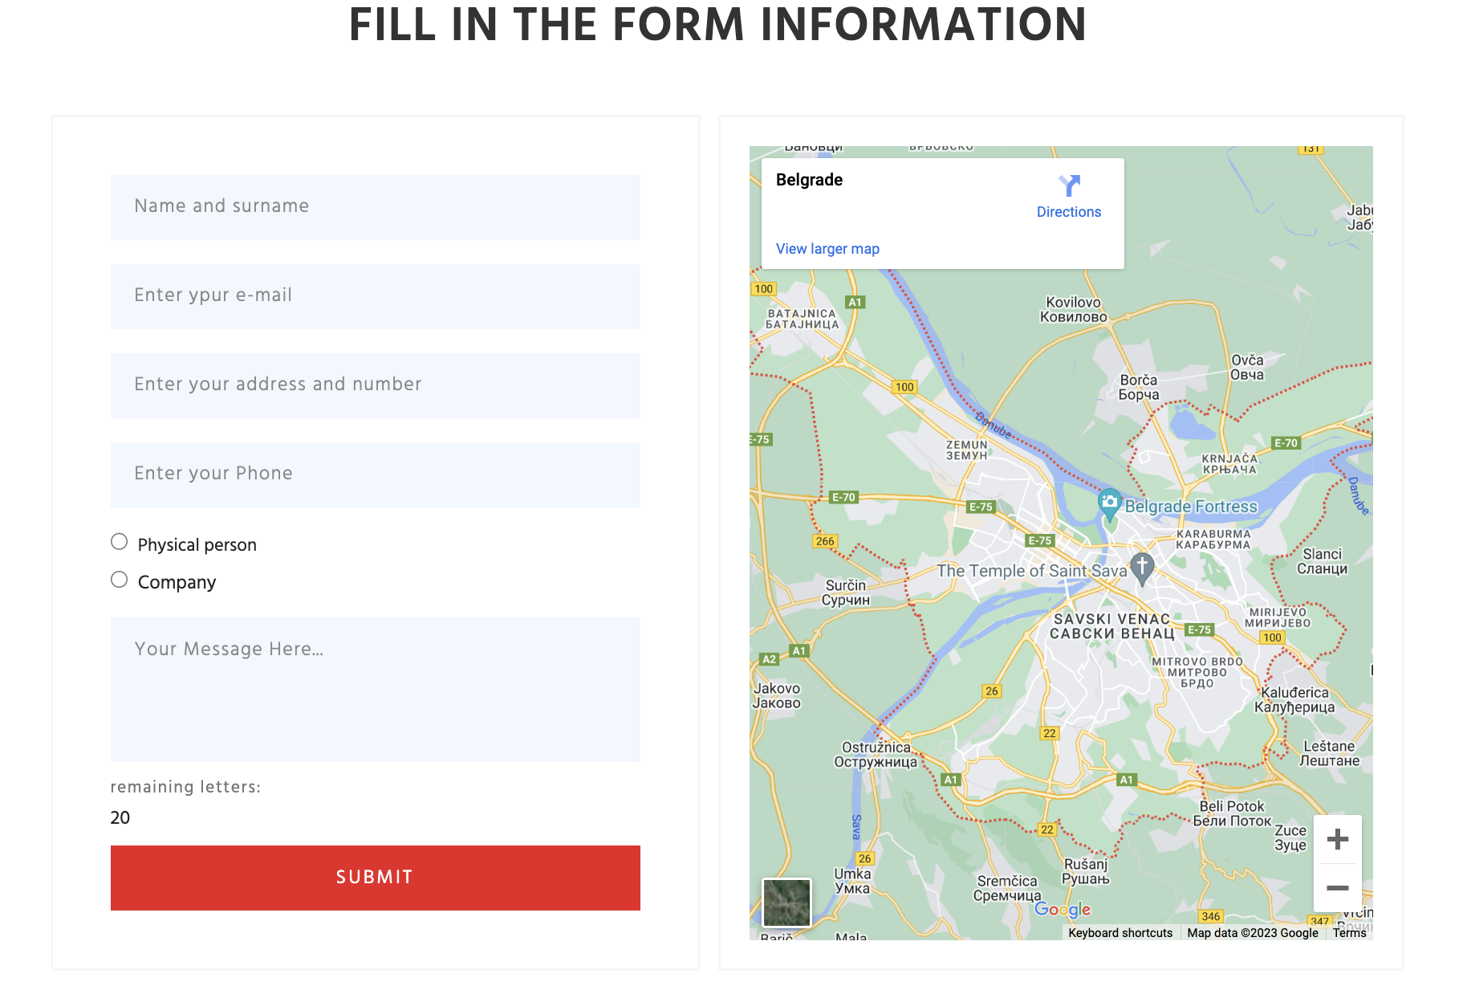

Na stranici kontakt se nalazi kontakt forma, sa klijentskom i serverskom proverom, podaci se salju putem ajaxa i posle provere se upisuju u bazu.

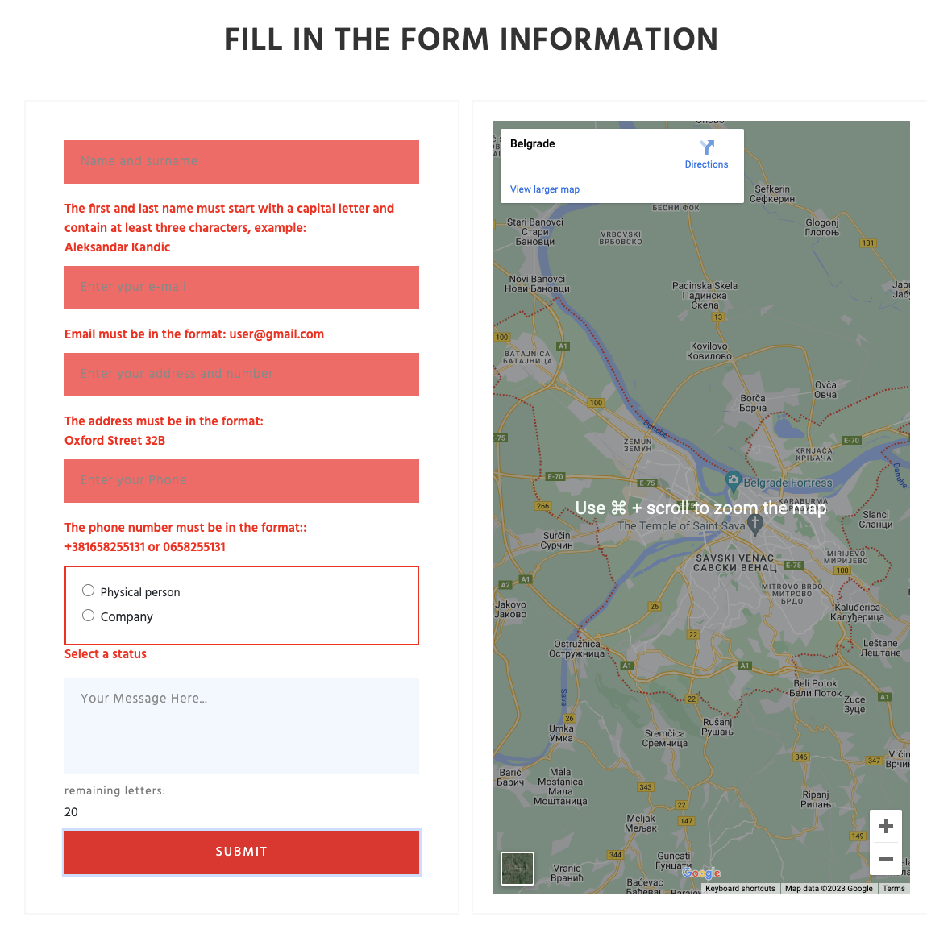

Ispis gresaka ukoliko do njih dodje.

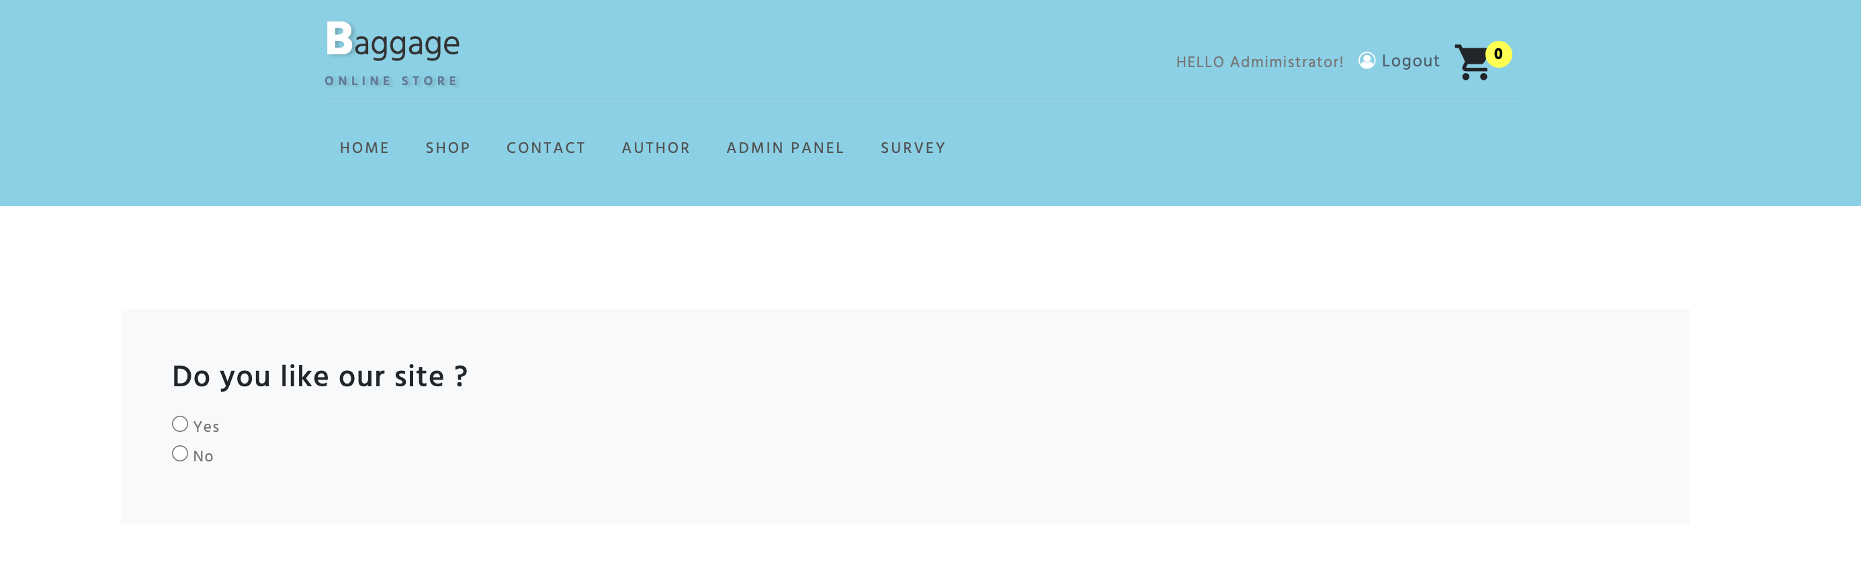

Na stranici anketa se nalazi anketa, koju unosi administrator, korisnik moze samo jednom da odgovori na jednu anketu.

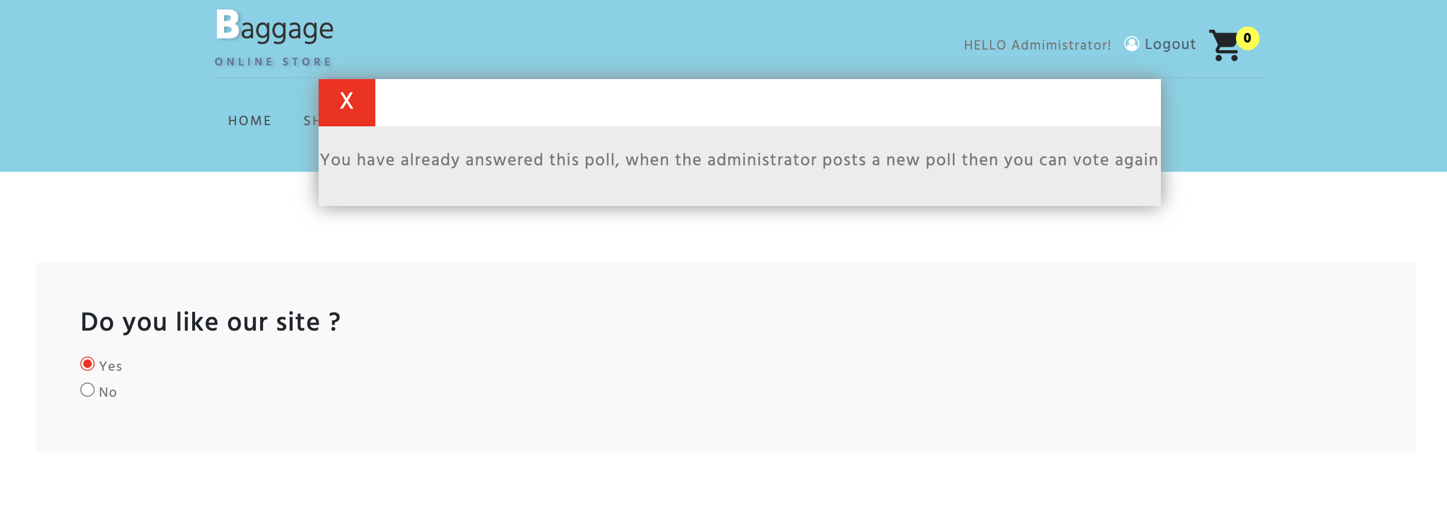

Poruka ukoliko ste vec odgovarali na anketu.

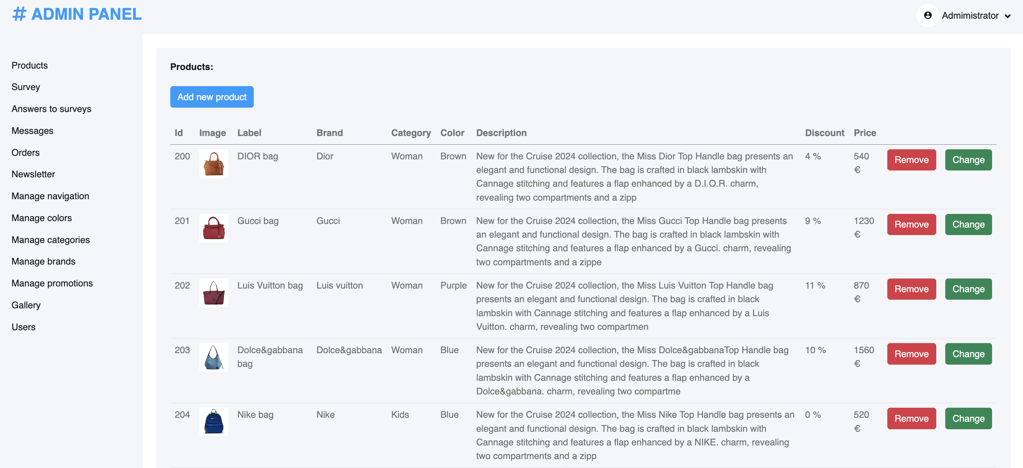

Stranica admin panel, na kojoj se nalazi kompletan CRUD za proizvode, anketu, navigaciju, boje, kategorije, brendove, promocije, galeriju, poruke, korisnike, newsletter i poruke.

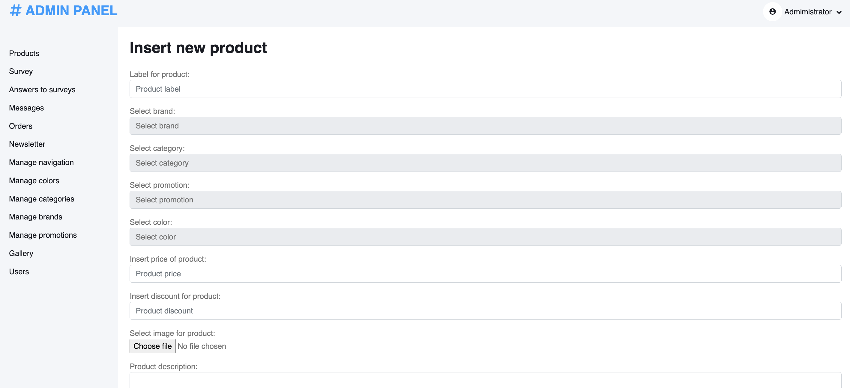

Dodavanje novog proizvoda, slican je izgled i za dodavanje ostalih kategorija.

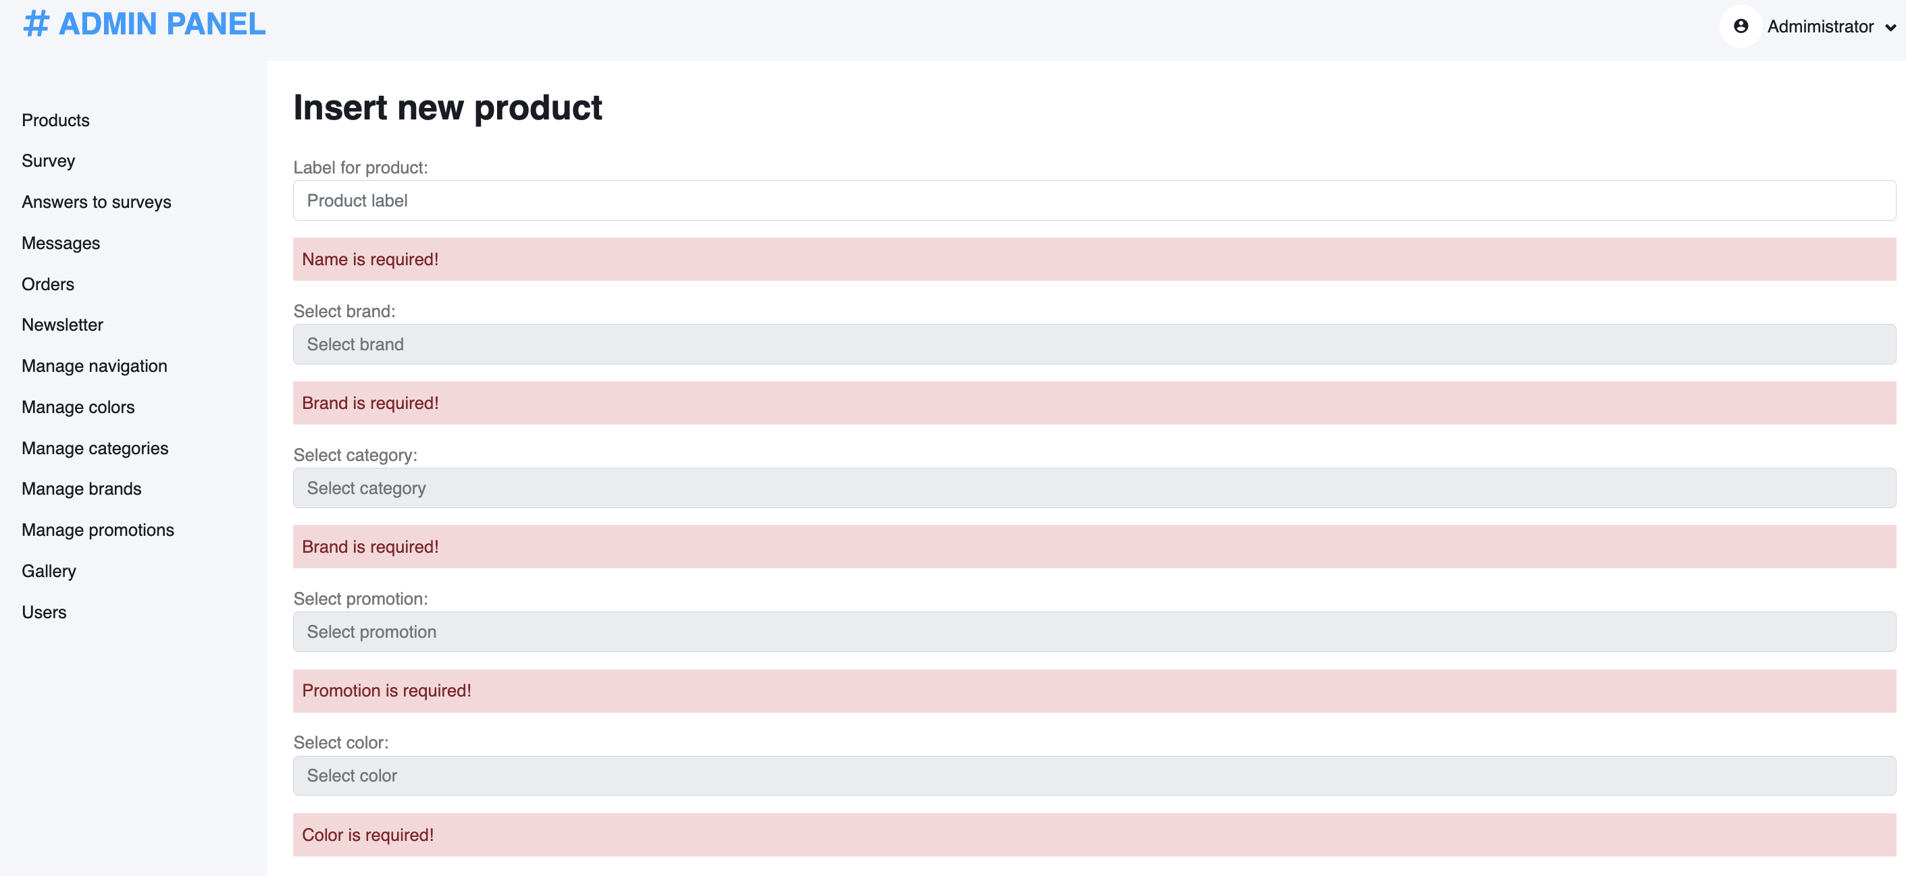

Ispis gresaka ukoliko do njih dodje.

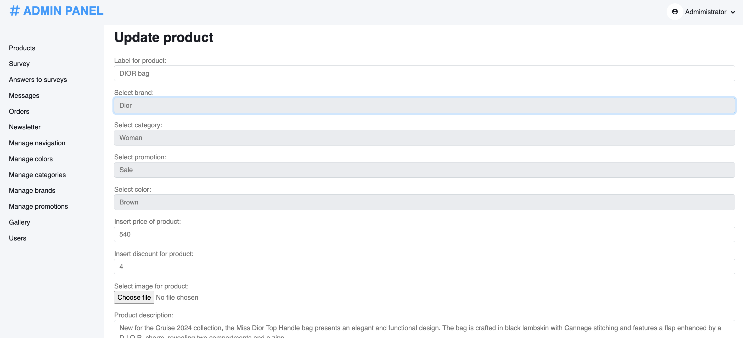

Stranica za izmenu proizvoda, takodje postoji ispis gresaka kao na slici iznad.

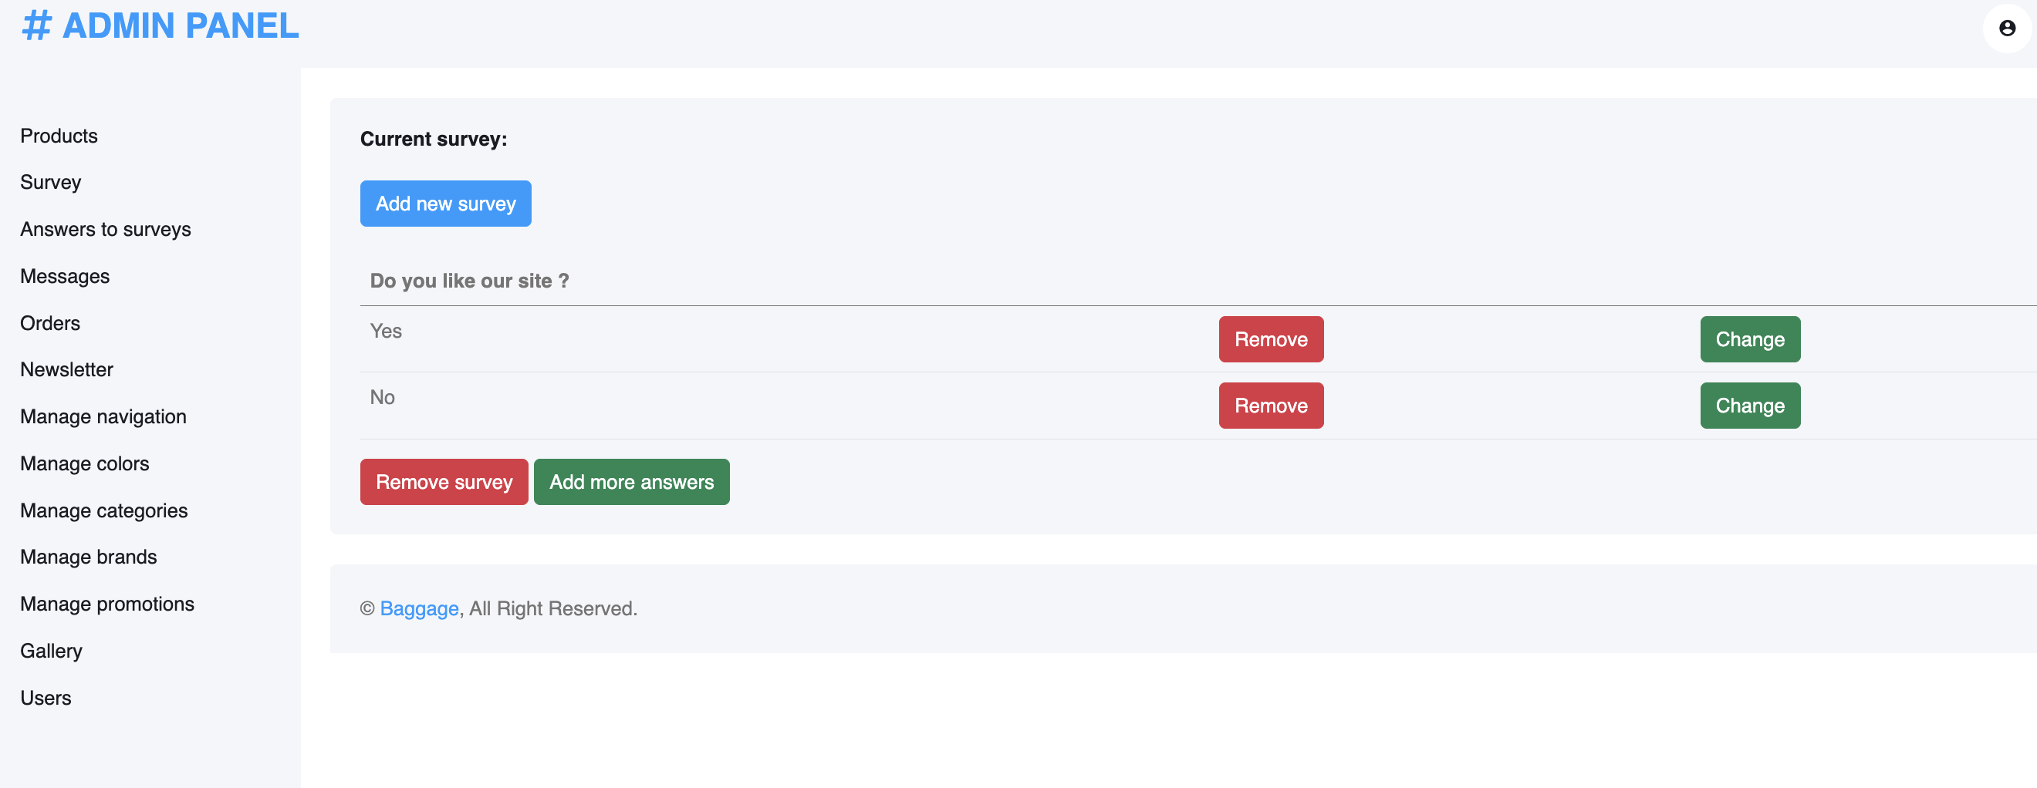

Stranicu za CRUD za anketu, sa mogucnoscu brisanja, dodavanja i izmene ankete, kao i dodavanje brisanje i izmenu pojedinacnih odgovora.

Dodavanje i izmena anketa su identicni kao za proizvod, odnosno kao i za ostale kategorije.

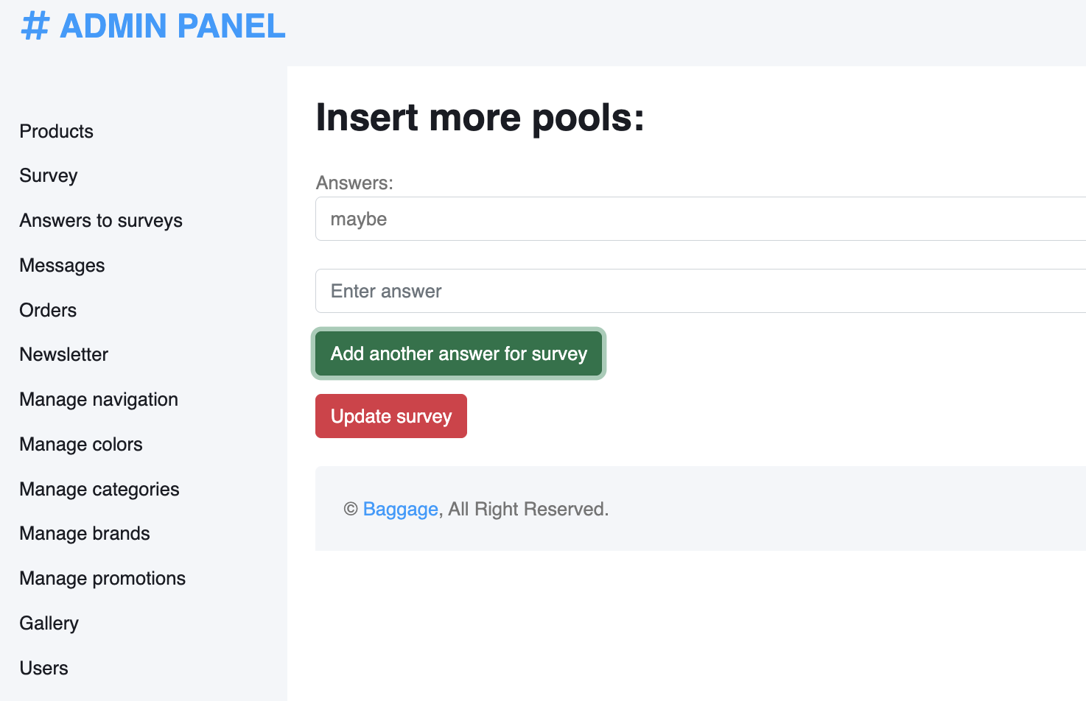

Dodavanje novog odgovora na postojecu anketu, moze se dodati proizvoljan broj odgovora.

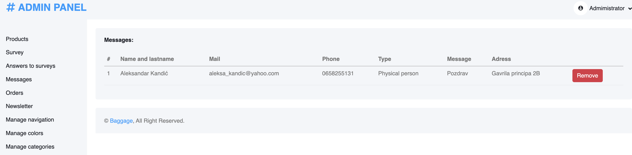

Stranica za poruke iz kontakt forme sa mogucnoscu brisanja poruka.

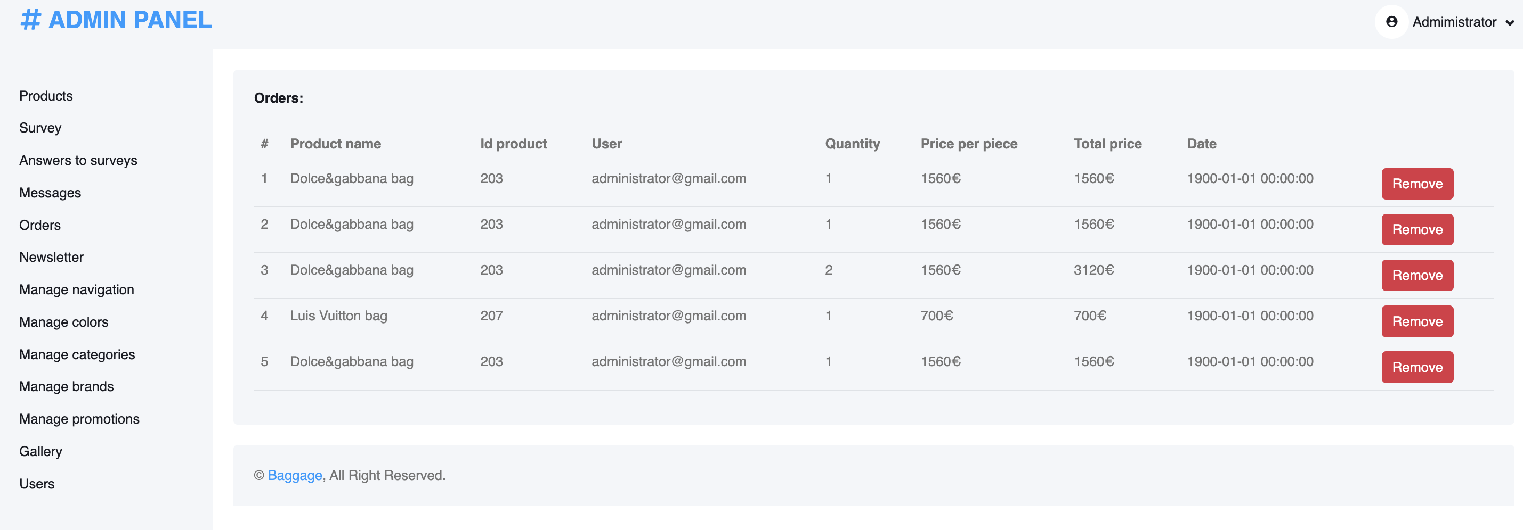

Stranica za narudzbine sa mogucnoscu brisanja narudzbina.

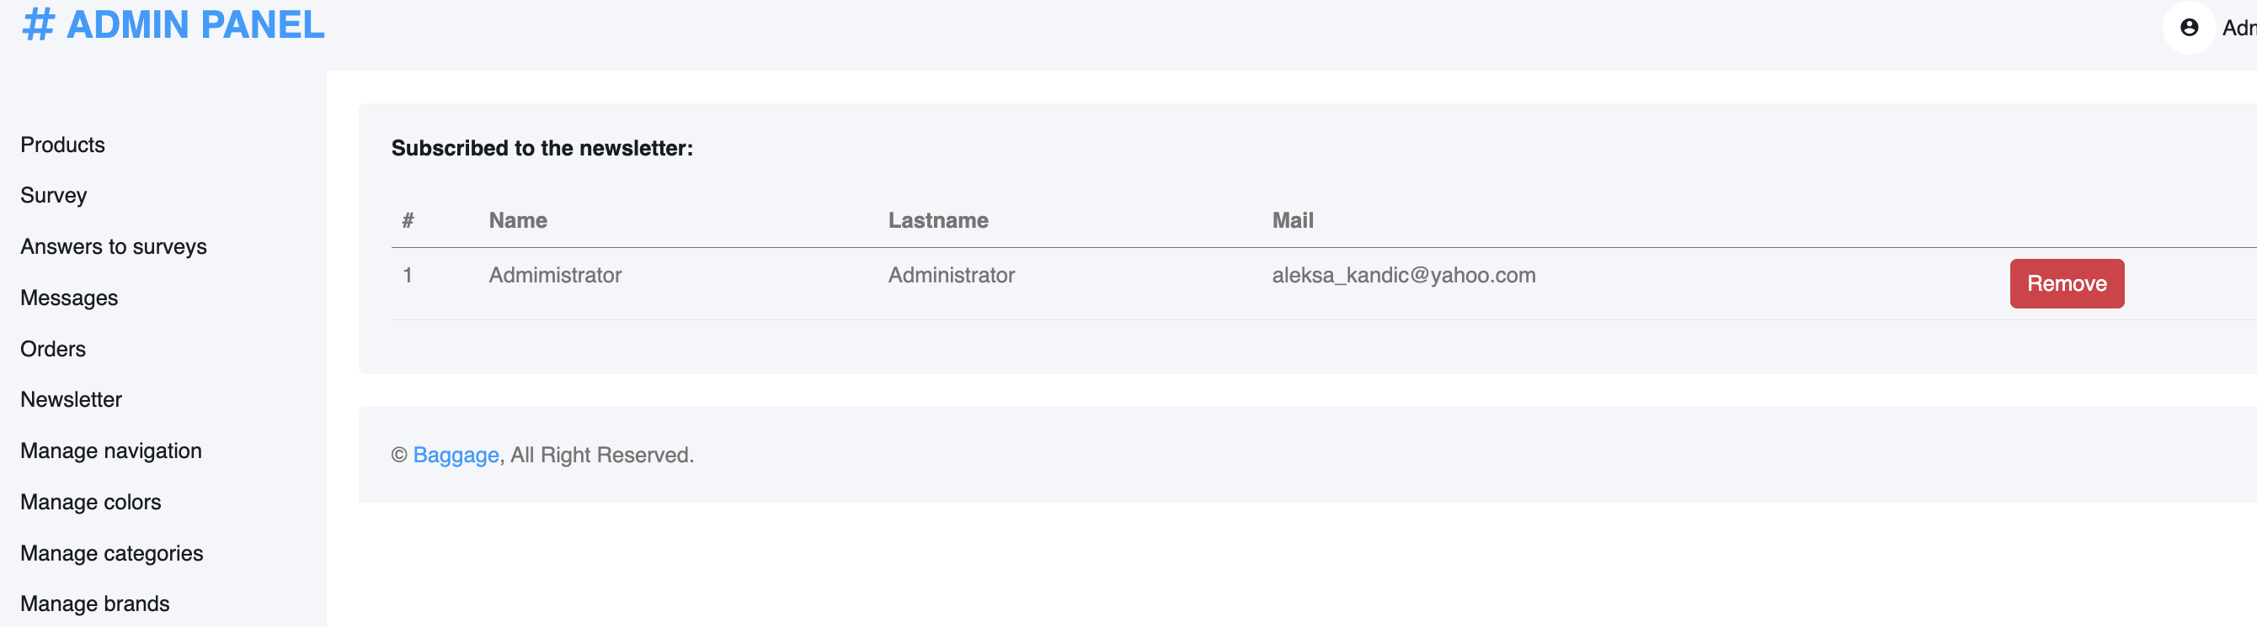

Stranica newsletter za prikaz projavljenih korisnika, sa mogucnoscu brisanja.

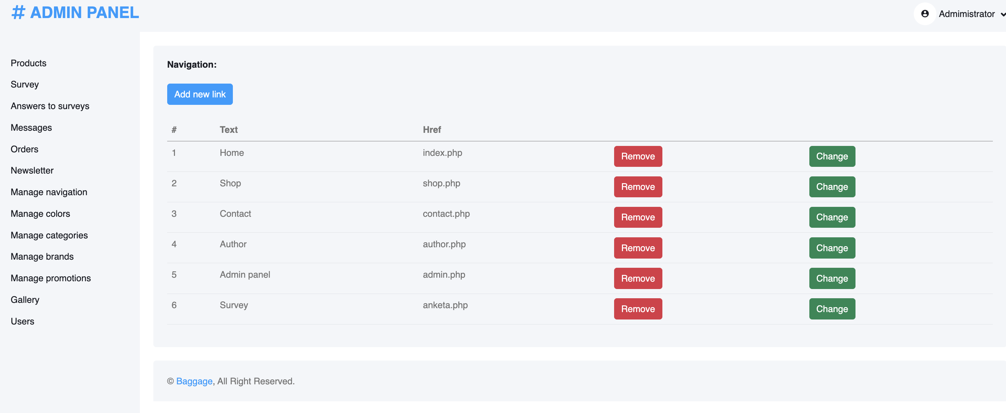

Stranice za CRUD za navigaciju, boje, kategorije, brendove, promocije su identicne, kao i unos njih i izmena.

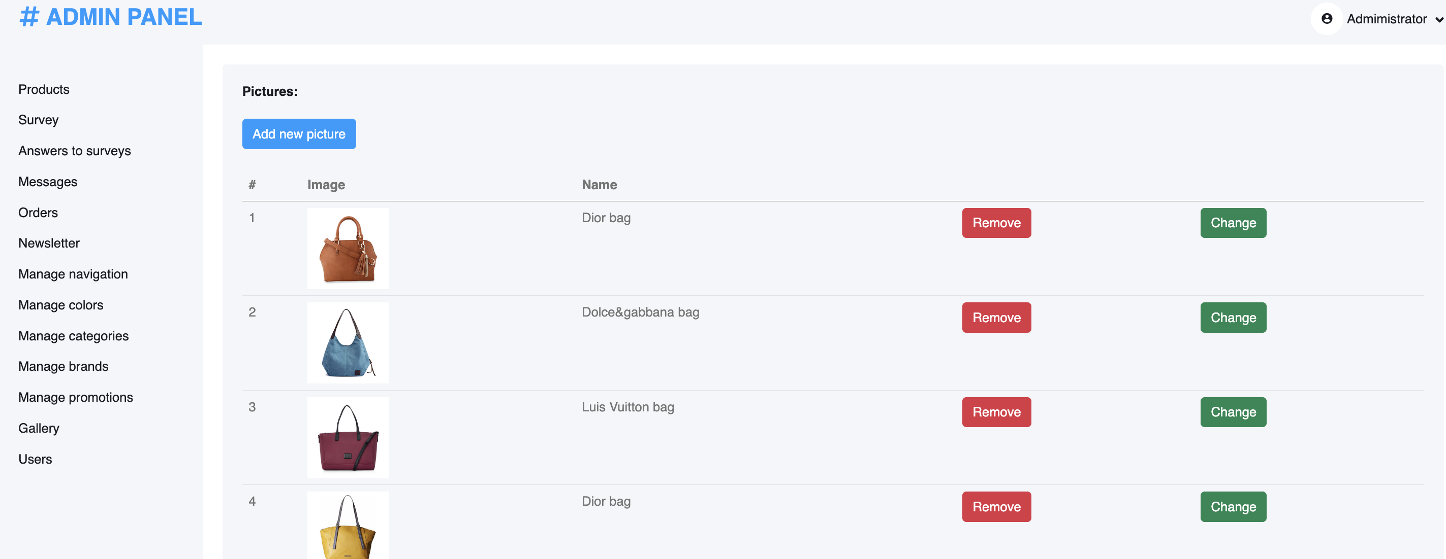

Stranica za galeriju, sa kompletnim CRUD-om.

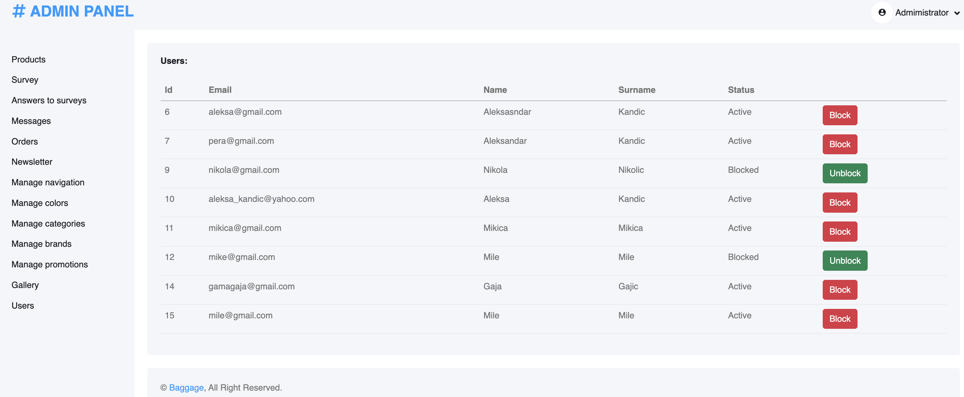

Stranica za korisnike, sa mogucnoscu blokiranja i odblokiranja korisnika.

# Kodovi

## CSS

html,

body {

margin: 0;

font-size: 100%;

background: #fff;

font-family: 'Hind', sans-serif;

scroll-behavior: smooth;

}

body a {

text-decoration: none;

transition: 0.5s all;

-webkit-transition: 0.5s all;

-moz-transition: 0.5s all;

-o-transition: 0.5s all;

-ms-transition: 0.5s all;

}

a:hover {

text-decoration: none;

}

input[type="button"],

input[type="submit"],

input[type="text"],

input[type="email"],

input[type="search"] {

transition: 0.5s all;

-webkit-transition: 0.5s all;

-moz-transition: 0.5s all;

-o-transition: 0.5s all;

-ms-transition: 0.5s all;

font-family: 'Hind', sans-serif;

}

h1,

h2,

h3,

h4,

h5,

h6 {

margin: 0;

letter-spacing: 1px;

font-family: 'Hind', sans-serif;

}

p {

font-size: 0.9em;

color: #777;

line-height: 1.9em;

letter-spacing: 1px;

margin-bottom: 0;

}

ul {

margin: 0;

padding: 0;

}

.breadcrumb,

ol {

margin-bottom: 0 !important;

}

/* header */

/*-- header --*/

.forms {

margin-top: 1.4em;

}

.top-w3pvt {

border-bottom: 1px solid #8bb4df;

padding-bottom: 0.5em;

}

.nav-top-wthree {

margin: 1em 0;

}

#navg{

width: 55% !important;

}

header a.btn {

border-radius: 4px;

color: #4d6171;

letter-spacing: 1px;

border: none;

outline: none;

}

header a.btn span {

color: #fff;

}

.search-form {

width: 100%;

}

form.newsletter {

background: #fff;

padding: 0.3em;

display: flex;

}

header .search {

outline: none;

padding: 6px 20px;

font-size: 14px;

color: #000;

width: 85%;

background: transparent;

text-transform: capitalize;

border: none;

letter-spacing: 2px;

float: left;

}

header button.btn {

color: #fff;

border: none;

padding: 7px 0px;

text-transform: uppercase;

text-decoration: none;

background: transparent;

-webkit-transition: 0.5s all;

-moz-transition: 0.5s all;

-o-transition: 0.5s all;

-ms-transition: 0.5s all;

transition: 0.5s all;

float: right;

cursor: pointer;

width: 15%;

font-size: 14px;

text-align: center;

background: #ec1c24;

}

.toggle,

[id^=drop] {

display: none;

}

/* Giving a background-color to the nav container. */

nav {

margin: 0;

padding: 0;

margin-top: 10px;

float: left;

}

#logo a {

float: left;

font-size: .8em;

display: initial;

margin: 0;

letter-spacing: 0px;

color: #333;

font-weight: 300;

padding: 3px 0;

border: none;

}

#logo a span {

color: #fff;

font-size: 1.4em;

font-weight: 700;

text-shadow: 3px 1px 3px rgba(19, 18, 18, 0.19);

}

.sub-des {

text-transform: uppercase;

display: block;

font-size: 0.3em;

margin: 0;

color: #5b7a9a;

letter-spacing: 4px;

font-weight: 600;

text-shadow: 3px 1px 3px rgba(78, 73, 73, 0.21);

}

/* Since we'll have the "ul li" "float:left"

* we need to add a clear after the container. */

nav:after {

content: "";

display: table;

clear: both;

}

/* Removing padding, margin and "list-style" from the "ul",

* and adding "position:reltive" */

nav ul {

padding: 0;

margin: 0;

list-style: none;

position: relative;

}

/* Positioning the navigation items inline */

nav ul li {

margin: 0px;

display: inline-block;

}

/* Styling the links */

nav a {

letter-spacing: 2px;

padding-left: 0;

padding-right: 0;

padding: 10px 0;

font-weight: 400;

font-size: 0.9em;

margin: 0 1em;

color: #515152;

text-transform: uppercase;

}

nav ul li ul li:hover {

background: #f8f9fa;

}

/* Background color change on Hover */

nav a:hover {

color: #ec1c24;

}

.menu li.active a {

color: #ec1c24;

font-weight: 600;

}

/* Hide Dropdowns by Default

* and giving it a position of absolute */

nav ul ul {

display: none;

position: absolute;

top: 30px;

background: #fff;

padding: 10px;

-moz-box-shadow: 1px 3px 8px 0 rgba(0, 0, 0, 0.15);

-webkit-box-shadow: 1px 3px 8px 0 rgba(0, 0, 0, 0.15);

box-shadow: 1px 3px 8px 0 rgba(0, 0, 0, 0.15);

}

/* Display Dropdowns on Hover */

nav ul li:hover > ul {

display: inherit;

}

/* Fisrt Tier Dropdown */

nav ul ul li {

width: 200px;

float: none;

display: list-item;

position: relative;

}

nav ul ul li a {

color: #333;

padding: 5px 10px;

display: block;

}

ul.menu li span {

color: #fff;

}

/* Second, Third and more Tiers

* We move the 2nd and 3rd etc tier dropdowns to the left

* by the amount of the width of the first tier.

*/

nav ul ul ul li {

position: relative;

top: -60px;

/* has to be the same number as the "width" of "nav ul ul li" */

left: 170px;

}

/* Change ' +' in order to change the Dropdown symbol */

li > a:only-child:after {

content: '';

}

/* Media Queries

--------------------------------------------- */

@media all and (max-width : 992px) {

.foot{

flex-direction: column !important;

}

.naziv{

text-align: center;

}

.cene{

text-align: center;

}

.row3{

flex-direction: column !important;

height: fit-content !important;

padding: 20px;

}

#modalCart{

width: 90% !important;

left: 5% !important;

}

.obrisi{

margin-top: 20px;

}

.kup{

flex-direction: column !important;

}

.menu li.active a {

color: #3369e7;

}

nav {

margin: 0;

}

nav a {

color: #333;

}

/* Hide the navigation menu by default */

/* Also hide the */

.toggle + a,

.menu {

display: none;

}

/* Stylinf the toggle lable */

.toggle {

display: inline-block;

padding: 9px 15px;

font-size: 20px;

text-decoration: none;

border: none;

float: none;

background-color: rgba(22, 21, 21, 0.43137254901960786);

color: #fff;

margin-bottom: 0;

cursor: pointer !important;

}

.menu .toggle {

float: none;

text-align: center;

margin: auto;

width: 90%;

padding: 5px;

font-weight: normal;

font-size: 15px;

letter-spacing: 1px;

}

.toggle:hover {

color: #fff;

background-color: #3369e7;

}

.nav-top-w3pvt {

margin: 1em 0;

position: absolute;

width: 71%;

}

/* Display Dropdown when clicked on Parent Lable */

[id^=drop]:checked + ul {

display: block;

background: #fff;

padding: 15px 0;

width: 100%;

text-align: center;

border: 1px solid #ddd;

}

/* Change menu item's width to 100% */

nav ul li {

display: block;

width: 100%;

padding: 7px 0;

}

nav a {

padding: 5px 0;

}

nav a:hover {

color: #3369e7;

}

.login-icon {

text-align: center;

}

nav ul ul .toggle,

nav ul ul a {

padding: 0 40px;

}

nav ul ul ul a {

padding: 0 80px;

}

nav a:hover,

nav ul ul ul a {

background-color: transparent;

}

nav ul li ul li .toggle,

nav ul ul a,

nav ul ul ul a {

padding: 14px 20px;

color: #FFF;

font-size: 17px;

}

nav ul li ul li .toggle,

nav ul ul a {

background-color: #fff;

}

nav ul ul li a {

font-size: 15px;

}

ul.inner-ul {

padding: 0 !important;

}

/* Hide Dropdowns by Default */

nav ul ul {

float: none;

position: static;

color: #ffffff;

/* has to be the same number as the "line-height" of "nav a" */

}

/* Hide menus on hover */

nav ul ul li:hover > ul,

nav ul li:hover > ul {

display: none;

}

/* Fisrt Tier Dropdown */

nav ul ul li {

display: block;

width: 100%;

padding: 0;

}

nav ul ul ul li {

position: static;

/* has to be the same number as the "width" of "nav ul ul li" */

}

nav {

margin: 0;

padding: 0;

margin-top: 0;

float: left;

width: 48%;

position: absolute;

z-index: 99;

}

}

@media all and (max-width : 330px) {

nav ul li {

display: block;

width: 94%;

}

}

.user span.fa {

font-size: 25px;

color: #fff;

}

/*-- //header --*/

/*--banner--*/

.main-sec {

background: #74d2e7;

position: relative;

}

.main-sec.inner-page {

background: #74d2e7;

min-height: 10em;

position: relative;

}

.banner-left-info {

margin-top: 14em;

}

.banner-wthree-info h3 {

font-size: 2.5em;

text-transform: uppercase;

color: #333;

margin-bottom: 0.7em;

}

.banner-wthree-info h3 span {

color: #fff;

}

.btn.shop {

background: #ec1c24;

-moz-transition: all 0.25s ease;

-o-transition: all 0.25s ease;

-webkit-transition: all 0.25s ease;

transition: all 0.25s ease;

color: #fff;

padding: 0.6em 2.5em;

text-transform: uppercase;

font-size: 0.9em;

letter-spacing: 2px;

font-weight: 600;

-moz-box-shadow: 1px 3px 8px 0 rgba(0, 0, 0, 0.15);

-webkit-box-shadow: 1px 3px 8px 0 rgba(0, 0, 0, 0.15);

box-shadow: 1px 3px 8px 0 rgba(0, 0, 0, 0.15);

}

/*--//banner--*/

/*--about--*/

.ab-content-img {

background: url(../images/banner1.jpg) no-repeat center;

background-size: cover;

-webkit-background-size: cover;

-o-background-size: cover;

-moz-background-size: cover;

-ms-background-size: cover;

min-height: 27em;

}

.title-wthree,

.title-wthree.two {

font-size: 2.5em;

text-transform: uppercase;

color: #333;

margin-bottom: 0.7em;

font-weight: 600;

}

.title-wthree.two {

color: #fff;

}

.ab-content h4 {

font-size: 1.2em;

color: #4c4d4e;

margin: 2em 0 1em 0;

text-transform: uppercase;

font-weight: 600;

}

.ab-info-con {

padding: 0 0.5em;

}

.ab-info-con.ab-inf-page h4 {

font-size: 1.4em;

color: #4c4d4e;

margin: 0em 0 1.2em 0;

text-transform: uppercase;

font-weight: 600;

}

.ab-info-con.ab-inf-page {

margin-top: 7em;

}

/*--//about--*/

/*--blogs--*/

/*--//blogs--*/

/*--/mid--*/

.bottom-w3pvt-left {

position: relative;

}

h4.text-wthree {

font-size: 2em;

color: #fff;

font-weight: 300;

}

.pos-wthree {

position: absolute;

bottom: 20%;

left: 10%;

}

.pos-w3pvt {

right: 10%;

position: absolute;

bottom: 20%;

}

h4.text-w3pvt {

font-size: 2em;

color: #fff;

font-weight: 300;

}

/*--//mid--*/

/*--/collection--*/

/*--//collection--*/

/* gallery page */

.gal-img img,

.popup img {

width: 100%;

}

/* popup */

.popup-effect {

position: fixed;

top: 0;

bottom: 0;

left: 0;

right: 0;

background: rgba(0, 0, 0, 0.7);

transition: opacity 0ms;

visibility: hidden;

opacity: 0;

z-index: 99;

}

.popup-effect:target {

visibility: visible;

opacity: 1;

}

.popup {

background: #fff;

border-radius: 4px;

max-width: 430px;

position: relative;

margin: 8em auto;

padding: 3em 2em;

z-index: 999;

text-align: center;

}

.popup .close {

position: absolute;

top: 5px;

right: 15px;

transition: all 200ms;

font-size: 30px;

font-weight: bold;

text-decoration: none;

color: #000;

}

/* //popup */

/* //gallery page */

/*--/shipping-grids--*/

.shiopping-w3pvt-gd {

background: #080808;

padding: 2em;

}

.shiopping-w3pvt-gd.sec {

background: #333;

}

.shiopping-w3pvt-gd:hover {

background: #74d2e7;

-moz-transition: all 0.25s ease;

-o-transition: all 0.25s ease;

-webkit-transition: all 0.25s ease;

transition: all 0.25s ease;

}

.shiopping-w3pvt-gd h3 {

font-size: 1.2em;

color: #fff;

margin: 0.5em 0;

text-transform: uppercase;

font-weight: 600;

}

.icon-gd span {

font-size: 2em;

text-align: center;

color: #ec1c24;

margin-bottom: 0.3em;

}

/*--//shipping-grids--*/

/*--/newsletter--*/

.newsletter-w3pvt,

.collections {

background: #f7f7f7;

}

.newsletter-w3pvt form {

margin: 0 auto;

width: 60%;

}

.newsletter-w3pvt p {

font-size: 1.2em;

margin-bottom: 2em;

color: #777;

font-weight: 600;

}

.subscribe-sec input {

padding: 0.85em 1em;

color: #495057;

border-radius: 0.25rem;

font-size: 0.9em;

border: none;

outline: none;

letter-spacing: 2px;

-moz-box-shadow: 1px 3px 8px 0 rgba(0, 0, 0, 0.15);

-webkit-box-shadow: 1px 3px 8px 0 rgba(0, 0, 0, 0.15);

box-shadow: 1px 3px 8px 0 rgba(0, 0, 0, 0.15);

-moz-box-shadow: 1px 3px 8px 0 rgba(0, 0, 0, 0.15);

-webkit-box-shadow: 1px 3px 8px 0 rgba(0, 0, 0, 0.15);

box-shadow: 1px 3px 8px 0 rgba(0, 0, 0, 0.15);

}

.btn.submit {

background: #74d2e7;

-moz-transition: all 0.25s ease;

-o-transition: all 0.25s ease;

-webkit-transition: all 0.25s ease;

transition: all 0.25s ease;

color: #fff;

padding: 0.8em 3em;

text-transform: uppercase;

font-size: 0.9em;

letter-spacing: 2px;

font-weight: 600;

-moz-box-shadow: 1px 3px 8px 0 rgba(0, 0, 0, 0.15);

-webkit-box-shadow: 1px 3px 8px 0 rgba(0, 0, 0, 0.15);

box-shadow: 1px 3px 8px 0 rgba(0, 0, 0, 0.15);

}

.btn.submit:hover,

.btn.shop:hover {

opacity: 0.9;

}

/*--//newsletter--*/

.content-grid {

max-width: 500px;

margin: 6em auto;

}

ul.links-unordered-list li.active a {

background: rgba(255, 255, 255, 0.05);

padding: 5px 20px;

color: #fff;

}

.icon span.fa {

font-size: 3em;

color: #555;

}

.icon {

margin-bottom: 3em;

}

.content-bottom {

padding: 0em 4em;

margin: 0 1em;

position: relative;

z-index: 1;

}

.logo h1 a {

font-size: 25px;

color: #fff;

text-transform: capitalize;

font-weight: 600;

letter-spacing: 1px;

}

.content-grid ul li {

display: inline-block;

}

li.switch-slide {

float: left;

}

ul.list-login li:nth-child(2) {

float: right;

}

ul.list-login-bottom li:nth-child(2) {

float: right;

}

.field-group label {

font-size: 15px;

}

.check {

margin: .5em 0;

}

.checkbox input,

.radio input {

position: absolute;

left: -9999px;

}

.checkbox i {

position: absolute;

bottom: 5px;

left: 2px;

display: block;

width: 14px;

height: 14px;

outline: none;

border: none;

background: #fff;

}

.check label {

margin: 0;

font-size: 1em;

text-transform: capitalize;

color: #fff;

letter-spacing: 1px;

font-weight: 300;

}

.checkbox {

position: relative;

padding-left: 28px !important;

cursor: pointer;

}

.checkbox input:checked + i:after,

.radio input:checked + i:after {

opacity: 1;

}

.checkbox input + i:after,

.radio input + i:after {

position: absolute;

opacity: 0;

transition: opacity 0.1s;

-o-transition: opacity 0.1s;

-ms-transition: opacity 0.1s;

-moz-transition: opacity 0.1s;

-webkit-transition: opacity 0.1s;

}

/*/////////////// FORM STYLES ////////////////////*/

ul.list-login {

margin-top: 1.5em;

margin-bottom: 1em;

}

.content-input-field button.btn {

background: #ec1c24;

border: none;

color: #fff;

padding: 15px 15px;

text-transform: uppercase;

font-size: 16px;

width: 100%;

margin-top: 10px;

letter-spacing: 2px;

cursor: pointer;

transition: 0.5s all;

-webkit-transition: 0.5s all;

-moz-transition: 0.5s all;

-o-transition: 0.5s all;

-ms-transition: 0.5s all;

border-radius: 0px;

}

.bottom-grid,

.bottom-grid1 {

display: flex;

display: -webkit-box;

display: -moz-box;

display: -ms-flexbox;

display: -webkit-flex;

justify-content: space-between;

margin: 0em 10em;

}

ul.links-unordered-list li {

display: inline-block;

margin-right: 10px;

}

ul.links-unordered-list li a {

font-size: 16px;

color: #ccc;

font-weight: normal;

letter-spacing: 1px;

padding: 0 5px;

text-transform: capitalize;

}

.content-input-field input {

font-size: 16px;

font-weight: 300;

color: #888;

letter-spacing: 1px;

border: none;

box-sizing: border-box;

width: 100%;

outline: none;

background: rgba(0, 123, 255, 0.06);

margin-bottom: 20px;

padding: 15px 20px;

border-radius: 0px;

}

::-webkit-input-placeholder {

/* Chrome/Opera/Safari */

color: #888;

}

::-moz-placeholder {

/* Firefox 19+ */

color: #888;

}

::-ms-input-placeholder {

/* IE 10+ */

color: #888;

}

::-moz-placeholder {

/* Firefox 18- */

color: #888;

}

/* switch */

label.switch {

position: relative;

display: inline-block;

height: 18px;

padding-left: 3em;

cursor: pointer;

color: #ccc;

font-weight: 300;

}

.content-bottom li:nth-child(2) a,

label.switch {

font-size: 15px;

letter-spacing: 1px;

font-weight: 300;

color: #999 !important;

text-transform: capitalize;

}

ul.list-login-bottom li:nth-child(1) a,

ul.list-login-bottom li:nth-child(2) a,

.list-login-bottom a {

font-size: 12px;

letter-spacing: 2px;

font-weight: normal;

text-transform: uppercase;

color: #333;

}

.content-bottom li:nth-child(2) a,

.content-bottom li:nth-child(1) a {

color: #333;

}

.switch input {

display: none;

}

.slider {

position: absolute;

cursor: pointer;

top: 2px;

left: 0;

right: 0;

bottom: 0;

width: 21%;

background-color: #cfd7d9;

-webkit-transition: .4s;

transition: .4s;

}

.slider:before {

position: absolute;

content: "";

height: 10px;

width: 10px;

left: 4px;

bottom: 3px;

background-color: #555;

-webkit-transition: .4s;

transition: .4s;

}

input:checked + .slider {

background-color: #cfd7d9;

}

input:focus + .slider {

box-shadow: 0 0 1px #555;

}

input:checked + .slider:before {

-webkit-transform: translateX(14px);

-ms-transform: translateX(14px);

transform: translateX(14px);

}

/* Rounded sliders */

.slider.round {

border-radius: 34px;

}

.slider.round:before {

border-radius: 50%;

}

/* //switch */

/*--/shop-page--*/

.item-info-product h4 a {

color: #080808;

font-size: 15px;

letter-spacing: 1px;

text-transform: uppercase;

font-weight: 700;

}

span.money {

font-size: 1em;

font-weight: 800;

color: #ff4c4c;

letter-spacing: 2px;

}

ul.stars li {

display: inline-block;

}

ul.stars li a span {

font-size: 0.7em;

color: #6a6c6d;

margin: 0 0.2em;

}

ul.stars li a span:hover {

opacity: 0.8;

}

.product_price {

margin: 1em 0 0 0;

padding: 1em 0 0 0;

border-top: 1px solid #ddd;

}

.product-shoe-info {

background: #f7f7f7;

padding: 1em;

}

.item-info-product {

padding: 1em 0 1em 0;

}

span.line {

text-decoration: line-through;

color: #999;

font-weight: 300;

}

.men-thumb-item {

padding: 1em;

}

ul.pagination li a {

color: #555;

}

/*--/single--*/

h3.shop-sing {

text-transform: uppercase;

font-size: 1.2em;

letter-spacing: 2px;

margin: 1.5em 0 2em 0;

color: #323a40;

}

p.italic-blue {

font-style: italic;

color: #89bff3;

font-weight: 500;

}

.available span a {

margin: 4% 0;

display: block;

color: #555555;

font-size: 0.8725em;

text-transform: uppercase;

text-shadow: 0 1px 0 #ffffff;

text-decoration: underline;

}

.desc1-right h3 {

text-shadow: 0 1px 0 #ffffff;

color: #1e272e;

font-size: 1.1em;

margin-bottom: 15px;

}

.desc1-right h5 {

font-size: 1.3em;

color: #62676b;

line-height: 1.5em;

-webkit-text-stroke: 0.2px;

font-weight: 400;

}

.desc1-right h5 a {

margin-left: 5px;

color: #555555;

text-transform: capitalize;

font-size: 14px;

-webkit-text-stroke: 0px;

letter-spacing: 0px;

}

.share h4 {

font-size: 0.9em;

color: #555555;

margin-bottom: 10px;

text-transform: uppercase;

text-shadow: 0 1px 0 #ffffff;

font-weight: 400;

}

h3.title-wthree-single {

font-size: 1.8em;

text-transform: uppercase;

color: #333;

margin-bottom: 0.7em;

font-weight: 600;

}

.desc1-right h5 span {

text-decoration: line-through;

}

.newsletter-w3pvt p.get-inf {

font-weight: 300;

font-size: 1em;

}

/*--//single--*/

/*--//shop-page--*/

/*--/contact--*/

.contact_right,

.contact_left {

border: 2px solid #f7f7f7;

}

.contact_left iframe {

width: 100%;

outline: none;

border: none;

height: 100%;

}

.information-wthree h4 {

font-size: 1.2em;

font-weight: 600;

letter-spacing: 1px;

color: #333;

}

.information-wthree label {

font-size: 1.2em;

color: #ec1c24;

margin-bottom: 0;

margin-top: 1em;

}

textarea {

min-height: 120px;

resize: none;

font-size: 16px;

font-weight: 300;

color: #888;

letter-spacing: 1px;

border: none;

box-sizing: border-box;

width: 100%;

outline: none;

background: rgba(0, 123, 255, 0.06);

padding: 15px 20px;

border-radius: 0px;

}

p.cont-wthree-para a {

font-size: 1.1em;

color: #ec1c24;

line-height: 3em;

}

/*--//contact--*/

/* footer */

/* footer logo */

.footer_wthree_gridf h2 a {

display: inline-block;

font-weight: 300;

font-size: 1em;

letter-spacing: 1px;

color: #333;

text-shadow: 2px 5px 3px rgba(0, 0, 0, 0.06);

padding: 0;

}

.footer_wthree_gridf h2 a span {

font-weight: 700;

color: #74d2e7;

font-size: 1.4em;

}

.sub-des2 {

text-transform: uppercase;

display: block;

font-size: 0.7em;

margin: 0;

color: #999;

letter-spacing: 7px;

font-weight: 600;

text-shadow: 3px 1px 3px rgba(78, 73, 73, 0.21);

}

/* //footer logo */

.cpy-right {

background: #eff1f1;

}

/* footer navigation */

.footer_wthree_gridf_list{

display: flex;

justify-content: space-between;

flex-direction: row;

}

.footer_wthree_gridf_list li {

list-style: none;

margin-right: 20px;

}

.footer_wthree_gridf_list li span.fa {

color: #ee4f4f;

padding-right: 1em;

}

.footer_wthree_gridf_list li a {

color: #555;

text-decoration: none;

text-transform: uppercase;

letter-spacing: 1px;

font-size: 0.75em;

display: block;

font-weight: 600;

margin: 1.8em 0;

}

.footer_wthree_gridf_list li a:hover {

color: #EA4335;

}

.footer_wthree_gridf_list li:last-child {

margin-bottom: 0;

}

.addressf-agileits-wthree p span.fa {

margin-right: .2em;

color: #ee4f4f;

display: inline-block;

text-align: center;

font-size: 3em;

vertical-align: middle;

}

h3.sub-w3ls-headf {

color: #3a3a3a;

font-size: 1.5em;

font-weight: 600;

letter-spacing: 1.5px;

margin-bottom: .7em;

line-height: 30px;

text-shadow: 0 1px 2px rgba(0, 0, 0, 0.29);

}

/* //footer navigation */

.move-top span {

color: #212529;

text-align: center;

border: none;

line-height: 2em;

}

/* social icons */

.w3ls-fsocial-grid {

padding: 2em 0;

border-top: 1px solid #edeff1;

margin: 3em 0 0 0;

text-align: center;

border-bottom: 1px solid #edeff1;

}

.social-ficons ul {

padding: 0;

margin: 0;

}

.social-ficons ul li {

display: inline-block;

margin: 0 1em;

}

.social-ficons ul li a {

color: #333;

text-align: center;

font-size: 15px;

}

.social-ficons ul li a span.fa.fa-facebook {

height: 32px;

width: 32px;

line-height: 32px;

background: transparent;

margin-right: 4px;

color: #3b5998;

transition: 0.5s all;

-webkit-transition: 0.5s all;

-moz-transition: 0.5s all;

-o-transition: 0.5s all;

-ms-transition: 0.5s all;

}

.social-ficons ul li a:hover span.fa.fa-facebook {

height: 32px;

width: 32px;

line-height: 32px;

background: #3b5998;

color: #FFFFFF;

}

.social-ficons ul li a span.fa.fa-twitter {

height: 32px;

width: 32px;

line-height: 32px;

background: transparent;

margin-right: 4px;

color: #1da1f2;

transition: 0.5s all;

-webkit-transition: 0.5s all;

-moz-transition: 0.5s all;

-o-transition: 0.5s all;

-ms-transition: 0.5s all;

}

.social-ficons ul li a:hover span.fa.fa-twitter {

height: 32px;

width: 32px;

line-height: 32px;

background: #1da1f2;

color: #FFFFFF;

}

.social-ficons ul li a span.fa.fa-google {

height: 32px;

width: 32px;

line-height: 32px;

background: transparent;

margin-right: 4px;

color: #ea4335;

transition: 0.5s all;

-webkit-transition: 0.5s all;

-moz-transition: 0.5s all;

-o-transition: 0.5s all;

-ms-transition: 0.5s all;

}

.social-ficons ul li a:hover span.fa.fa-google {

height: 32px;

width: 32px;

line-height: 32px;

background: #ea4335;

color: #FFFFFF;

}

.cpy-right a {

color: #888;

}

/* //social icons */

/* footer */

/*--//footer --*/

/*--responsive--*/

@media(max-width:1450px) {

.title-wthree,

.title-wthree.two {

font-size: 2.3em;

}

h4.text-w3pvt,

h4.text-wthree {

font-size: 1.6em;

}

}

@media(max-width:1366px) {

.banner-left-info {

margin-top: 12em;

}

.main-sec.inner-page {

min-height: 16em;

}

}

@media(max-width:1280px) {

.banner-wthree-info h3 {

font-size: 2.3em;

margin-bottom: 0.7em;

}

.ab-content h4 {

font-size: 1em;

margin: 2em 0 1em 0;

}

}

@media(max-width:1080px) {

.newsletter-w3pvt form {

margin: 0 auto;

width: 90%;

}

}

@media(max-width:1050px) {

.social-ficons ul li {

margin: 0 0.5em;

}

}

@media(max-width:1024px) {}

@media(max-width:992px) {

.banner-left-info {

margin: 3em 0;

}

.banner-img img {

width: 70%;

}

.banner-wthree-info h3 {

font-size: 2.5em;

padding: 0 2em 0 0em;

}

.ab-content-img {

min-height: 20em;

}

.bottom-w3pvt-left img {

width: 100%;

}

.social-ficons ul li {

margin: 0 0.3em;

}

.shop-info-grid {

float: left;

width: 50%;

}

}

@media(max-width:900px) {

.title-wthree,

.title-wthree.two {

font-size: 2em;

}

h4.text-wthree {

font-size: 1.6em;

}

}

@media(max-width:800px) {

.search-form {

width: 40%;

float: right;

}

.item-info-product h4 a {

font-size: 12px;

}

}

@media(max-width:768px) {}

@media(max-width:767px) {

.content-gd-wthree {

margin: 2em 0;

}

.contact_left.p-4 {

margin-top: 2em;

}

.newsletter-w3pvt p {

font-size: 1em;

}

.subscribe-sec input {

margin-bottom: 1em;

}

}

@media(max-width:736px) {

.banner-wthree-info h3 {

font-size: 2.3em;

padding: 0 2em 0 0em;

}

}

@media(max-width:600px) {

.banner-wthree-info h3 {

font-size: 2em;

padding: 0 2em 0 0em;

}

.title-wthree,

.title-wthree.two {

font-size: 1.8em;

}

.btn.shop {

padding: 0.6em 2em;

}

.content-grid {

max-width: 500px;

margin: 3em auto;

}

nav a {

font-size: 0.8em;

}

.content-bottom {

padding: 0em 0em;

margin: 0 1em;

}

.btn.shop {

padding: 0.6em 1.5em;

font-size: 0.8em;

}

.ab-content-img {

min-height: 15em;

}

}

@media(max-width:568px) {

.main-sec.inner-page {

min-height: 13em;

}

#logo a {

float: left;

font-size: .7em;

}

.shop-info-grid {

float: left;

width: 80%;

margin: 0 auto;

}

.page-link {

padding: 0.5rem 0.5rem;

margin-left: -1px;

}

header .search {

padding: 6px 10px;

font-size: 12px;

width: 85%;

}

}

@media(max-width:480px) {

.sub-des {

font-size: 0.27em;

letter-spacing: 4px;

}

header a.btn {

font-size: 0.85em;

}

}

@media(max-width:440px) {

.banner-wthree-info h3 {

font-size: 1.8em;

padding: 0 2em 0 0em;

}

.banner-left-info {

margin: 2em 0 1.5em 0;

}

h4.text-w3pvt,

h4.text-wthree {

font-size: 1.2em;

}

}

@media(max-width:414px) {

.title-wthree,

.title-wthree.two {

font-size: 1.6em;

}

.banner-wthree-info h3 {

font-size: 1.6em;

padding: 0 2em 0 0em;

}

.search-form {

width: 55%;

float: right;

}

}

@media(max-width:384px) {}

@media(max-width:375px) {}

@media(max-width:320px) {

.title-wthree,

.title-wthree.two {

font-size: 1.4em;

}

.banner-wthree-info h3 {

font-size: 1.4em;

padding: 0 2em 0 0em;

}

}

/*--//responsive--*/

/*--MOJ CSS--*/

#modalCart{

width: 60%;

height: fit-content;

background-color: rgb(236, 236, 236);

position: fixed;

top: 100px;

left: 20%;

height: 500px;

z-index: 100;

display: none;

box-shadow: 0 0 20px #8e8989;

}

#modalError{

width: 50%;

height: fit-content;

background-color: rgb(236, 236, 236);

position: fixed;

top: 100px;

left: 25%;

height: 150px;

z-index: 100;

display: none;

box-shadow: 0 0 20px #8e8989;

}

#modalMail{

width: 50%;

height: fit-content;

background-color: rgb(236, 236, 236);

position: fixed;

top: 100px;

left: 25%;

z-index: 100;

display: none;

box-shadow: 0 0 20px #8e8989;

font-size: 20px;

padding-bottom: 30px;

}

.row2{

width: 100%;

height: 50px;

background-color: white;

margin-left: 0px;

display: flex !important;

justify-content: space-between !important;

align-items: center;

}

#closeModal{

width: 60px;

height: 100%;

background-color: red;

display: flex;

justify-content: center;

align-items: center;

color: white;

font-size: 25px;

cursor: pointer;

}

#closeModal2{

width: 60px;

height: 100%;

background-color: red;

display: flex;

justify-content: center;

align-items: center;

color: white;

font-size: 25px;

cursor: pointer;

}

#closeModal3{

width: 60px;

height: 100%;

background-color: red;

display: flex;

justify-content: center;

align-items: center;

color: white;

font-size: 25px;

cursor: pointer;

float: right;

}

#closeModal4{

width: 60px;

height: 100%;

background-color: red;

display: flex;

justify-content: center;

align-items: center;

color: white;

font-size: 25px;

cursor: pointer;

float: right;

}

.block{

display: block !important;

}

#cart{

cursor: pointer;

display: flex;

justify-content: center;

align-items: start;

}

#cart>i{

font-size: 40px;

}

#sort{

width: 100%;

margin: 0px auto;

display: flex;

flex-direction: column;

margin-top: 70px !important;

}

.wid{

width: 100%;

display: flex;

justify-content: center;

}

#fot{

display: flex;

justify-content: space-between;

align-items: center;

}

#list{

margin-top: 70px;

font-size: 25px;

flex-wrap: wrap;

}

#broj{

position: relative;

font-weight: 700;

color: black;

font-size: 15px;

}

#krug{

position: relative;

right: 5px;

width: 25px;

height: 25px;

border-radius: 50%;

background-color: yellow;

display: flex;

justify-content: center;

align-items: center;

}

#krug>p{

margin-top: 2px;

}

#plus{

width: 30px;

height: 30px;

margin: 0px auto;

background-color: red;

cursor: pointer;

}

#poruka{

margin: 0px auto;

}

.err{

color: red !important;

}

.save{

color: green;

}

.col{

height: 100% !important;

}

.red{

margin: 10px auto;

width: 80%;

}

#izlaz{

display: flex;

flex-direction: row;

}

output{

margin-left: 20px;

}

.cena{

font-size: 15px;

color: black;

font-weight: 600;

}

#rangeValue{

margin-top: 4px;

}

#range{

margin-left: 15px;

}

.new{

width: 100px;

opacity: 0.7;

color: white;

font-weight: 600;

position: absolute;

}

.dodatak{

color: #767b94 !important;

font-size: 20px !important;

font-weight: 600;

font-style: italic;

}

#opis{

font-size: 18px !important;

}

.nas{

min-height: 70px;

}

.blk{

display: flex;

justify-content: center;

}

.crvena{

background-color: red;

}

.plava{

background-color: rgb(110, 110, 255);

}

.zelena{

background-color: rgb(110, 177, 10);

}

.red>h2{

font-size: 20px;

}

.display-block{

display: block;

}

.okvir-greska{

background-color: rgb(255, 97, 97) !important;

}

.in{

color: #000 !important;

font-weight: 600;

}

.err{

margin-bottom: 10px;

font-weight: 600;

}

input[type=radio] {

border: 3px;

width: 15px;

height: 15px;

accent-color: red !important;

}

#sel5{

background-color: rgba(0, 123, 255, 0.06);

}

.okvir{

border: 2px solid red;

padding: 20px;

}

.okvirTA{

border: 2px solid red;

}

#modalKontakt{

width: 50%;

height: fit-content;

background-color: rgb(236, 236, 236);

position: fixed;

top: 100px;

left: 25%;

z-index: 100;

display: none;

box-shadow: 0 0 20px #8e8989;

font-size: 20px;

text-align: center;

padding-bottom: 30px;

}

#ispis{

margin-top: 20px;

}

.ja{

background-image: url("../images/ja.jpg");

background-size: cover;

min-height: 400px;

}

.mreze{

color: #74d2e7 !important;

font-size: 35px !important;

}

.txtt{

color: #74d2e7 !important;

}

.block-none{

display: none !important;

}

#ban{

min-height: 500px !important;

margin: 0px auto;

}

#nas{

margin-left: 11% !important;

}

#brend{

margin-top: 10px;

}

#reset{

width: 80%;

margin: 0px auto !important;

margin-top: 20px;

height: 40px;

background-color: #74d2e7;

cursor: pointer;

transition: 0.1s;

color: rgb(255, 255, 255);

font-size: 20px;

font-weight: 500;

box-shadow: 0px 2px 4px rgba(0, 0, 0, 0.25);

border: 0px;

}

#reset:hover{

scale: 1.01;

}

.link{

text-decoration: none !important;

color: #000;

}

.link:hover{

text-decoration: none !important;

color: #000;

}

.art{

transition: 0.2s;

}

.art:hover{

transform: scale(1.01);

}

.shoe:hover{

background-color: #ececec;

}

.shoe{

transition: 0.2s;

box-shadow: 0px 4px 10px rgba(121, 121, 121, 0.25);

}

#cene{

display: flex;

flex-direction: row;

justify-content: space-between;

width: 130px;

}

#modalContent{

overflow-y: auto;

word-break: break-all;

height: 85%;

}

.aa{

height: 100px;

background-color: #000;

margin-top: 10px;

}

.add-to-cart-button {

background-color: #74d2e7;

border: none;

color: white;

width: 100px;

height: 50px;

text-align: center;

text-decoration: none;

display: inline-block;

font-size: 14px;

cursor: pointer;

box-shadow: 0px 2px 4px rgba(0, 0, 0, 0.25);

position: static;

margin-top: 20px;

}

#add-to-cart-button {

background-color: #74d2e7;

border: none;

color: white;

width: 100px;

height: 50px;

text-align: center;

text-decoration: none;

display: inline-block;

font-size: 14px;

cursor: pointer;

box-shadow: 0px 2px 4px rgba(0, 0, 0, 0.25);

position: static;

margin-top: 20px;

}

.nazziv{

min-height: 80px !important;

}

.aki{

min-height: 300px;

}

.kup{

width: 100%;

padding: 10px 20px;

min-height: 100px;

border-top: 1px solid rgb(177, 177, 177);

border-bottom: 1px solid rgb(177, 177, 177);

margin: 0px auto;

display: flex;

flex-direction: row;

justify-content: space-between;

align-items: center;

}

.cartSlika>img{

width: 100px !important;

}

.row3{

display: flex;

flex-direction: row;

justify-content: space-between;

height: 50px;

background-color: rgb(201, 201, 201);

align-items: center;

}

#obrisi{

padding-top: 12px !important;

height: 100%;

background-color: red;

padding: 0px 20px;

display: flex;

justify-content: center;

align-items: center !important;

cursor: pointer;

color: white;

}

#naruci{

height: 100%;

background-color: green;

padding: 0px 20px;

display: flex;

justify-content: center;

align-items: center;

cursor: pointer;

color: white;

}

#em{

text-align: center;

margin-top: 10%;

font-size: 30px;

}

.kocka{

width: 30px;

height: 30px;

background-color: #000;

}

#dodato{

padding: 20px;

background-color: rgb(41, 255, 41);

position: fixed;

right: 2%;

bottom: 2%;

display: none;

}

#dodato > p{

color: white !important;

}

.brojac{

display: flex;

flex-direction: row;

width: 100px;

justify-content: space-between;

background-color: #f9f9f9;

}

.kol{

border: 0px !important;

cursor: pointer;

background-color: #ced8e0;

width: 30px;

height: 30px;

}

.broj{

display: flex;

justify-content: center;

align-items: center;

}

.tot{

display: flex;

flex-direction: row;

margin-left: 10px;

}

.obrisi{

border: 0px !important;

cursor: pointer;

height: 30px;

background-color: #ced8e0;

}

#izlaz{

display: flex;

flex-direction: row;

height: 100%;

}

.naziv{

width: 100px;

word-break: keep-all !important;

}

.foot{

display: flex;

justify-content: space-between;

padding: 0% 5%;

}

#doc{

color: red;

font-size: 20px;

}

#raz{

width: 120px;

}

.navv{

display: flex !important;

justify-content: space-between !important;

flex-direction: row !important;

align-items: center !important;

}

#osoba{

margin-left: 60%;

margin-top: 25px;

}

.menu{

width: 100% !important;

}

#navigation{

width: 100% !important;

}

#pretraga{

width: 200px;

display: flex;

flex-direction: row;

justify-content: space-between;

align-items: flex-end !important;

}

#tt{

width: 300px !important;

height: 40px;

margin-left: 15% !important;

}

#trazi{

width: 300px;

height: 40px;

}

#preusmeri{

display: none;

}

#obrisi{

display: none;

}

.plavo{

background-color: #74d2e7;

padding: 0px 200px !important;

}

.slika{

cursor: pointer;

}

.shop{

color: white !important;

}

## JavaScript

const BASEURL = "data/";

var url = window.location.search;

//console.log(url)

let buttonCloseModal = document.getElementById("closeModal");

let modalCart = document.getElementById("modalCart");

let buttonCart = document.getElementById("cart");

if(buttonCart!=null){

buttonCart.addEventListener("click",function(){

if(modalCart.hasAttribute("class")){

modalCart.classList.remove("block");

modalCart.removeAttribute("class");

}

else {

modalCart.classList.add("block");

$("#modalContent").html( showProducts)

}

});

}

if(buttonCloseModal!=null){

buttonCloseModal.addEventListener("click",function(){

modalCart.classList.remove("block");

modalCart.removeAttribute("class");

});

}

//callback funkcija

function ajaxCallBack(url,method,result){

$.ajax({

url: url,

method: method,

dataTyte: "json",

success: result,

error: function(x){

let buttonCloseModalError = document.getElementById("closeModal4");

let modalError = document.getElementById("modalError");

buttonCloseModalError.addEventListener("click", function(){

modalError.classList.add("block")

$("#cont").html(x)

})

}

});

}

function ajaxCallBackPHP(url,method,data,result){

$.ajax({

url: url,

method: method,

dataTyte: "json",

data: data,

success: result,

error: function(x){

let buttonCloseModalError = document.getElementById("closeModal4");

let modalError = document.getElementById("modalError");

buttonCloseModalError.addEventListener("click", function(){

modalError.classList.add("block")

$("#cont").html(x)

})

}

});

}

//local storage

function saveToLocalStorage(naziv, vrednost){

localStorage.setItem(naziv, JSON.stringify(vrednost));

}

function getFromLocalStorage(naziv){

return JSON.parse(localStorage.getItem(naziv));

}

// ajaxCallBack(BASEURL+"navigation.json","get",function(result){

// //printNavigation(result, "#navigation");

// //printNavigation(result, "#list");

// });

// ajaxCallBack(BASEURL+"social.json","get",function(result){

// printSocialNetwork(result);

// });

let productsCart = getFromLocalStorage("cart")

if(productsCart!=null){

let number = productsCart.length

$("#broj").html(`${number}`)

}

else{

$("#broj").html(`0`)

}

//funkcija za ispis navigacije

// function printNavigation(x, id){

// let ispis = "";

// for(let el of x){

// ispis+=`<li class=""><a class="d-flex justify-content-center" href="${el.href}">${el.text}</a></li>`;

// }

// //$(id).html(ispis);

// }

//funkcija za ispis socijalnih mreza u futeru

function printSocialNetwork(x){

let ispis = "";

for(el of x){

ispis+=`<li><a href="${el.href}"><span class="${el.className}"></span> ${el.name}</a></li>`

}

$("#social").html(ispis);

}

//single stranica

if(url.indexOf("single")!=-1 || url=="/single"){

let urlParametar = new URLSearchParams(window.location.search)

let productId = urlParametar.get("id")

var brands = []

var products= []

var colors = []

var types = []

//console.log(productId)

let dugme = document.getElementById("add-to-cart-button");

dugme.setAttribute("data-id", productId);

dugme.addEventListener("click",addToCart)

dugme.addEventListener("click",addToCartAnimation)

dugme.addEventListener("click",showProducts)

function nadji(data){

let products = data;

var trazeniProizvod = products.find(function(p) {

return p.id == productId;

});

$("#slika").attr("src", trazeniProizvod.image.src)

$("#naziv").html(trazeniProizvod.name)

$("#opis").html(trazeniProizvod.description)

$("#nova").html(trazeniProizvod.price.current+" &euro;")

$("#stara").html(trazeniProizvod.price.old!=null?trazeniProizvod.price.old+" &euro;":"")

$("#add-to-cart-button").attr("data-id",trazeniProizvod.id);

}

dugme.addEventListener("click",addToCart)

dugme.addEventListener("click",addToCartAnimation)

dugme.addEventListener("click",showProducts)

setInterval(function(){

if(getFromLocalStorage("cart")!=null){

$("#preusmeri").addClass("block")

}else{

$("#preusmeri").removeClass("block")

}

},100)

setInterval(function(){

if(getFromLocalStorage("cart")!=null){

$("#obrisi").addClass("block")

}else{

$("#obrisi").removeClass("block")

}

},100)

}

if(url.indexOf("home")!=-1 || url=="/index.php" || url=="/"){

let shopButtons = $(".shop")

shopButtons.click(openModalOrRedirect)

function openModalOrRedirect(){

$.ajax({

url: "models/isLogIn.php",

method: "GET",

dataTyte: "json",

data : {

logovanje : 1

},

success: function(x){

if(x){

window.location = "index.php?page=shop"

}else{

let modal = document.getElementById("modalKontakt")

modal.classList.add("block")

$("#ispis").html("You must be logged in to access the shop page")

let buttonCloseModal2 = document.getElementById("closeModal2")

buttonCloseModal2.addEventListener("click",function(){

modal.classList.remove("block");

});

}

},

error: function(x){

}

});

}

function top6Products(x, id){

let ispis =""

let sortiran = []

sortiran = x.sort(function(a,b){

return b.stars - a.stars

})

let prvih6 = sortiran.slice(0,6)

for(let e of prvih6){

ispis+=`

<div class="col-md-4 col-sm-6 gal-img">

<a class="link" href="single.php?id=${e.id}">

<img src="${e.image.src}" alt="${e.image.alt}" class="img-fluid mt-4"><br/>

<ul class="stars d-flex justify-content-center">

${countOfStars(e.stars)}

</ul>

</a>

</div>

`

}

$(id).html(ispis)

}

function countOfStars(x){

let ispis=""

for(let i=1 ; i<=5;i++){

if(i<=x){

ispis+=`<li><span class="fa fa-star" aria-hidden="true"></span></li>`

}

else if(i>x && parseInt(x)==i-1 && x%(i-1)!=0){

ispis+=`<li><span class="fa fa-star-half-o" aria-hidden="true"></span></li>`

}

else{

ispis+=`<li><span class="fa fa-star-o" aria-hidden="true"></span></li>`

}

}

return ispis

}

let slike = $(".slika");

slike.click(gallery)

function gallery(){

let trenutna = (this).src

let trenutniNaslov = $(this).data("naslov")

let naslov = $("#naslov")

//console.log(trenutniNaslov)

naslov.html(trenutniNaslov)

let glavna = $("#glavna")

glavna.attr("src", trenutna)

}

}

//stranica za shop

if(url.indexOf("shop")!=-1 || url=="?page=shop"){

window.onload = function(){

$.ajax({

url:"models/artikliZaKorpu.php",

method:"POST",

type:"JSON",

success:function(result){

saveToLocalStorage("artikli", result)

},

error:function(x){

console.log(x);

}

})

$.ajax({

url:"models/filteri.php",

method:"POST",

type:"JSON",

data:{

vrati : 1

},

success:function(result){

let p = JSON.parse(result)

printProducts(p.proizvodi, p.promocije, p.staraCena, p.popusti)

},

error:function(x){

console.log(x);

}

})

}

let chcBoxs = document.getElementsByClassName("chc");

for(let i=0;i<chcBoxs.length;i++){

chcBoxs[i].addEventListener("change", filteri);

}

$("#trazi").keyup(filteri)

$("#sor").change(filteri)

function filteri(){

let marke = $('input[type=checkbox][name=marka]:checked').map(function() {

return $(this).val();

}).get();

let boje = $('input[type=checkbox][name=boja]:checked').map(function() {

return $(this).val();

}).get();

let kategorije = $('input[type=checkbox][name=kat]:checked').map(function() {

return $(this).val();

}).get();

let unos = $("#trazi").val()

var sort = $("#sor").val()

$.ajax({

url:"models/filteri.php",

method:"POST",

type:"JSON",

data:{

marke : marke,

boje : boje,

kategorije : kategorije,

unos : unos,

sort : sort

},

success:function(result){

let p = JSON.parse(result)

printProducts(p.proizvodi, p.promocije, p.staraCena, p.popusti)

//console.log(p.staraCena)

},

error:function(x){

console.log(x);

}

})

};

//funkcija za stampanje proizvoda

function printProducts(x, prom, cena, popust){

let redObj = document.getElementById("baner");

let z=0

let b = 0

if(x.length==0){

redObj.innerHTML = `<div class="row">

<div class="col-12">

<p class="alert alert-danger">

There is currently no product for the selected category</p>

</div>

</div>`

}

else{

let ispis=`

<h3 class="title-wthree mb-lg-2 mb-2 text-center">Shop Now</h3>

<div class="row shop-wthree-info text-center">

`;

for(let element of x){

ispis += `<div class="col-lg-3 col-sm-6 shop-info-grid text-center mt-4 art" >

<div class="col product-shoe-info shoe"><div class="aki">

<a class="link" href="index.php?page=single&id=${element.id_proizvod}">

<div class="men-thumb-item blk">

${badge(prom[z])}

<img src="images/${element.slika}" class="img-fluid" alt="${element.naziv}">

</div>

<div class="item-info-product gore">

<div class="nas">

<h4 class="nazziv">

${element.naziv}

</h4>

</div>

<div class="product_price">

<div class="grid-price">

${getPrice(cena[z].cena, popust[z].procenat)}

</div>

</div>

<h6 class="mt-4">${isFreeShipping(cena[z].cena)}</h6>

</div>

</a>

</div>

<button class="add-to-cart-button" data-id="${element.id_proizvod}">Add to cart</button>

</div>

</div>`

z++

if(!(++b%4 && b!=0)) {ispis += `</div><div class="row shop-wthree-info text-center">`}

}

redObj.innerHTML=ispis+="</div>";

$(".add-to-cart-button").click(addToCart);

$(".add-to-cart-button").click(addToCartAnimation);

$(".add-to-cart-button").click(showProducts);

}}

//funkcija za vracanje trendinga, sta je novo, poslednji model

function badge(x){

if(x!=null){

return `<div class="new ${x.boja}">${x.promocija}</div>`

}

else{

return ""

}

}

//funkcija koja vraca cene

function getPrice(cena, popust){

//console.log(popust)

let ispis =""

if(popust>0){

ispis+=`<span class="line">${cena}&euro;</span>&nbsp;&nbsp;<span class="money">${Math.round(cena * (1- (popust/100)),0)}&euro;</span><br/>

<span class="save">Save ${Math.round(cena - cena * (1- (popust/100)))}&euro;</span>`

}

else{

ispis+=`<span class="money">${cena}&euro;</span>`

}

return ispis

}

//funkcija za proveru da li je dostava besplatna

function isFreeShipping(x){

//console.log(x)

let ispis="";

if(x>500){

ispis = `Free shipping`

}

return ispis

}

//funkcija za ispis liste za sort

function sortPrint(array, id){

let ispis =""

for(let i=0; i<array.length;i++){

if(i==0){

ispis+=`<option value="${i}" hidden>${array[i]}</option>`

}

else{

ispis+=`<option value="${i}">${array[i]}</option>`

}

}

$(id).html(ispis);

}

let nizSort = ["Select sort type","Sort by name A-Z","Sort by name Z-A"]

sortPrint(nizSort,"#sor");

let resetFilterObj = document.getElementById("reset")

//resetFilterObj.addEventListener("click", resetFilters)

function resetFilters(){

let proizvodi = getFromLocalStorage("sviProizvodi");

let ddlObj = document.getElementsByClassName("ddl")

for(let d of ddlObj){

d.selectedIndex=0

}

let chcObj = document.getElementsByClassName("chc")

for(let c of chcObj){

c.checked=false

}

let rangeValue = document.getElementById("rangeValue");

rangeValue.value = findMaxPrice(getFromLocalStorage("sviProizvodi"))

var slider = document.getElementById("range");

slider.value = slider.max;

//printProducts(proizvodi)

}

}

if(url.indexOf("contact")!=-1 || url=="?page=contact"){

window.onload=function(){

// ajaxCallBack(BASEURL+"cities.json","get",function(result){

// printCities(result,"#sel5");

// });

let dugme = document.getElementById("dugme")

dugme.addEventListener("click", obradaForme)

}

function printCities(x, id){

let ispis=`<option value="0">Select your city</option>`

for(let e of x){

ispis+=`<option value="${e.id}">${e.name}</option>`

}

$(id).html(ispis)

}

let greskaTA = false

let objTA = document.getElementById("ta")

let brojSlova = document.getElementById("slova").textContent

let brojObj = document.getElementById("slova")

let broj = Number(brojSlova)

let konacno = 0

let brojac = 20

objTA.addEventListener("keydown", function(){

let taValue = document.getElementById("ta").value.length

let taNum = Number(taValue)

if(taNum==0){taNum+=1}

konacno = brojac - (taNum)

brojObj.innerHTML=konacno

if(taValue>20){

brojObj.innerHTML=0

greskaTA = true

objTA.parentElement.parentElement.classList.add("okvirTA")

}

else{

objTA.parentElement.parentElement.classList.remove("okvirTA")

greskaTA = false

}

})

function obradaForme(){

//elementi forme koji se proveravaju

let objImePrezime = document.getElementById("text1");

let objMail = document.getElementById("text2");

let objRadio = document.getElementsByName("rbtn");

let objTel = document.getElementById("text3");

let objAdresa = document.getElementById("text5")

//regularni izrazi za sve elemente forme

let regIzrazImePrezime = /^[A-ZŠĐŽČĆ][a-zšđčćž]{2,19}(\s[A-ZŠĐŽČĆ][a-zšđčćž]{2,19}){1,3}$/;

let regBrojTelefona = /^(\+381|0)(6[0-9])([0-9]{6,8})$/;

let regAdresa = /^[A-Z][a-z]+(\s[A-Z][a-z]+)*(\s[a-z]+)*(\s\d+[A-Za-z]?)?$/;

let greskaImePrez = false;

let greskaBroj = false;

let greskaRadio = false;

let greskaSelect = false;

let greskaMejl = false;

let greskaAdresa = false;

if(!regIzrazImePrezime.test(objImePrezime.value)){

objImePrezime.nextElementSibling.classList.add("display-block");

objImePrezime.nextElementSibling.innerHTML = "The first and last name must start with a capital letter and contain at least three characters, example:<br/>Aleksandar Kandic";

objImePrezime.classList.add("okvir-greska");

greskaImePrez=true;

}

else{

objImePrezime.nextElementSibling.classList.remove("display-block");

objImePrezime.nextElementSibling.innerHTML = "";

objImePrezime.classList.remove("okvir-greska");

greskaImePrez=false;

}

//provera broja telefona

if(!regBrojTelefona.test(objTel.value)){

objTel.nextElementSibling.classList.add("display-block");

objTel.nextElementSibling.innerHTML = "The phone number must be in the format::<br/> +381658255131 or 0658255131";

objTel.classList.add("okvir-greska");

greskaBroj=true;

}

else{

objTel.nextElementSibling.classList.remove("display-block");

objTel.nextElementSibling.innerHTML = "";

objTel.classList.remove("okvir-greska");

greskaBroj=false;

}

//prevera adrese

if(!regAdresa.test(objAdresa.value)){

objAdresa.nextElementSibling.classList.add("display-block");

objAdresa.nextElementSibling.innerHTML = "The address must be in the format:<br/>Oxford Street 32B";

objAdresa.classList.add("okvir-greska");

greskaAdresa=true;

}

else{

objAdresa.nextElementSibling.classList.remove("display-block");

objAdresa.nextElementSibling.innerHTML = "";

objAdresa.classList.remove("okvir-greska");

greskaAdresa=false;

}

//provera mejla

if(!regMail.test(objMail.value)){

objMail.nextElementSibling.classList.add("display-block");

objMail.nextElementSibling.innerHTML = "Email must be in the format: user@gmail.com";

objMail.classList.add("okvir-greska");

greskaMejl=true;

}

else{

objMail.nextElementSibling.classList.remove("display-block");

objMail.nextElementSibling.innerHTML = "";

objMail.classList.remove("okvir-greska");

greskaMejl=false;

}

//radio kupljenje vrednosti

let radioValue = "";

for(let i=0;i<objRadio.length;i++){

if(objRadio[i].checked){

radioValue = objRadio[i].value;

break;

}

}

//provera radio buttona

if(radioValue == ""){

objRadio[0].parentElement.nextElementSibling.classList.add("display-block");

objRadio[0].parentElement.classList.add("okvir");

objRadio[0].parentElement.nextElementSibling.innerHTML = "Select a status"

greskaRadio = true;

}

else{

objRadio[0].parentElement.nextElementSibling.classList.remove("display-block");

objRadio[0].parentElement.nextElementSibling.innerHTML = "";

objRadio[0].parentElement.classList.remove("okvir");

greskaRadio=false;

}

//console.log(radioValue)

if(!greskaImePrez && !greskaBroj && !greskaMejl && !greskaSelect && !greskaRadio && !greskaTA && !greskaAdresa){

let brojSlova = document.getElementById("slova")

brojSlova.innerHTML=20

let modal = document.getElementById("modalKontakt")

modal.classList.add("block")

$("#ispis").html("You have successfully sent a message, one of the employees will contact you soon")

let buttonCloseModal2 = document.getElementById("closeModal2")

buttonCloseModal2.addEventListener("click",function(){

modal.classList.remove("block");

});

$.ajax({

url:"logic/kontakt.php",

method:"post",

type:"json",

data:{

imePrezime : objImePrezime.value,

mail : objMail.value,

adresa : objAdresa.value,

telefon : objTel.value,

tip : radioValue,

poruka : objTA.value

},

success:function(x){

//console.log(x)

},

error:function(){

}

})

document.getElementById("formaNova").reset();

}

}

}

if(url.indexOf("author.php")!=-1 || url=="/author.php"){

window.onload = function(){

let listaObj = document.getElementById("mrz")

let nizMreza = ["instagram mreze","facebook-box mreze ml-3","twitter-box mreze ml-3","linkedin mreze ml-3"]

let ispis = ""

for(let x of nizMreza){

ispis+=`<li><a href="#"><i class="zmdi zmdi-${x}"></i></a></li>`

}

listaObj.innerHTML=ispis

}

}

let regMail = /^([a-zA-Z0-9_\-\.]+)@((\[[0-9]{1,3}\.[0-9]{1,3}\.[0-9]{1,3}\.)|(([a-zA-Z0-9\-]+\.)+))([a-zA-Z]{2,4}|[0-9]{1,3})(\]?)$/;

let mailobj = document.getElementById("email");

if(url.indexOf("admin")==-1){

let buttonCloseModal3 = document.getElementById("closeModal3");

var modalCart2 = document.getElementById("modalMail");

var upis = document.getElementById("suc")

buttonCloseModal3.addEventListener("click",function(){

modalCart2.classList.remove("block");

$("#suc").removeClass("err");

});

}

$("#su").click(function(){

if(regMail.test(mailobj.value)){

modalCart2.classList.add("block")

upis.innerHTML="You have successfully subscribe to the Handbags Store mailing list"

$.ajax({

url:"models/newsletter.php",

method:"POST",

type:"json",

data:{

mejl : mailobj.value

},

success:function(x){

//console.log(x)

},

error:function(x){

console.log(x);

}

})

}

else{

$("#suc").addClass("err");

modalCart2.classList.add("block")

upis.innerHTML="You made a mistake when entering your email address, the address must be in the following format: user@gmail.com"

}

})

function cartEmpty(){

return modalContent.innerHTML = `<p id="em">Your cart is empty</p>`

}

function showProducts(){

let products = getFromLocalStorage("cart");

let modalContent = document.getElementById("modalContent")

if(products==null){

$("#total").html("0 &euro;")

return cartEmpty()

}

else{

ispis=""

let allProduct = getFromLocalStorage("artikli")

let filtrirani=[]

allProduct = JSON.parse(allProduct)

//console.log(allProduct)

for(let pa of allProduct){

for(let pc of products){

if(pa.id_proizvod ==pc.id){

filtrirani.push(pa)

}

}

}

function quantity(id){

for(let p of products){

if(p.id == id){

return p.quantity

}

}

}

let suma=0

for(p of filtrirani){

ispis+=`<div class="kup">

<div class="cartSlika">

<img src="images/${p.slika}"/>

</div>

<p class="naziv">${p.naziv}</p>

<div>

<p>

Price per piece: ${p.cena} &euro;

</p><br/>

<p>

Total price for quantity: ${p.cena * quantity(p.id_proizvod)} &euro;

</p>

</div>

<div class="brojac">

<button class="minus kol" data-id="${p.id_proizvod}">-</button>

<div class="broj">${quantity(p.id_proizvod)}</div>

<button class="pluss kol" data-id="${p.id_proizvod}">+</button>

</div>

<button class="obrisi" data-id="${p.id_proizvod}">

Remove item

</button>

</div>`

suma +=p.cena * quantity(p.id_proizvod)

$("#total").html(suma+" &euro;")

}

modalContent.innerHTML = ispis

let buttonsObrisi = document.getElementsByClassName('obrisi');

let obrisi = Array.from(buttonsObrisi)

obrisi.forEach(function(button) {

button.addEventListener('click', removeItemFromCart);

});

let buttonsPlus = document.getElementsByClassName('pluss');

let niz1 = Array.from(buttonsPlus)

niz1.forEach(function(button) {

button.addEventListener('click', plus);

});

let buttonsMinus = document.getElementsByClassName('minus');

let niz2 = Array.from(buttonsMinus)

niz2.forEach(function(button) {

button.addEventListener('click', minus);

});

}

function removeItemFromCart(){

let id = $(this).data("id")

let svi = getFromLocalStorage("cart")

let fil = svi.filter(x=> x.id != id)

saveToLocalStorage("cart",fil)

$("#broj").html(fil.length)

if(fil.length==0){

$("#total").html("0 &euro;")

localStorage.removeItem("cart")

return cartEmpty()

}

showProducts()

}

function plus(){

let id = $(this).data("id")

let svi = getFromLocalStorage("cart")

let fil = svi.filter(x=>x.id == id)

fil[0] = {

id:id,

quantity: fil[0].quantity++

}

saveToLocalStorage("cart", svi)

showProducts()

}

function minus(){

let id = $(this).data("id")

let svi = getFromLocalStorage("cart")

let fil = svi.filter(x=>x.id == id)

if(fil[0].quantity>1){

fil[0] = {

id:id,

quantity: fil[0].quantity--

}

}

if(fil[0].quantity<2){

let fil2 = svi.filter(x=>x.id != id)

saveToLocalStorage("cart", fil2)

showProducts()

if(fil2.length==0){

$("#total").html("0 &euro;")

localStorage.removeItem("cart")

cartEmpty()

}

$("#broj").html(fil2.length)

}

else{

saveToLocalStorage("cart", svi)

showProducts()

}

}

}

setInterval(function(){

if(getFromLocalStorage("cart")!=null){

$("#preusmeri").addClass("block")

}else{

$("#preusmeri").removeClass("block")

}

},100)

setInterval(function(){

if(getFromLocalStorage("cart")!=null){

$("#obrisi").addClass("block")

}else{

$("#obrisi").removeClass("block")

}

},100)

$("#obrisi").click(function(){

localStorage.removeItem("cart")

showProducts()

$("#total").html("0 &euro;")

$("#broj").html("0")

})

function addToCart(){

let prouctId = $(this).data("id");

let cart = getFromLocalStorage("cart");

if(cart == null){

firstItem();

numberOfProducts();

}

else{

if(productIsInCart()){

update();

}

else{

addItemToCart();

numberOfProducts();

}

}

function firstItem(){

let products = [

{

id: prouctId,

quantity: 1

}

];

saveToLocalStorage("cart", products);

}

function productIsInCart(){

return cart.filter(el => el.id == prouctId).length;

}

function update(){

let productsLS = getFromLocalStorage("cart");

for(let p of productsLS){

if(p.id == prouctId){

p.quantity++;

break;

}

}

saveToLocalStorage("cart", productsLS);

}

function addItemToCart(){

let productLS = getFromLocalStorage("cart");

productLS.push({

id: prouctId,

quantity: 1

});

saveToLocalStorage("cart", productLS);

}

}

function numberOfProducts(){

let productsCart = getFromLocalStorage("cart");

//console.log(productsCart)

if(productsCart == null){

$("#broj").html(`0`);

}

else{

let numberOfProducts = productsCart.length;

$("#broj").html(`${numberOfProducts}`)

//console.log(numberOfProducts)

}

}

var dodato = document.getElementById("dodato");

function addToCartAnimation() {

dodato.classList.add("block");

setTimeout(function() {

dodato.classList.remove("block");

}, 1000);

}

let buttonCloseModalError = document.getElementById("closeModal4");

let modalError = document.getElementById("modalError");

if(url.indexOf("admin")==-1){

buttonCloseModalError.addEventListener("click", function(){

modalError.classList.remove("block")

})

}

if(url.indexOf("register")!=-1 || url=="?page=register"){

$("#registruj").click(function(){

let objIme = document.getElementById("ime");

let objPrezime = document.getElementById("prezime");

let objMail = document.getElementById("mail");

let objPass = document.getElementById("pass");

let objRePass = document.getElementById("pass2");

let regIzrazIme = /^[A-Z][a-z]{2,19}$/;

let regMail = /^([a-zA-Z0-9_\-\.]+)@((\[[0-9]{1,3}\.[0-9]{1,3}\.[0-9]{1,3}\.)|(([a-zA-Z0-9\-]+\.)+))([a-zA-Z]{2,4}|[0-9]{1,3})(\]?)$/;

let greskaIme = false;

let greskaPrezime = false;

let greskaMejl = false;

let greskaPass = false;

let greskaPass2 = false;

//provera imena i prezimena

if(!regIzrazIme.test(objIme.value)){

objIme.nextElementSibling.classList.add("display-block");

objIme.classList.add("okvir-greska");

objIme.nextElementSibling.innerHTML = "The first and last name must start with a capital letter and contain at least three characters, example:<br/>Aleksandar";

greskaIme=true;

}

else{

objIme.nextElementSibling.classList.remove("display-block");

objIme.classList.remove("okvir-greska");

objIme.nextElementSibling.innerHTML = "";

greskaIme=false;

}

if(!regIzrazIme.test(objPrezime.value)){

objPrezime.nextElementSibling.classList.add("display-block");

objPrezime.classList.add("okvir-greska");

objPrezime.nextElementSibling.innerHTML = "The first and last name must start with a capital letter and contain at least three characters, example:<br/>Kandic";

greskaPrezime=true;

}

else{

objPrezime.nextElementSibling.classList.remove("display-block");

objPrezime.classList.remove("okvir-greska");

objPrezime.nextElementSibling.innerHTML = "";

greskaPrezime=false;

}

if(!regMail.test(objMail.value)){

objMail.nextElementSibling.classList.add("display-block");

objMail.nextElementSibling.innerHTML = "Email must be in the format: user@gmail.com";

objMail.classList.add("okvir-greska");

greskaMejl=true;

}

else{

objMail.nextElementSibling.classList.remove("display-block");

objMail.nextElementSibling.innerHTML = "";

objMail.classList.remove("okvir-greska");

greskaMejl=false;

}

if(objPass.value.length<8){

objPass.nextElementSibling.classList.add("display-block");

objPass.nextElementSibling.innerHTML = "The password must contain at least 8 characters";

objPass.classList.add("okvir-greska");

greskaPass=true;

}

else{

objPass.nextElementSibling.classList.remove("display-block");

objPass.nextElementSibling.innerHTML = "";

objPass.classList.remove("okvir-greska");

greskaPass=false;

}

if(objPass.value != objRePass.value){

objRePass.nextElementSibling.classList.add("display-block");

objRePass.nextElementSibling.innerHTML = "Passwords do not match";

objRePass.classList.add("okvir-greska");

greskaPass2=true;

}

else{

objRePass.nextElementSibling.classList.remove("display-block");

objRePass.nextElementSibling.innerHTML = "";

objRePass.classList.remove("okvir-greska");

greskaPass2=false;

}

if(!greskaIme && !greskaPrezime && !greskaMejl && !greskaPass && !greskaPass2){

let imee = objIme.value

let prezimee = objPrezime.value

let maill = objMail.value

let passwordd = objPass.value

let passwordd2 = objRePass.value

//console.log(imee)

$.ajax({

url:"models/registracija.php",

method:"POST",

type:"json",

data:{

ime:imee,

prezime:prezimee,

mail:maill,

password:passwordd,

password2:passwordd2

},

success:function(x){

$("#prijava").html(x)

$("#prijava").addClass("display-block")

},

error:function(x){

console.log(x);

}

})

document.getElementById("formaRegister").reset();

}

else{

$("#prijava").html('')

$("#prijava").removeClass("display-block")

}

})

}

if(url.indexOf("login")!=-1 || url=="?page=login"){

$("#signin").click(function(){

let objMail = document.getElementById("mail");

let objPass = document.getElementById("password");

let regMail = /^([a-zA-Z0-9_\-\.]+)@((\[[0-9]{1,3}\.[0-9]{1,3}\.[0-9]{1,3}\.)|(([a-zA-Z0-9\-]+\.)+))([a-zA-Z]{2,4}|[0-9]{1,3})(\]?)$/;

let greskaMejl = false;

let greskaPass = false;

if(!regMail.test(objMail.value)){

objMail.nextElementSibling.classList.add("display-block");

objMail.nextElementSibling.innerHTML = "Email must be in the format: user@gmail.com";

objMail.classList.add("okvir-greska");

greskaMejl=true;

}

else{

objMail.nextElementSibling.classList.remove("display-block");

objMail.nextElementSibling.innerHTML = "";

objMail.classList.remove("okvir-greska");

greskaMejl=false;

}

if(objPass.value.length<8){

objPass.nextElementSibling.classList.add("display-block");

objPass.nextElementSibling.innerHTML = "The password must contain at least 8 characters";

objPass.classList.add("okvir-greska");

greskaPass=true;

}

else{

objPass.nextElementSibling.classList.remove("display-block");

objPass.nextElementSibling.innerHTML = "";

objPass.classList.remove("okvir-greska");

greskaPass=false;

}

if(!greskaMejl && !greskaPass){

let maill = objMail.value

let passwordd = objPass.value

$.ajax({

url:"models/logovanje.php",

method:"POST",

type:"json",

data:{

mail:maill,

password:passwordd,

},

success:function(x){

if(x=="redirect"){

window.location.href = "index.php?page=shop";

}

else{

$("#prijava").html(x)

$("#prijava").addClass("display-block")

}

},

error:function(x){

console.log(x);

}

})

//document.getElementById("formaRegister").reset();

}

else{

$("#prijava").html('')

$("#prijava").removeClass("display-block")

}

})//?page=admin&adminPage=addMorePool

}

if(url.indexOf("?page=admin&adminPage=addSurvey")!=-1 || url.indexOf("?page=admin&adminPage=addMorePool")!=-1 || url=="?page=admin&adminPage=addSurvey"){

let dugme = $("#dodaj")

dugme.click(function(){

let dodatno = document.getElementById("dodatniOdgovori");

var novoPolje = document.createElement("input");

novoPolje.type = "text";

novoPolje.placeholder = "Enter answer";

novoPolje.classList.add("form-control");

novoPolje.classList.add("mb-3");

novoPolje.name = "odgovori[]";

dodatno.appendChild(novoPolje);

})

}

if(url.indexOf("survay")!=-1 || url=="?page=survey"){

$(".ank").change(function(){

let idAnkete = $("#skriven").val()

let izabran = $(".ank:checked").val()

$.ajax({

url:"models/anketaOdgovor.php",

method:"POST",

type:"json",

data:{

odgovor:izabran,

id:idAnkete

},

success:function(x){

let modal = document.getElementById("modalKontakt")

modal.classList.add("block")

$("#ispis").html(x)

let buttonCloseModal2 = document.getElementById("closeModal2")

buttonCloseModal2.addEventListener("click",function(){

modal.classList.remove("block");

});

},

error:function(x){

console.log(x);

}

})

})

}

$("#preusmeri").click(function(event){

event.stopPropagation()

let porudzbina = JSON.stringify(getFromLocalStorage("cart"))

$.ajax({

url:"models/narudzbina.php",

method:"POST",

type:"JSON",

data:{

porudzbina : porudzbina

},

success:function(result){

let modal = document.getElementById("modalKontakt")

modal.classList.add("block")

$("#ispis").html("You have successfully placed an order, one of the employees will contact you soon")

let buttonCloseModal2 = document.getElementById("closeModal2")

buttonCloseModal2.addEventListener("click",function(){

modal.classList.remove("block");

localStorage.removeItem("cart")

showProducts()

$("#broj").html("0")

});

},

error:function(x){

let modal = document.getElementById("modalKontakt")

modal.classList.add("block")

$("#ispis").html(x)

let buttonCloseModal2 = document.getElementById("closeModal2")

buttonCloseModal2.addEventListener("click",function(){

modal.classList.remove("block");

});

}

})

})

## PHP

### footer.php

<!--/newsletter -->

<?php

if(isset($_SESSION['korisnik'])){?>

<section class="newsletter-w3pvt py-5">

<div class="container py-md-5">

<form method="post" action="#">

<p class="text-center">Subscribe to the Handbags Store mailing list to receive updates on new arrivals, special offers and other discount information.</p>

<div class="row subscribe-sec">

<div class="col-md-9">

<input type="email" class="form-control" id="email" placeholder="Enter Your Email.." name="email" >

</div>

<div class="col-md-3">

<button type="button" class="btn submit" id="su">Subscribe</button>

</div>

</div>

<div class="row p-3">

<p id="poruka"></p>

</div>

</form>

</div>

</section>

<?php } ?>

<!--//newsletter -->

<!--/shipping-->

<section class="shipping-wthree">

<div class="shiopping-grids d-lg-flex">

<div class="col-lg-4 shiopping-w3pvt-gd text-center">

<div class="icon-gd"><span class="fa fa-truck" aria-hidden="true"></span>

</div>

<div class="icon-gd-info">

<h3>FREE SHIPPING</h3>

<p>On all order over 500&euro;</p>

</div>

</div>

<div class="col-lg-4 shiopping-w3pvt-gd sec text-center">

<div class="icon-gd"><span class="fa fa-bullhorn" aria-hidden="true"></span></div>

<div class="icon-gd-info">

<h3>FREE RETURN</h3>

<p>On 1st exchange in 10 days</p>

</div>

</div>

<div class="col-lg-4 shiopping-w3pvt-gd text-center">

<div class="icon-gd"> <span class="fa fa-gift" aria-hidden="true"></span></div>

<div class="icon-gd-info">

<h3>MEMBER DISCOUNT</h3>

<p>Register to receive notifications</p>

</div>

</div>

</div>

</section>

<!--//shipping-->

<!-- footer -->

<div class="footer_agileinfo_topf py-5">

<div class="container py-md-5">

<div class="row" id="fot">

<div class="col-lg-3 footer_wthree_gridf">

<h2><a href="index.php?page=home"><span>B</span>aggage

</a> </h2>

<label class="sub-des2">Online Store</label>

</div>

<div class="col-lg-5 f-flex align-items-center col-sm-12 footer_wthree_gridf mt-md-0 mt-4" >

<ul class="footer_wthree_gridf_list">

<?php

$result = ispisNavigacije();

foreach($result as $r): ?>

<li><a class='d-flex justify-content-center' href='?page=<?=$r->page?>'><?=$r->text?></a></li>

<?php endforeach ?>

</ul>

</div>

</div>

<div class="move-top text-center mt-lg-4 mt-3">

<a href="#"><span class="fa fa-angle-double-up" aria-hidden="true"></span></a>

</div>

</div>

</div>

<!-- //footer -->

<!-- copyright -->

<div class="cpy-right text-center py-3 foot">

<div><a id="doc" target="_blank" href="dokumentacija.docx">Documentation</a></div>

<p>© 2019 Baggage. All rights reserved | Design by

<a href="http://w3layouts.com"> W3layouts.</a>

</p>

<div id="raz"></div>

</div>

<!-- //copyright -->

<script

src="https://code.jquery.com/jquery-3.6.1.js"

integrity="sha256-3zlB5s2uwoUzrXK3BT7AX3FyvojsraNFxCc2vC/7pNI="

crossorigin="anonymous">

</script>

<script src="js/main.js" type="text/javaScript"></script>

</body>

</html>

### footerAdmin.php

<!-- Footer Start -->

<div class="container-fluid col-12 pt-4 px-4">

<div class="bg-light rounded-top p-4">

<div class="row">

<div class="col-12 col-sm-6 text-center text-sm-start">

&copy; <a href="index.php?page=home">Baggage</a>, All Right Reserved.

</div>

</div>

</div>

</div>

</div>

<!-- Content End -->

<!-- Back to Top -->

<a href="#" class="btn btn-lg btn-primary btn-lg-square back-to-top"><i class="bi bi-arrow-up"></i></a>

</div>

<!-- JavaScript Libraries -->

<script src="https://code.jquery.com/jquery-3.4.1.min.js"></script>

<script src="https://cdn.jsdelivr.net/npm/bootstrap@5.0.0/dist/js/bootstrap.bundle.min.js"></script>

<!-- <script src="lib/chart/chart.min.js"></script> -->

<!-- <script src="lib/easing/easing.min.js"></script> -->

<!-- <script src="lib/waypoints/waypoints.min.js"></script> -->

<!-- <script src="lib/owlcarousel/owl.carousel.min.js"></script> -->

<!-- <script src="lib/tempusdominus/js/moment.min.js"></script> -->

<!-- <script src="lib/tempusdominus/js/moment-timezone.min.js"></script> -->

<!-- <script src="lib/tempusdominus/js/tempusdominus-bootstrap-4.min.js"></script> -->

<!-- Template Javascript -->

<script src="js/main.js"></script>

</body>

</html>

<script>

$(".obrisi").click(function(){

$(this).closest("tr").remove()

})

function obrisi(id, link) {

$.ajax({

url : "models/"+link,

method: "POST",

data: { id: id },

success: function(x) {

//console.log(x)

},

error: function(x){

}

})

}

</script>

### headAdmin.php

<div class="content col-12">

<nav class="navbar navbar-expand bg-light navbar-light sticky-top px-4 py-0">

<a href="index.html" class="navbar-brand d-flex d-lg-none me-4">

<h2 class="text-primary mb-0"><i class="fa fa-hashtag"></i></h2>

</a>

<div class="navbar-nav align-items-center ms-auto">

<div class="nav-item dropdown">

<a href="#" class="nav-link dropdown-toggle" data-bs-toggle="dropdown">

<i class="zmdi zmdi-account-circle "></i>

<span class="d-none d-lg-inline-flex"><?php echo $_SESSION['korisnik']->ime;?></span>

</a>

<div class="dropdown-menu dropdown-menu-end bg-light border-0 rounded-0 rounded-bottom m-0">

<a href="models/logout.php" class="dropdown-item">Log Out</a>

</div>

</div>

</div>

</nav>

### header.php

<?php

ob_start();

include("models/functions.php");

?>

<!DOCTYPE html>

<html lang="zxx">

<head>

<title>Baggage Ecommerce | Home</title>

<meta charset="UTF-8"/>

<meta http-equiv="X-UA-Compatible" content="IE=edge"/>

<meta name="author" content="Aleksandar Kandić"/>

<meta name="language" content="english"/>

<meta name="copyright" content="gags store"/>

<meta name="description" content="bags store, all bags in our stole"/>

<meta name="viewport" content="width=device-width, initial-scale=1"/>

<meta name="keywords" content="Baggage Responsive web template, Bootstrap Web Templates, Flat Web Templates, Android Compatible web template, Smartphone Compatible web template, free webdesigns for Nokia, Samsung, LG, SonyEricsson, Motorola web design, bags,adidas,nike,versace,dior,gucci,dolce and gabana" />

<link rel="stylesheet" href="css/bootstrap.css"/>

<link rel="stylesheet" href="css/bootstrap.css"/>

<link rel="stylesheet" href="css/style.css" type="text/css" media="all"/>

<link href="css/font-awesome.css" rel="stylesheet"/>

<link rel="stylesheet" href="https://cdnjs.cloudflare.com/ajax/libs/material-design-iconic-font/2.2.0/css/material-design-iconic-font.min.css"/>

<link href="//fonts.googleapis.com/css?family=Hind:300,400,500,600,700" rel="stylesheet"/>

<link rel="stylesheet" href="https://cdnjs.cloudflare.com/ajax/libs/material-design-iconic-font/2.2.0/css/material-design-iconic-font.min.css"/>

<link rel="icon" type="image/x-icon" href="images/favicon.ico"/>

</head>

<body>

<div id="modalCart">

<div class="row2">

<h4 class="ml-2">Your cart</h4>

<div id="closeModal">X</div>

</div>

<div id="modalContent">

</div>

<div class="row3">

<div class="tot">

<h3>Total price:&nbsp;</h3>

<h3 id="total"></h3>

</div>

<div id="izlaz">

<a id="preusmeri"><div id="naruci">Checkout</div></a>

<div id="obrisi">Empty the cart</div>

</div>

</div>

</div>

<div id="modalError" >

<div class="row2">

<h4 class="ml-2"></h4>

<div id="closeModal4">X</div>

<div id="cont"></div>

</div>

<p class="text-center pt-4 py-3 px-3"></p>

</div>

<div id="modalMail" >

<div class="row2">

<h4 class="ml-2"></h4>

<div id="closeModal3">X</div>

</div>

<p class="text-center pt-4 py-3 px-3" id="suc"></p>

</div>

<div class="main-sec">

<!-- //header -->

<header class="py-sm-3 pt-3 pb-2" id="home">

<div class="container">

<!-- nav -->

<div class="top-w3pvt d-flex navv">

<div id="logo">

<h1> <a href="index.html"><span class="log-w3pvt">B</span>aggage</a> <label class="sub-des">Online Store</label></h1>

</div>

<?php

if(isset($_SESSION["korisnik"])){?>

<p id="osoba">HELLO <?=$_SESSION["korisnik"]->ime?>!</p>

<?php }?>

<?php

if(!isset($_SESSION["korisnik"])){?>

<div class="forms ml-auto">

<a href="?page=login" class="btn"><span class="fa fa-user-circle-o"></span> Sign In</a>

<a href="?page=register" class="btn"><span class="fa fa-pencil-square-o"></span> Sign Up</a>

</div>

<?php }

else{?>

<div class="forms ml-auto">

<a href="models/logout.php" class="btn"><span class="fa fa-user-circle-o"></span> Logout</a>

</div>

<?php } ?>

<?php

if(isset($_SESSION["korisnik"])):?>

<div class="forms ml-auto" id="cart">

<i class="zmdi zmdi-shopping-cart"></i><div id="krug"><p id="broj">0</p></div>

</div>

<?php endif?>

</div>

<div class="nav-top-wthree navv">

<nav id="navg">

<label for="drop" class="toggle"><span class="fa fa-bars"></span></label>

<input type="checkbox" id="drop" />

<ul class="menu" id="navigation">

<?php

$result = ispisNavigacije();

foreach($result as $r): ?>

<li><a class='d-flex justify-content-center' href='?page=<?=$r->page?>'><?=$r->text?></a></li>

<?php endforeach ?>

</ul>

</nav>

<div id="pretraga">

<?php

if(strpos($_SERVER['QUERY_STRING'], 'shop')){?>

<form id="tt" action="#" method="post" class="newsletter">

<input class="search" id="trazi" type="search" placeholder="Search here..." required="">

</form>

<?php }?>

</div>

<div class="clearfix"></div>

</div>

</div>

</header>

</div>

### headerAdmin.php

<?php

@session_start();

ob_start();

if($_SESSION["korisnik"]->uloga != "admin"){

header("Location: index.php?page=home");

exit;

}

include("models/functionAdmin.php");

?>

<!DOCTYPE html>

<html lang="en">

<head>

<meta charset="utf-8">

<title>Admin Panel Baggage</title>

<meta content="width=device-width, initial-scale=1.0" name="viewport">

<meta content="" name="keywords">

<meta content="" name="description">

<!-- Favicon -->

<link rel="stylesheet" href="https://cdnjs.cloudflare.com/ajax/libs/material-design-iconic-font/2.2.0/css/material-design-iconic-font.min.css"/>

<link rel="icon" type="image/x-icon" href="images/favicon.ico"/>

<!-- Google Web Fonts -->

<!-- <link rel="preconnect" href="https://fonts.googleapis.com"> -->

<!-- <link rel="preconnect" href="https://fonts.gstatic.com" crossorigin> -->

<!-- <link href="https://fonts.googleapis.com/css2?family=Heebo:wght@400;500;600;700&display=swap" rel="stylesheet"> -->

<!-- Icon Font Stylesheet -->

<link href="https://cdnjs.cloudflare.com/ajax/libs/font-awesome/5.10.0/css/all.min.css" rel="stylesheet">

<link href="https://cdn.jsdelivr.net/npm/bootstrap-icons@1.4.1/font/bootstrap-icons.css" rel="stylesheet">

<!-- Libraries Stylesheet -->

<!-- <link href="lib/owlcarousel/assets/owl.carousel.min.css" rel="stylesheet"> -->

<!-- <link href="lib/tempusdominus/css/tempusdominus-bootstrap-4.min.css" rel="stylesheet" /> -->

<!-- Customized Bootstrap Stylesheet -->

<link href="css/css/bootstrap.min.css" rel="stylesheet">

<link rel="stylesheet" href="https://cdnjs.cloudflare.com/ajax/libs/material-design-iconic-font/2.2.0/css/material-design-iconic-font.min.css">

<!-- Template Stylesheet -->

<link href="css/css/style.css" rel="stylesheet">

</head>

<body>

<div class="position-relative bg-white d-flex p-0">

<!-- Spinner Start -->

<!-- <div id="spinner" class="show bg-white position-fixed translate-middle w-100 vh-100 top-50 start-50 d-flex align-items-center justify-content-center">

<div class="spinner-border text-primary" style="width: 3rem; height: 3rem;" role="status">

<span class="sr-only">Loading...</span>

</div>

</div> -->

<!-- Spinner End -->

<!-- Sidebar Start -->

<div class="sidebar pe-4 pb-3">

<nav class="navbar bg-light navbar-light">

<a href="index.php?page=admin&adminPage=products" class="navbar-brand mx-4 mb-3">

<h3 class="text-primary"><i class="fa fa-hashtag me-2"></i>ADMIN PANEL</h3>

</a>

<div class="d-flex align-items-center ms-4 mb-4">

</div>

<div class="navbar-nav w-100">

<a href="?page=admin&adminPage=products" class="nav-item nav-link">Products</a>

<a href="?page=admin&adminPage=survey" class="nav-item nav-link">Survey</a>

<a href="?page=admin&adminPage=answers" class="nav-item nav-link">Answers to surveys</a>

<a href="?page=admin&adminPage=messages" class="nav-item nav-link">Messages</a>

<a href="?page=admin&adminPage=orders" class="nav-item nav-link">Orders</a>

<a href="?page=admin&adminPage=newsletter" class="nav-item nav-link">Newsletter</a>

<a href="?page=admin&adminPage=manageNavigation" class="nav-item nav-link">Manage navigation</a>

<a href="?page=admin&adminPage=manageColors" class="nav-item nav-link">Manage colors</a>

<a href="?page=admin&adminPage=manageCategories" class="nav-item nav-link">Manage categories</a>

<a href="?page=admin&adminPage=manageBrands" class="nav-item nav-link">Manage brands</a>

<a href="?page=admin&adminPage=managePromotions" class="nav-item nav-link">Manage promotions</a>

<a href="?page=admin&adminPage=gallery" class="nav-item nav-link">Gallery</a>

<a href="?page=admin&adminPage=users" class="nav-item nav-link">Users</a>

</div>

</nav>

</div>

### admin.php

<?php

include("views/fixed/headerAdmin.php");

include("config/konekcija.php");

$upitProizvod = "SELECT DISTINCT p.id_proizvod, opis, naziv, slika, naziv_brend, boja, naziv_kategorija

FROM proizvod p

JOIN brend b on p.id_brend = b.id_brend

JOIN proizvod_boja pb ON p.id_proizvod = pb.id_proizvod

JOIN boja bo ON pb.id_boja = bo.id_boja

JOIN kategorija k ON p.id_kategorija = k.id_kategorija";

$rez = $konekcija->query($upitProizvod);

$proizvodi = $rez->fetchAll();

?> <?php

include("views/fixed/headAdmin.php");

?>

<div class="container-fluid pt-4 px-4">

<?php

if(isset($_GET["adminPage"])){

if(in_array($_GET["adminPage"], straniceAdmin)){

include "views/pages/adminPages/" . $_GET["adminPage"] . ".php";

//echo("views/pages/adminPages/" . $_GET["adminPage"] . ".php");

}else{

include "views/pages/adminPages/products.php";

}

}else{

include "views/pages/adminPages/products.php";

}

?>

</div>

<?php

include("views/fixed/footerAdmin.php");

?>

### author.php

<div id="modalKontakt">

<div class="row2">

<div id="closeModal2">X</div><br/>

</div>

<p id="ispis"></p>

</div>

</div>

<section class="banner-bottom py-5">

<div class="container py-md-5">

<div class="row mr-0">

<div class="col d-flex flex-column">

<h1 class="text-center mt-5">About Me</h1>

<hr class="mx-auto"/>

</div>

</div>

<div class="container my-5">

<div class="row ">

<div class="col-lg-5 col-sm-12 col-12 ja radr">

</div>

<div class="col-lg-7 col-sm-12 col-12 pt-5 pl-5 pr-5 pb-2 radl bg-light">

<h1 class="mb-4">Something about me</h1>

<h3>Name:</h3>

<h5 class="mb-4 text-black-50">Aleksandar</h5>

<h3>Lastname:</h3>

<h5 class="mb-4 text-black-50">Kandic</h5>

<h3>Adress:</h3>

<h5 class="mb-4 text-black-50">Kosmajska 123, Sopot</h5>

<h3 class="mb-2">Social</h3>

<ul class="d-flex list-unstyled flex-row" id="mrz">

</ul>

<p class="txt">

Here you can check out my <span id="portfolio"><a target="_blank" href="https://aleksandar1021.github.io/portfolio/" class="txtt">portfolio.</a></span>

</p>

</div>

</div>

</div>

</div>

</section>

### contact.php

</div>

<div id="modalKontakt">

<div class="row2">

<div id="closeModal2">X</div><br/>

</div>

<p id="ispis"></p>

</div>

<section class="banner-bottom py-5">

<div class="container py-md-5">

<h5 class="title-wthree mb-lg-5 mb-4 text-center">Fill in the form information</h5>

<div class="row contact_information">

<div class="col-md-6">

<div class="contact_right p-lg-5 p-4">

<form action="#" method="post" name="forma" id="formaNova">

<div class="field-group">

<div class="content-input-field">

<input class="in" name="text1" id="text1" type="text" value="" placeholder="Name and surname"/>

<span class="err"></span>

</div>

</div>

<div class="field-group">

<div class="content-input-field">

<input class="in" name="text2" id="text2" type="email" value="" placeholder="Enter ypur e-mail"/>

<span class="err"></span>

</div>

</div>

<div class="field-group">

<div class="content-input-field">

<input class="in" name="text5" id="text5" type="text" value="" placeholder="Enter your address and number"/>

<span class="err"></span>

</div>

</div>

<div class="field-group">

<div class="content-input-field">

<input class="in" name="text3" id="text3" type="text" value="" placeholder="Enter your Phone"/>

<span class="err"></span>

</div>

</div>

<div id="rad" class="field-group">

<input type="radio" name="rbtn" class="rbtn" id="rbtn1" value="Physical person">&nbsp;&nbsp;<label for="rbtn1">Physical person</label><br/>

<input type="radio" name="rbtn" class="rbtn" id="rbtn2" value="Company">&nbsp;&nbsp;<label for="rbtn2"></label>Company

</div>

<span class="err"></span>

<div class="field-group mt-3">

<div class="content-input-field" >

<textarea id="ta" placeholder="Your Message Here..."></textarea>

</div>

</div>

<p>remaining letters: </p><span id="slova">20</span>

<div class="content-input-field">

<button type="button" class="btn" id="dugme">Submit</button>

</div>

</form>

</div>

</div>

<div class="col-md-6 contact_left p-4">

<iframe src="https://www.google.com/maps/embed?pb=!1m18!1m12!1m3!1d181140.1199807135!2d20.282512941325635!3d44.81515972783491!2m3!1f0!2f0!3f0!3m2!1i1024!2i768!4f13.1!3m3!1m2!1s0x475a7aa3d7b53fbd%3A0x1db8645cf2177ee4!2sBelgrade!5e0!3m2!1sen!2srs!4v1676498894245!5m2!1sen!2srs" allowfullscreen="" loading="lazy" referrerpolicy="no-referrer-when-downgrade"></iframe>

</div>

<div class="col-lg-4 col-md-6 mt-lg-4 contact-inn-w3pvt">

<div class="mt-5 information-wthree">

<h4 class="text-uppercase mb-4"><span class="fa fa-comments"></span> Communication</h4>

<p class="cont-wthree-para mb-3 text-capitalize">for general queries, including property Sales and constructions, please email us at <a href="mailto:info@example.com">info@example.com</a></p>

</div>

</div>

<div class="col-lg-4 col-md-6 mt-lg-4 contact-inn-w3pvt">

<div class="mt-5 information-wthree">

<h4 class="text-uppercase mb-4"><span class="fa fa-life-ring"></span> Technical Support</h4>

<p class="cont-wthree-para mb-3 text-capitalize">we are ready to help! if you have any queries or issues, contact us for support <label>+12 388 455 6789</label>.</p>

</div>

</div>

<div class="col-lg-4 col-md-6 mt-lg-4 contact-inn-w3pvt">

<div class="mt-5 information-wthree">

<h4 class="text-uppercase mb-4"><span class="fa fa-map"></span> Others</h4>

<p class="cont-wthree-para mb-3 text-capitalize">we are ready to help! if you have any queries or issues, contact us for support <label>+12 388 455 6789</label>.</p>

</div>

</div>

</div>

</div>

</section>

### home.php

<div id="modalKontakt">

<div class="row2">

<div id="closeModal2">X</div><br/>

</div>

<p id="ispis"></p>

</div>

<div class="banner-wthree-info container-fluid plavo">

<div class="row">

<div class="col-lg-5 banner-left-info">

<h3>The Largest Range <span>of HandBags</span></h3>

<a class="btn shop">Shop Now</a>

</div>

<div class="col-lg-7 banner-img">

<img src="images/bag.png" alt="part image" class="img-fluid">

</div>

</div>

</div>

</div>

<section class="banner-bottom py-5">

<div class="container py-md-5">

<div class="row d-flex flex-column mb-5">

<?php

$prvaSlika = getFirstImage();

?>

<div class="col-lg-12 gallery-content-info text-center mt-lg-8">

<h3 class="title-wthree mb-2 ">OUR GALLERY</h3>

<p class="mb-5">Click on the image to see it in a larger format</p>

</div>

<div class="row col-lg-4 mx-auto">

<img id="glavna" src="images/gallery/<?= $prvaSlika -> src ?>" alt="<?= $prvaSlika -> naziv ?>" class="col-12">

<h3 data-naslov="<?= $prvaSlika->naziv ?>" id="naslov" class="mx-auto"><?= $prvaSlika->naziv ?></h3>

</div>

<div class="row col-lg-10 mx-auto d-flex flex-row justify-content-center">

<?php

$slike = getAll("galerija");

foreach($slike as $s): ?>

<div class="col-2">

<img data-naslov="<?= $s->naziv ?>" src="images/gallery/<?= $s -> src ?>" alt="<?= $s -> naziv ?>" class="col-12 slika">

</div>

<?php endforeach ?>

</div>

</div>

</section>

<section class="collections mb-5">

<div class="container-fluid">

<div class="row">

<div class="col-md-8 ab-content-img">

</div>

<div class="col-md-4 ab-content text-center p-lg-5 p-3 my-lg-5">

<h4>Travel Must Haves</h4>

<p>Our bags will make every trip easier, they are practical and can hold a lot of things.</p>

<a class="btn shop mt-3">Shop Now</a>

</div>

</div>

</div>

</section>

<section class="banner-bottom py-5 bg-light mt-5">

<div class="container py-md-3">

<div class="row grids-wthree-info text-center">

<div class="col-lg-4 ab-content">

<div class="ab-info-con">

<h4>Fast & Free Delivery</h4>

<p>We provide you with faster and safe delivery to your home by a verified courier service.</p>

</div>

</div>

<div class="col-lg-4 ab-content">

<div class="ab-info-con">

<h4>Safe & Secure Payments</h4>

<p>Payment is safe, it takes place on the site's platform.</p>

</div>

</div>

<div class="col-lg-4 ab-content">

<div class="ab-info-con">

<h4>100% Money Back Guarantee</h4>

<p>If you are not satisfied with the product, you can exchange it within 10 days or get your money back.</p>

</div>

</div>

</div>

</div>

</section>

<!-- /banner-bottom -->

<!--/collections -->

<section class="banner-bottom py-5">

<div class="container py-md-5">

<h3 class="title-wthree mb-lg-5 mb-4 text-center">Safety Meets Style </h3>

<div class="row text-center">

<div class="col-md-4 content-gd-wthree">

<img src="images/c1.jpg" class="img-fluid" alt="" />

</div>

<div class="col-md-4 content-gd-wthree ab-content py-lg-5 my-lg-5">

<h4>Need Extra Space ?</h4>

<p>Our cords are designed for your every situation, everything fits in them comfortably, without overcrowding.</p>

<a class="btn shop mt-3">Shop Now</a>

</div>

<div class="col-md-4 content-gd-wthree">

<img src="images/c2.jpg" class="img-fluid" alt="" />

</div>

</div>

</div>

</section>

<!-- //collections-->

<!-- /mid-section -->

<section class="mid-section">

<div class="d-lg-flex p-0">

<div class="col-lg-6 bottom-w3pvt-left p-lg-0">

<img src="images/ab1.jpg" class="img-fluid" alt="" />

<div class="pos-wthree">

<h4 class="text-wthree">Every Friday, 50% Off Any <br> Women's Bags</h4>

<a class="btn shop mt-3">Shop Now</a>

</div>

</div>

<div class="col-lg-6 bottom-w3pvt-left bottom-w3pvt-right p-lg-0">

<img src="images/ab2.jpg" class="img-fluid" alt="" />

<div class="pos-w3pvt">

<h4 class="text-w3pvt">Every Friday, 30% Off Any <br> Men's Bags</h4>

<a class="btn shop mt-3">Shop Now</a>

</div>

</div>

</div>

</section>

### login.php

</div>

<!-- //banner-->

<!--/login -->

<section class="banner-bottom py-5">

<div class="container">

<div class="content-grid bg-light p-3">

<div class="text-center icon">

<span class="fa fa-unlock-alt"></span>

</div>

<div class="content-bottom">

<form action="#" method="post">

<div id="prijava" class="alert-danger my-5 "></div>

<div class="field-group">

<div class="content-input-field">

<input name="mail" id="mail" type="text" value="" placeholder="User Email"/>

<span class="err"></span>

</div>

</div>

<div class="field-group">

<div class="content-input-field">

<input name="password" id="password" type="Password" placeholder="Password">

<span class="err"></span>

</div>

</div>

<div class="content-input-field">

<button id="signin" type="button" class="btn">Sign In</button>

</div>

<ul class="list-login-bottom">

<li class="mb-5 mt-3 ">

<a href="index.php?page=register" class="text-danger">Don't have an Account?</a>

</li>

</ul>

</form>

</div>

</div>

</div>

</section>

### register.php

</div>

<!-- //banner-->

<!--/login -->

<section class="banner-bottom py-5">

<div class="container">

<div class="content-grid bg-light pb-5 pt-5">

<div class="text-center icon">

<span class="fa fa-user-circle-o"></span>

</div>

<div class="content-bottom">

<form action="#" method="post" id="formaRegister">

<div id="prijava" class="alert-success my-5"></div>

<div class="field-group">

<div class="content-input-field">

<input name="ime" id="ime" type="text" placeholder="User Name"/>

<span class="err"></span>

</div>

</div>

<div class="field-group">

<div class="content-input-field">

<input name="prezime" id="prezime" type="text" placeholder="User Lastname"/>

<span class="err"></span>

</div>

</div>

<div class="field-group">

<div class="content-input-field">

<input name="mail" id="mail" type="text"placeholder="User Email"/>

<span class="err"></span>

</div>

</div>

<div class="field-group">

<div class="content-input-field">

<input name="pass" id="pass" type="Password" placeholder="Password">

<span class="err"></span>

</div>

</div>

<div class="field-group">

<div class="content-input-field">

<input name="pass2" id="pass2" type="Password" placeholder="Confirm Password">

<span class="err"></span>

</div>

</div>

<div class="content-input-field" id="registruj">

<button type="button" class="btn">Sign Up</button>

</div>

<div class="list-login-bottom text-center mt-lg-5 mt-4">

<a href="#" class="">By clicking Signup, I agree to your terms</a>

</div>

</form>

</div>

</div>

</div>

</section>

### shop.php

<?php

@session_start();

if(!isset($_SESSION['korisnik'])){

header("Location: index.php?page=home");

}

?>

</div>

<div id="modalKontakt">

<div class="row2">

<div id="closeModal2">X</div><br/>

</div>

<p id="ispis"></p>

</div>

<section class="banner-bottom py-2">

<div class="row col-12" id="ban">

<div id="sort" class="row col-lg-3 col-sm-12 my-0">

<h1 id="nas">Filters:</h1>

<div class="red border py-2 px-2">

<h2 class="ml-2 mt-2 mb-2">Brand</h2>

<?php

ispisChcBrend("brend");

?>

<h2 class="ml-2 mt-2 mb-2">Color</h2>

<?php

ispisChcBoja("boja");

?>

<h2 class="ml-2 mt-2 mb-2">Category</h2>

<?php

ispisChcKategorija("kategorija");

?>

</div>

<div class="red">

<h2>Sort by</h2>

<select name="sort" id="sor" class="wid ddl">

</select>

</div>

</div>

<div class="container py-5 col-lg-9 col-sm 12" id="baner">

</div>

</div>

<div id="dodato">

<p>The product has been added to the cart</p>

</div>

</section>

### single.php

<?php

@session_start();

$id = $_GET["id"];

$upitProizvod = "SELECT opis, naziv, slika, naziv_brend, boja, naziv_kategorija

FROM proizvod p

JOIN brend b on p.id_brend = b.id_brend

JOIN proizvod_boja pb ON p.id_proizvod = pb.id_proizvod

JOIN boja bo ON pb.id_boja = bo.id_boja

JOIN kategorija k ON p.id_kategorija = k.id_kategorija

WHERE p.id_proizvod = $id";

$rez = $konekcija->query($upitProizvod);

$proizvod = $rez->fetch();

$cena = "SELECT cena FROM cena c JOIN proizvod p on c.id_proizvod = p.id_proizvod WHERE p.id_proizvod = $id ORDER BY datum desc LIMIT 0,1";

$result2 = $konekcija->query($cena);

$trenutna = $result2->fetch();

$upitPopust = "SELECT procenat FROM popust po JOIN proizvod p on po.id_proizvod = p.id_proizvod WHERE p.id_proizvod = $id ORDER BY datum_popust desc LIMIT 0,1";

$popust = $konekcija->query($upitPopust);

$pop = $popust->fetch();

?>

</div>

</div>

<!-- //banner-->

<!--/banner-bottom -->

<div id="modalKontakt">

<div class="row2">

<div id="closeModal2">X</div><br/>

</div>

<p id="ispis"></p>

</div>

<section class="banner-bottom py-5">

<div class="container py-md-5">

<!-- product right -->

<div class="left-ads-display wthree">

<div class="row">

<div class="desc1-left col-md-6" >

<img id="slika" src="images/<?=$proizvod->slika?>" class="img-fluid" alt="<?=$proizvod->naziv?>">

</div>

<div class="desc1-right col-md-6 pl-lg-3">

<h1 id="naziv"></h1>

<h2 class="mt-2">Brand:</h2>

<h3 class="mt-1 dodatak" id="brand"><?=$proizvod->naziv_brend?></h3>

<h2 class="mt-2 ">Color:</h2>

<h3 class="mt-1 dodatak" id="color"><?=$proizvod->boja?></h3>

<h2 class="mt-2 ">Intended for:</h2>

<h3 class="mt-1 dodatak" id="za"><?=$proizvod->naziv_kategorija?></h3>

<h2 class="mt-2 ">Price:</h2>

<div id="cene">

<?php

if($pop->procenat>0){

$saPopustomCena = round($trenutna->cena - ($trenutna->cena * ($pop->procenat/100)));

echo "<del class='mt-2 dodatak' id='stara'>$trenutna->cena &euro;</del>";

echo "<h3 class='mt-2 dodatak' id='nova'>$saPopustomCena &euro;</h3>";

}

else{

echo "<span class='mt-2 dodatak' id='stara'>$trenutna->cena &euro;</span>";

}

?>

</div>

<button id="add-to-cart-button">Add to cart</button>

</div>

<div id="dodato">

<p>The product has been added to the cart</p>

</div>

</div>

<div class="sub-para-w3pvt my-5">

<h2 class="shop-sing mb-4 mb-3">Description:</h2>

<p id="opis"><?=$proizvod->opis?></p>

</div>

</section>

<!-- /banner-bottom -->

### survey.php

<?php

@session_start();

if(!isset($_SESSION['korisnik'])){

header("Location: index.php");

}

?>

</div>

<div class="row col-12 my-5">

<div class=" mx-auto p-5 col-10 my-5 bg-light anketa">

<?php

$upitAnketa = "SELECT * FROM anketa ORDER BY datum DESC LIMIT 0,1";

$rez = $konekcija->query($upitAnketa);

$result = $rez->fetch();

if($result){

$pitanje = $result->pitanje;

}

?>

<div id="modalKontakt">

<div class="row2">

<div id="closeModal2">X</div><br/>

</div>

<p id="ispis"></p>

</div>

<h3 class="mb-3"><?=$result?$pitanje:""?></h3>

<?php

if($result){

$idAnkete = $result->id_anketa;

$odgovoriUpit = "SELECT * FROM odgovor WHERE id_anketa = $idAnkete";

$rezOdgovori = $konekcija->query($odgovoriUpit);

$resultOdgovori = $rezOdgovori->fetchAll();

echo"<input id='skriven' type='hidden' value='$idAnkete'/>";

foreach($resultOdgovori as $o){

echo "<p><input type='radio' class='ank' name='odgovor' value ='$o->id_odgovor'/> $o->odgovor</p>";

}

}else{

echo("<p class='alert alert-danger'>There are currently no polls posted</p>");

}

?>

</div>

</div>

### addBrand.php

<?php

$greske = [];

if(isset($_POST["potvrdi"])) {

if(!isset($_POST['label'])) {

$greske['label'] = "Name is required!";

}else {

if(!$_POST["label"]) {

$greske['label'] = "Name is required!";

}

}

if(!count($greske)) {

$brand = $_POST["label"];

$upitBrand="INSERT INTO brend(naziv_brend) VALUES (:brand)";

$stmt = $konekcija->prepare($upitBrand);

$stmt->bindParam(":brand", $brand);

$result = $stmt->execute();

if(!$result) {

$errors["greske"] = "An error has occurred.";

} else {

$errors["success"] = "Successful entry.";

header("Location: ?page=admin&adminPage=manageBrands");

}

}

}

?>

<div class="container-fluid p-0">

<h2 class="mb-4">Insert new brand</h2>

<form method="post" action="?page=admin&adminPage=addBrand" enctype="multipart/form-data">

<div class="form-group mb-3">

<label for="exampleFormControlInput1">Brand name:</label>

<input type="text" class="form-control" id="color" name="label" placeholder="Brand name">

<?php

if(isset($greske['label'])){

echo "<p class = 'alert-danger p-2 mt-3'>" . $greske['label'] . "</p>";

}

?>

</div>

<button type="submit" name="potvrdi" class="btn btn-danger">Insert Brand</button>

</form>

</div>

### addCategory.php

<?php

$greske = [];

if(isset($_POST["potvrdi"])) {

if(!isset($_POST['label'])) {

$greske['label'] = "Name is required!";

}else {

if(!$_POST["label"]) {

$greske['label'] = "Name is required!";

}

}

if(!count($greske)) {

$brand = $_POST["label"];

$upitBrand="INSERT INTO kategorija(naziv_kategorija) VALUES (:brand)";

$stmt = $konekcija->prepare($upitBrand);

$stmt->bindParam(":brand", $brand);

$result = $stmt->execute();

if(!$result) {

$errors["greske"] = "An error has occurred.";

} else {

$errors["success"] = "Successful entry.";

header("Location: ?page=admin&adminPage=manageCategories");

}

}

}

?>

<div class="container-fluid p-0">

<h2 class="mb-4">Insert new category</h2>

<form method="post" action="?page=admin&adminPage=addCategory" enctype="multipart/form-data">

<div class="form-group mb-3">

<label for="exampleFormControlInput1">Category name:</label>

<input type="text" class="form-control" id="color" name="label" placeholder="Category name">

<?php

if(isset($greske['label'])){

echo "<p class = 'alert-danger p-2 mt-3'>" . $greske['label'] . "</p>";

}

?>

</div>

<button type="submit" name="potvrdi" class="btn btn-danger">Insert category</button>

</form>

</div>

### addColor.php

<?php

$greske = [];

if(isset($_POST["potvrdi"])) {

if(!isset($_POST['label'])) {

$greske['label'] = "Name is required!";

}else {

if(!$_POST["label"]) {

$greske['label'] = "Name is required!";

}

}

if(!count($greske)) {

$color = $_POST["label"];

$upitBoja="INSERT INTO boja(boja) VALUES (:boja)";

$stmt = $konekcija->prepare($upitBoja);

$stmt->bindParam(":boja", $color);

$result = $stmt->execute();

if(!$result) {

$errors["greske"] = "An error has occurred.";

} else {

$errors["success"] = "Successful entry.";

header("Location: ?page=admin&adminPage=manageColors");

}

}

}

?>

<div class="container-fluid p-0">

<h2 class="mb-4">Insert new color</h2>

<form method="post" action="index.php?page=admin&adminPage=addColor" enctype="multipart/form-data">

<div class="form-group mb-3">

<label for="exampleFormControlInput1">Color name:</label>

<input type="text" class="form-control" id="color" name="label" placeholder="Color name">

<?php

if(isset($greske['label'])){

echo "<p class = 'alert-danger p-2 mt-3'>" . $greske['label'] . "</p>";

}

?>

</div>

<button type="submit" name="potvrdi" class="btn btn-danger">Insert color</button>

</form>

</div>

### addImage.php

<?php

$greske = [];

if(isset($_POST["potvrdi"])) {

$greske = [];

if(!isset($_POST['label'])) {

$greske['label'] = "Name is required!";

}else {

if(!$_POST["label"]) {

$greske['label'] = "Name is required!";

}

}

if($_FILES["slika"]["error"] == UPLOAD_ERR_NO_FILE) {

$greske["slika"] = "Image is required!";

}else {

$dozvoljeniTipovi = ["image/jpeg", "image/png", "image/jpg"];

$slikaFajl = $_FILES["slika"];

$tipSlike = $slikaFajl["type"];

$velicina = $slikaFajl["size"];

$tmpPutanja = $slikaFajl["tmp_name"];

if(!in_array($tipSlike, $dozvoljeniTipovi)) {

$greske[] = "File type not allowed. Allowed types are: jpg, jpeg, png.";

}

if($velicina > 2000000) {

$greske[] = "The file must not exceed 2mb.";

}

$tipFajla = explode(".", $slikaFajl["name"])[1];

$noviNazivSlike = time() . uniqid() . "." . $tipFajla;

$novaPutanjaSlike = "images/gallery/" . $noviNazivSlike;

$premestaj = move_uploaded_file($tmpPutanja, $novaPutanjaSlike);

if(!$premestaj) {

$greske[] = "Error uploading image.";

}

}

if(!count($greske)) {

$label = $_POST["label"];

$upitProizvod = "INSERT INTO galerija (src, naziv) VALUES (:src, :naziv)";

$stmt = $konekcija->prepare($upitProizvod);

$stmt->bindParam(":naziv", $label);

$stmt->bindParam(":src", $noviNazivSlike);

if(!$stmt->execute()) {

$errors["greske"] = "An error has occurred.";

} else {

$errors["success"] = "Successful entry.";

header("Location: index.php?page=admin&adminPage=gallery");

exit;

}

}

}

?>

<div class="container-fluid p-0">

<h2 class="mb-4">Insert new product</h2>

<form method="post" action="index.php?page=admin&adminPage=addImage" enctype="multipart/form-data">

<div class="form-group mb-3">

<label for="exampleFormControlInput1">Label for product:</label>

<input type="text" class="form-control" id="label" name="label" placeholder="Product label">

<?php

if(isset($greske['label'])){

echo "<p class = 'alert-danger p-2 mt-3'>" . $greske['label'] . "</p>";

}

?>

</div>

<div class="form-group">

<label for="exampleFormControlFile1">Select image for gallery:</label><br/>

<input type="file" name="slika" class="form-control-file mb-3" id="exampleFormControlFile1">

<?php

if(isset($greske['slika'])){

echo "<p class = 'alert-danger p-2 mt-3'>" . $greske['slika'] . "</p>";

}

?>

</div>

<button type="submit" name="potvrdi" class="btn btn-danger">Insert picture</button>

</form>

</div>

### addMorePool.php

<div class="container-fluid p-0">

<h2 class="mb-4">Insert more pools:</h2>

<form method="post" action="models/addMorePool.php?id=<?=$_GET['id']?>" enctype="multipart/form-data">

<div class="form-group mb-3">

<label for="exampleFormControlInput1">Answers:</label>

<input type="text" class="form-control mb-4" name="odgovori[]" placeholder="Enter answer">

<div id="dodatniOdgovori"></div>

<button type="button" name="dodaj" class="btn btn-success" id="dodaj">Add another answer for survey</button>

</div>

<?php

if(isset($_SESSION["greskeUnos"])){

$ispis = "<p class='alert alert-danger'>";

foreach($_SESSION["greskeUnos"] as $g){

$ispis .= $g."<br>";

}

$ispis .= "<p>";

echo($ispis);

unset($_SESSION['greskeUnos']);

}

?>

<button type="submit" name="potvrdi" class="btn btn-danger">Update survey</button>

</form>

</div>

### addNavigation.php

<?php

$greske = [];

if(isset($_POST["potvrdi"])) {

if(!isset($_POST['label'])) {

$greske['label'] = "Href is required!";

}else {

if(!$_POST["label"]) {

$greske['label'] = "Href is required!";

}

}

if(!isset($_POST['text'])) {

$greske['text'] = "Text is required!";

}else {

if(!$_POST["text"]) {

$greske['text'] = "Text is required!";

}

}

if(!count($greske)) {

$href = $_POST["label"];

$text = $_POST["text"];

$upitBoja="INSERT INTO navigacija(text, link) VALUES (:text, :link)";

$stmt = $konekcija->prepare($upitBoja);

$stmt->bindParam(":link", $href);

$stmt->bindParam(":text", $text);

$result = $stmt->execute();

if(!$result) {

$errors["greske"] = "An error has occurred.";

} else {

$errors["success"] = "Successful entry.";

header("Location: ?page=admin&adminPage=manageNavigation");

}

}

}

?>

<div class="container-fluid p-0">

<h2 class="mb-4">Insert new link</h2>

<form method="post" action="?page=admin&adminPage=addNavigation" enctype="multipart/form-data">

<div class="form-group mb-3">

<label for="exampleFormControlInput1">Link name:</label>

<input type="text" class="form-control" id="color" name="label" placeholder="Link name">

<?php

if(isset($greske['label'])){

echo "<p class = 'alert-danger p-2 mt-3'>" . $greske['label'] . "</p>";

}

?>

<label class="mt-3" for="exampleFormControlInput1">Text name:</label>

<input type="text" class="form-control" id="text" name="text" placeholder="Text name">

<?php

if(isset($greske['text'])){

echo "<p class = 'alert-danger p-2 mt-3'>" . $greske['text'] . "</p>";

}

?>

</div>

<button type="submit" name="potvrdi" class="btn btn-danger">Insert link</button>

</form>

</div>

### addProducts.php

<?php

$greske = [];

if(isset($_POST["potvrdi"])) {

if(!isset($_POST['label'])) {

$greske['label'] = "Name is required!";

}else {

if(!$_POST["label"]) {

$greske['label'] = "Name is required!";

}

}

if($_POST["brand"] =="0") {

$greske["brand"] = "Brand is required!";

}

if($_POST["prom"] =="-1") {

$greske["prom"] = "Promotion is required!";

}

if($_POST["cat"] == "0") {

$greske["cat"] = "Brand is required!";

}

if($_POST["boja"] == "0") {

$greske["boja"] = "Color is required!";

}

if(!isset($_POST["price"])) {

$greske["price"] = "Price is required!";

}else {

if(!$_POST["price"]) {

$greske["price"] = "Price is required!";

}

}

if(!isset($_POST["opis"])) {

$greske["opis"] = "Description is required!";

}else {

if(!$_POST["opis"]) {

$greske["opis"] = "Description is required!";

}

}

if($_FILES["slika"]["error"] == UPLOAD_ERR_NO_FILE) {

$greske["slika"] = "Image is required!";

}else {

$dozvoljeniTipovi = ["image/jpeg", "image/png", "image/jpg"];

$slikaFajl = $_FILES["slika"];

$tipSlike = $slikaFajl["type"];

$velicina = $slikaFajl["size"];

$tmpPutanja = $slikaFajl["tmp_name"];

if(!in_array($tipSlike, $dozvoljeniTipovi)) {

$greske[] = "File type not allowed. Allowed types are: jpg, jpeg, png.";

}

if($velicina > 2000000) {

$greske[] = "The file must not exceed 2mb.";

}

$tipFajla = explode(".", $slikaFajl["name"])[1];

$noviNazivSlike = time() . uniqid() . "." . $tipFajla;

$novaPutanjaSlike = "images/" . $noviNazivSlike;

$premestaj = move_uploaded_file($tmpPutanja, $novaPutanjaSlike);

if(!$premestaj) {

$greske[] = "Error uploading image.";

}

}

if(!count($greske)) {

$label = $_POST["label"];

$opis = $_POST["opis"];

$idKat = $_POST["cat"];

$idBoje = $_POST["boja"];

$idBrand = $_POST["brand"];

$cena=$_POST["price"];

$popust = $_POST["discount"];

$promocija=$_POST["prom"];

$upitProizvod="";

if($promocija>0){

$upitProizvod = "INSERT INTO proizvod (naziv, opis, id_brend, slika, id_kategorija, id_promocija) VALUES (:naziv, :opis, :id_brend, :slika, :id_kategorija, :id_promocija)";

}

else{

$upitProizvod = "INSERT INTO proizvod (naziv, opis, id_brend, slika, id_kategorija) VALUES (:naziv, :opis, :id_brend, :slika, :id_kategorija)";

}

$stmt = $konekcija->prepare($upitProizvod);

$stmt->bindParam(":naziv", $label);

$stmt->bindParam(":opis", $opis);

$stmt->bindParam(":id_brend", $idBrand);

$stmt->bindParam(":slika", $noviNazivSlike);

$stmt->bindParam(":id_kategorija", $idKat);

if($promocija>0){

$stmt->bindParam(":id_promocija", $promocija);

}

$result = $stmt->execute();

$lastInsertedId=$konekcija->lastInsertId();

$upitSnizenje="INSERT INTO popust(procenat,id_proizvod) VALUES (:procenat, :id_proizvod)";

$stmt1 = $konekcija->prepare($upitSnizenje);

$stmt1->bindParam(":procenat", $popust);

$stmt1->bindParam(":id_proizvod", $lastInsertedId);

$result1 = $stmt1->execute();

$upitCena="INSERT INTO cena(cena, id_proizvod) VALUES (:cena, :id_proizvod)";

$stmt2 = $konekcija->prepare($upitCena);

$stmt2->bindParam(":cena", $cena);

$stmt2->bindParam(":id_proizvod", $lastInsertedId);

$result2 = $stmt2->execute();

$upitProizvodBoja="INSERT INTO proizvod_boja(id_proizvod ,id_boja) VALUES (:id_proizvod,:id_boja)";

$stmt3 = $konekcija->prepare($upitProizvodBoja);

$stmt3->bindParam(":id_proizvod", $lastInsertedId);

$stmt3->bindParam(":id_boja", $idBoje);

$result3 = $stmt3->execute();

if(!$result) {

$errors["greske"] = "An error has occurred.";

} else {

$errors["success"] = "Successful entry.";

header("Location: index.php?page=admin&adminPage=products");

exit;

}

}

}

?>

<div class="container-fluid p-0">

<h2 class="mb-4">Insert new product</h2>

<form method="post" action="index.php?page=admin&adminPage=addProducts" enctype="multipart/form-data">

<div class="form-group mb-3">

<label for="exampleFormControlInput1">Label for product:</label>

<input type="text" class="form-control" id="label" name="label" placeholder="Product label">

<?php

if(isset($greske['label'])){

echo "<p class = 'alert-danger p-2 mt-3'>" . $greske['label'] . "</p>";

}

?>

</div>

<div class="form-group mb-3">

<label for="exampleFormControlSelect1">Select brand:</label>

<select class="form-control" id="brand" name="brand">

<?php

$upitBrend ="SELECT * FROM brend";

$rez = $konekcija->query($upitBrend);

$brendovi = $rez->fetchAll();

echo "<option hidden value='0'>Select brand</option>";

foreach($brendovi as $b){

echo "<option value='$b->id_brend'>$b->naziv_brend</option>";

}

?>

</select>

<?php

if(isset($greske['brand'])){

echo "<p class = 'alert-danger p-2 mt-3'>" . $greske['brand'] . "</p>";

}

?>

</div>

<div class="form-group mb-3">

<label for="exampleFormControlSelect1">Select category:</label>

<select class="form-control" id="cat" name="cat">

<?php

$upitBrend ="SELECT * FROM kategorija";

$rez = $konekcija->query($upitBrend);

$brendovi = $rez->fetchAll();

echo "<option hidden value='0'>Select category</option>";

foreach($brendovi as $b){

echo "<option value='$b->id_kategorija'>$b->naziv_kategorija</option>";

}

?>

</select>

<?php

if(isset($greske['cat'])){

echo "<p class = 'alert-danger p-2 mt-3'>" . $greske['cat'] . "</p>";

}

?>

</div>

<div class="form-group mb-3">

<label for="exampleFormControlSelect1">Select promotion:</label>

<select class="form-control" id="prom" name="prom">

<?php

$upitBrend ="SELECT * FROM promocija";

$rez = $konekcija->query($upitBrend);

$brendovi = $rez->fetchAll();

echo "<option hidden value='-1'>Select promotion</option>";

echo "<option value='0'>Without promotion</option>";

foreach($brendovi as $b){

echo "<option value='$b->id_promocija'>$b->promocija</option>";

}

?>

</select>

<?php

if(isset($greske['prom'])){

echo "<p class = 'alert-danger p-2 mt-3'>" . $greske['prom'] . "</p>";

}

?>

</div>

<div class="form-group mb-3">

<label for="exampleFormControlSelect1">Select color:</label>

<select class="form-control" id="boja" name="boja">

<?php

$upitBrend ="SELECT * FROM boja";

$rez = $konekcija->query($upitBrend);

$brendovi = $rez->fetchAll();

echo "<option hidden value='0'>Select color</option>";

foreach($brendovi as $b){

echo "<option value='$b->id_boja'>$b->boja</option>";

}

?>

</select>

<?php

if(isset($greske['boja'])){

echo "<p class = 'alert-danger p-2 mt-3'>" . $greske['boja'] . "</p>";

}

?>

</div>

<div class="form-group mb-3">

<label for="exampleFormControlInput1">Insert price of product:</label>

<input type="text" class="form-control" id="price" name="price" placeholder="Product price">

<?php

if(isset($greske['price'])){

echo "<p class = 'alert-danger p-2 mt-3'>" . $greske['price'] . "</p>";

}

?>

</div>

<div class="form-group mb-3">

<label for="exampleFormControlInput1">Insert discount for product:</label>

<input type="text" class="form-control" id="discount" name="discount" placeholder="Product discount">

</div>

<div class="form-group">

<label for="exampleFormControlFile1">Select image for product:</label><br/>

<input type="file" name="slika" class="form-control-file mb-3" id="exampleFormControlFile1">

<?php

if(isset($greske['slika'])){

echo "<p class = 'alert-danger p-2 mt-3'>" . $greske['slika'] . "</p>";

}

?>

</div>

<div class="form-group mb-5">

<label for="exampleFormControlTextarea1">Product description:</label>

<textarea name="opis" class="form-control" id="exampleFormControlTextarea1" rows="7"></textarea>

<?php

if(isset($greske['opis'])){

echo "<p class = 'alert-danger p-2 mt-3'>" . $greske['opis'] . "</p>";

}

?>

</div>

<button type="submit" name="potvrdi" class="btn btn-danger">Insert product</button>

</form>

</div>

### addPromotion.php

<?php

$greske = [];

if(isset($_POST["potvrdi"])) {

if(!isset($_POST['label'])) {

$greske['label'] = "Name is required!";

}else {

if(!$_POST["label"]) {

$greske['label'] = "Name is required!";

}

}

if(!count($greske)) {

$prom = $_POST["label"];

$upit="INSERT INTO promocija(promocija) VALUES (:promocija)";

$stmt = $konekcija->prepare($upit);

$stmt->bindParam(":promocija", $prom);

$result = $stmt->execute();

if(!$result) {

$errors["greske"] = "An error has occurred.";

} else {

$errors["success"] = "Successful entry.";

header("Location: ?page=admin&adminPage=managePromotions");

}

}

}

?>

<div class="container-fluid p-0">

<h2 class="mb-4">Insert new color</h2>

<form method="post" action="index.php?page=admin&adminPage=addPromotion" enctype="multipart/form-data">

<div class="form-group mb-3">

<label for="exampleFormControlInput1">Promotion name:</label>

<input type="text" class="form-control" id="color" name="label" placeholder="Promotion name">

<?php

if(isset($greske['label'])){

echo "<p class = 'alert-danger p-2 mt-3'>" . $greske['label'] . "</p>";

}

?>

</div>

<button type="submit" name="potvrdi" class="btn btn-danger">Insert promotion</button>

</form>

</div>

### addSurvay.php

<div class="container-fluid p-0">

<h2 class="mb-4">Insert new survey</h2>

<form method="post" action="models/addSurvey.php" enctype="multipart/form-data">

<div class="form-group mb-3">

<label for="exampleFormControlInput1">Question:</label>

<input type="text" class="form-control mb-4" id="pitanje" name="pitanje" placeholder="Enter question">

<label for="exampleFormControlInput1">Answers:</label>

<input type="text" class="form-control mb-4" name="odgovori[]" placeholder="Enter answer">

<div id="dodatniOdgovori"></div>

<button type="button" name="dodaj" class="btn btn-success" id="dodaj">Add another answer for survey</button>

</div>

<?php

if(isset($_SESSION["greskeUnos"])){

$ispis = "<p class='alert alert-danger'>";

foreach($_SESSION["greskeUnos"] as $g){

$ispis .= $g."<br>";

}

$ispis .= "<p>";

echo($ispis);

unset($_SESSION['greskeUnos']);

}

?>

<button type="submit" name="potvrdi" class="btn btn-danger">Insert survey</button>

</form>

</div>

### answers.php

<?php

$upitAnkete = "SELECT * FROM pitanje_odgovor po JOIN korisnik k ON po.id_korisnik = k.id_korisnik";

$stm = $konekcija->prepare($upitAnkete);

$stm->execute();

$ankete = $stm->fetchAll();

?>

<div class="container-fluid p-0">

<div class="row g-4">

<div class="col-sm-12 col-xl-12">

<div class="bg-light rounded h-100 p-4">

<h6 class="mb-4">Answers:</h6>

<table class="table">

<thead>

<tr>

<th scope="col">#</th>

<th scope="col">User Name</th>

<th scope="col">User Email</th>

<th scope="col">Question</th>

<th scope="col">Answer</th>

<th scope="col"></th>

</tr>

</thead>

<tbody>

<tr>

<?php

foreach($ankete as $index => $a){?>

<tr>

<td scope="row"><?= $index+1 ?></td>

<td><?= $a->ime ?></td>

<td><?= $a->mail ?></td>

<td><?= $a->pitanje ?></td>

<td><?= $a->odgovor ?></td>

<td><a onclick="obrisi(<?= $a->id_po ?>, 'removeAnswer.php')"><button type="button" class="btn obrisi btn-danger">Remove</button></a></td>

</tr>

<?php } ?>

</tr>

</tbody>

</table>

</div>

</div>

</div>

</div>

### gallery.php

<div class="row g-4">

<div class="col-sm-12 col-xl-12">

<div class="bg-light rounded h-100 p-4">

<h6 class="mb-4">Pictures:</h6>

<a href="index.php?page=admin&adminPage=addImage"><button type="button" class="btn btn-primary mb-4">Add new picture</button></a>

<table class="table">

<thead>

<tr>

<th scope="col">#</th>

<th scope="col">Image</th>

<th scope="col">Name</th>

<th scope="col"></th>

<th scope="col"></th>

</tr>

</thead>

<tbody>

<tr>

<?php

$upitSlike = "SELECT * FROM galerija";

$stmt = $konekcija -> prepare($upitSlike);

$stmt -> execute();

$slike = $stmt -> fetchAll();

foreach($slike as $index => $s){

?>

<tr>

<td scope="row"><?= $index +1 ?></td>

<td><img width="100" src="images/gallery/<?= $s->src ?>"/></td>

<td><?= $s->naziv ?></td>

<td><a onclick="obrisi(<?= $s->id_galerija ?>,'removePicture.php')"><button type="button" class="btn obrisi btn-danger">Remove</button></a></td>

<td><a href="index.php?page=admin&adminPage=updateGallery&id=<?= $s->id_galerija?>"><button type="button" class="btn btn-success">Change</button></a></td>

</tr>

<?php } ?>

</tr>

</tbody>

</table>

</div>

</div>

</div>

### manageBrands.php

<?php

$brendovi = getAll("brend");

?>

<div class="container-fluid p-0">

<div class="row g-4">

<div class="col-sm-12 col-xl-12">

<div class="bg-light rounded h-100 p-4">

<h6 class="mb-4">Brands:</h6>

<a href="?page=admin&adminPage=addBrand"><button type="button" class="btn btn-primary mb-4">Add new brand</button></a>

<table class="table">

<thead>

<tr>

<th scope="col">#</th>

<th scope="col">Brand</th>

<th scope="col"></th>

<th scope="col"></th>

</tr>

</thead>

<tbody>

<tr>

<?php

foreach($brendovi as $index => $p){?>

<tr>

<td scope="row"><?= $index + 1 ?></td>

<td><?= $p->naziv_brend ?></td>

<td><a onclick="obrisi(<?= $p->id_brend ?>, 'removeBrand.php')"><button type="button" class="btn obrisi btn-danger">Remove</button></a></td>

<td><a href="?page=admin&adminPage=updateBrand&id=<?= $p->id_brend ?>"><button type="button" class="btn btn-success">Change</button></a></td>

</tr>

<?php } ?>

</tr>

</tbody>

</table>

</div>

</div>

</div>

</div>

### manageCategories.php

<?php

$kategorije = getAll("kategorija");

?>

<div class="container-fluid p-0">

<div class="row g-4">

<div class="col-sm-12 col-xl-12">

<div class="bg-light rounded h-100 p-4">

<h6 class="mb-4">Colors:</h6>

<a href="?page=admin&adminPage=addCategory"><button type="button" class="btn btn-primary mb-4">Add new category</button></a>

<table class="table">

<thead>

<tr>

<th scope="col">#</th>

<th scope="col">Category</th>

<th></th>

<th></th>

</tr>

</thead>

<tbody>

<tr>

<?php

foreach($kategorije as $index => $p){?>

<tr>

<td scope="row"><?= $index + 1 ?></td>

<td><?= $p->naziv_kategorija ?></td>

<td><a onclick="obrisi(<?= $p->id_kategorija ?>, 'removeCategory.php')"><button type="button" class="btn obrisi btn-danger">Remove</button></a></td>

<td><a href="?page=admin&adminPage=updateCategory&id=<?= $p->id_kategorija ?>"><button type="button" class="btn btn-success">Change</button></a></td>

</tr>

<?php } ?>

</tr>

</tbody>

</table>

</div>

</div>

</div>

</div>

### manageColors.php

<?php

$boje = getAll("boja");

?>

<div class="container-fluid p-0">

<div class="row g-4">

<div class="col-sm-12 col-xl-12">

<div class="bg-light rounded h-100 p-4">

<h6 class="mb-4">Colors:</h6>

<a href="?page=admin&adminPage=addColor"><button type="button" class="btn btn-primary mb-4">Add new color</button></a>

<table class="table">

<thead>

<tr>

<th scope="col">#</th>

<th scope="col">Color</th>

<th></th>

<th></th>

</tr>

</thead>

<tbody>

<tr>

<?php

foreach($boje as $index => $p){?>

<tr>

<td scope="row"><?= $index + 1?></td>

<td><?= $p->boja ?></td>

<td><a onclick="obrisi(<?= $p->id_boja ?>, 'removeColor.php')"><button type="button" class="btn obrisi btn-danger">Remove</button></a></td>

<td><a href="?page=admin&adminPage=updateColor&id=<?= $p->id_boja ?>"><button type="button" class="btn btn-success">Change</button></a></td>

</tr>

<?php } ?>

</tr>

</tbody>

</table>

</div>

</div>

</div>

</div>

### manageNavigation.php

<?php

$boje = getAll("navigacija");

?>

<div class="container-fluid p-0">

<div class="row g-4">

<div class="col-sm-12 col-xl-12">

<div class="bg-light rounded h-100 p-4">

<h6 class="mb-4">Navigation:</h6>

<a href="?page=admin&adminPage=addNavigation"><button type="button" class="btn btn-primary mb-4">Add new link</button></a>

<table class="table">

<thead>

<tr>

<th scope="col">#</th>

<th scope="col">Text</th>

<th scope="col">Href</th>

<th scope="col"></th>

<th scope="col"></th>

</tr>

</thead>

<tbody>

<tr>

<?php

//var_dump($proizvodi);

foreach($boje as $index => $p){?>

<tr>

<td scope="row"><?= $index + 1 ?></td>

<td><?= $p->text ?></td>

<td><?= $p->link ?></td>

<td><a onclick="obrisi(<?= $p->id_nav ?>, 'removeNavigation.php')"><button type="button" class="btn obrisi btn-danger">Remove</button></a></td>

<td><a href="?page=admin&adminPage=updateNavigation&id=<?= $p->id_nav ?>"><button type="button" class="btn btn-success">Change</button></a></td>

</tr>

<?php } ?>

</tr>

</tbody>

</table>

</div>

</div>

</div>

</div>

### managePromotions.php

<?php

$promocije = getAll("promocija");

?>

<div class="container-fluid p-0">

<div class="row g-4">

<div class="col-sm-12 col-xl-12">

<div class="bg-light rounded h-100 p-4">

<h6 class="mb-4">Colors:</h6>

<a href="?page=admin&adminPage=addPromotion"><button type="button" class="btn btn-primary mb-4">Add new promotion</button></a>

<table class="table">

<thead>

<tr>

<th scope="col">#</th>

<th scope="col">Color</th>

<th></th>

<th></th>

</tr>

</thead>

<tbody>

<tr>

<?php

//var_dump($proizvodi);

foreach($promocije as $index => $p){?>

<tr>

<td scope="row"><?= $index + 1 ?></td>

<td><?= $p->promocija ?></td>

<td><a onclick="obrisi(<?= $p->id_promocija ?>, 'removePromotion.php')"><button type="button" class="btn obrisi btn-danger">Remove</button></a></td>

<td><a href="?page=admin&adminPage=updatePromotion&id=<?= $p->id_promocija ?>"><button type="button" class="btn btn-success">Change</button></a></td>

</tr>

<?php } ?>

</tr>

</tbody>

</table>

</div>

</div>

</div>

</div>

### messages.php

<?php

$upitPoruke = "SELECT * FROM kontakt";

$stm = $konekcija->prepare($upitPoruke);

$stm->execute();

$poruke = $stm->fetchAll();

?>

<div class="col-sm-12 col-xl-12">

<div class="bg-light rounded h-100 p-4">

<h6 class="mb-4">Messages:</h6>

<table class="table">

<thead>

<tr>

<th scope="col">#</th>

<th scope="col">Name and lastname</th>

<th scope="col">Mail</th>

<th scope="col">Phone</th>

<th scope="col">Type</th>

<th scope="col">Message</th>

<th scope="col">Adress</th>

<th scope="col"></th>

</tr>

</thead>

<tbody>

<tr>

<?php

//var_dump($proizvodi);

foreach($poruke as $index => $p){?>

<tr>

<td scope="row"><?= $index+1 ?></td>

<td><?= $p->ime_prezime ?></td>

<td><?= $p->k_mail ?></td>

<td><?= $p->telefon ?></td>

<td><?= $p->tip_korisnika ?></td>

<td><?= $p->poruka ?></td>

<td><?= $p->adresa?></td>

<td><a onclick="obrisi(<?= $p->id_kontakt ?>, 'removeContact.php')"><button type="button" class="btn obrisi btn-danger">Remove</button></a></td>

</tr>

<?php } ?>

</tr>

</tbody>

</table>

</div>

</div>

### newsletter.php

<?php

$upitPoruke = "SELECT n.mail, n.id_novosti, k.ime, k.prezime FROM novosti n JOIN korisnik k on k.id_korisnik = n.id_korisnik";

$stm = $konekcija->prepare($upitPoruke);

$stm->execute();

$poruke = $stm->fetchAll();

?>

<div class="container-fluid p-0">

<div class="row g-4">

<div class="col-sm-12 col-xl-12">

<div class="bg-light rounded h-100 p-4">

<h6 class="mb-4">Subscribed to the newsletter:</h6>

<table class="table">

<thead>

<tr>

<th scope="col">#</th>

<th scope="col">Name</th>

<th scope="col">Lastname</th>

<th scope="col">Mail</th>

<th scope="col"></th>

</tr>

</thead>

<tbody>

<tr>

<?php

//var_dump($proizvodi);

foreach($poruke as $index => $p){?>

<tr>

<td scope="row"><?= $index + 1 ?></td>

<td><?= $p->ime ?></td>

<td><?= $p->prezime ?></td>

<td><?= $p->mail ?></td>

<td><a onclick="obrisi(<?= $p->id_novosti ?>, 'removeNewsletter.php')"><button type="button" class="btn obrisi btn-danger">Remove</button></a></td>

</tr>

<?php } ?>

</tr>

</tbody>

</table>

</div>

</div>

</div>

</div>

### orders.php

<?php

$upit = "SELECT *, k.datum as dat FROM kupovina k JOIN korisnik ko ON ko.id_korisnik = k.id_korisnik JOIN proizvod p ON k.id_proizvod = p.id_proizvod";

$stm = $konekcija->prepare($upit);

$stm->execute();

$kupovine = $stm->fetchAll();

?>

<div>

<div class="container-fluid p-0">

<div class="row g-4">

<div class="col-sm-12 col-xl-12">

<div class="bg-light rounded h-100 p-4">

<h6 class="mb-4">Orders:</h6>

<table class="table">

<thead>

<tr>

<th scope="col">#</th>

<th scope="col">Product name</th>

<th scope="col">Id product</th>

<th scope="col">User</th>

<th scope="col">Quantity</th>

<th scope="col">Price per piece</th>

<th scope="col">Total price</th>

<th scope="col">Date</th>

<th scope="col"></th>

</tr>

</thead>

<tbody>

<tr>

<?php

//var_dump($proizvodi);

foreach($kupovine as $index => $k){?>

<tr>

<td><?= $index+1 ?></td>

<td scope="row"><?= $k->naziv ?></td>

<td scope="row"><?= $k-> id_proizvod?></td>

<td><?= $k->mail ?></td>

<td><?= $k->kolicina ?></td>

<td><?= $k->cena_komad ?>&euro;</td>

<td><?= $k->ukupna_cena ?>&euro;</td>

<td><?= $k->dat ?></td>

<td><a onclick="obrisi(<?= $k->id_kupovina ?>, 'removeOrder.php')"><button type="button" class="btn obrisi btn-danger">Remove</button></a></td>

</tr>

<?php } ?>

</tr>

</tbody>

</table>

</div>

</div>

</div>

</div>

</div>

### products.php

<div class="row g-4">

<div class="col-sm-12 col-xl-12">

<div class="bg-light rounded h-100 p-4">

<h6 class="mb-4">Products:</h6>

<a href="index.php?page=admin&adminPage=addProducts"><button type="button" class="btn btn-primary mb-4">Add new product</button></a>

<table class="table">

<thead>

<tr>

<th scope="col">Id</th>

<th scope="col">Image</th>

<th scope="col">Label</th>

<th scope="col">Brand</th>

<th scope="col">Category</th>

<th scope="col">Color</th>

<th scope="col">Description</th>

<th scope="col">Discount</th>

<th scope="col">Price</th>

<th scope="col"></th>

<th scope="col"></th>

</tr>

</thead>

<tbody>

<tr>

<?php

//var_dump($proizvodi);

foreach($proizvodi as $p){

$cena = "SELECT cena FROM cena c JOIN proizvod p on c.id_proizvod = p.id_proizvod WHERE p.id_proizvod = $p->id_proizvod ORDER BY datum desc LIMIT 0,1";

$result2 = $konekcija->query($cena);

$trenutna = $result2->fetch();

$upitPopust = "SELECT procenat FROM popust po JOIN proizvod p on po.id_proizvod = p.id_proizvod WHERE p.id_proizvod = $p->id_proizvod ORDER BY datum_popust desc LIMIT 0,1";

$popust = $konekcija->query($upitPopust);

$pop = $popust->fetch();

?>

<tr>

<td scope="row"><?= $p->id_proizvod ?></td>

<td><img class="slika" src="images/<?= $p->slika ?>"/></td>

<td><?= $p->naziv ?></td>

<td><?= $p->naziv_brend ?></td>

<td><?= $p->naziv_kategorija ?></td>

<td><?= $p->boja ?></td>

<td><?= $p->opis ?></td>

<td><?= $pop->procenat?> %</td>

<td><?= $trenutna->cena?> &euro;</td>

<td><a onclick="obrisi(<?= $p->id_proizvod ?>,'removeProduct.php')"><button type="button" class="btn obrisi btn-danger">Remove</button></a></td>

<td><a href="index.php?page=admin&adminPage=updateProduct&id=<?= $p->id_proizvod ?>"><button type="button" class="btn btn-success">Change</button></a></td>

</tr>

<?php } ?>

</tr>

</tbody>

</table>

</div>

</div>

</div>

### removeColor.php

<?php

include "../config/konekcija.php";

if(isset($_POST["id"])) {

$id_boje = $_POST["id"];

$upit = "DELETE from boja where id_boja = :id_boja";

$stmt = $konekcija->prepare($upit);

$stmt->bindParam(":id_boja", $id_boje);

$result = $stmt->execute();

if(!$result){

http_response_code(500);

}

else{

http_response_code(200);

}

} else {

http_response_code(500);

}

?>

### survay.php

<?php

$upit = "SELECT * FROM anketa a ORDER BY a.datum DESC LIMIT 0,1";

$stm = $konekcija -> prepare($upit);

$stm -> execute();

$anketa = $stm -> fetch();

if($anketa){

$id = strval($anketa -> id_anketa);

$upitPitanja = "SELECT * FROM odgovor WHERE id_anketa = $id";

$stm1 = $konekcija -> prepare($upitPitanja);

$stm1 -> execute();

$pitanja = $stm1 -> fetchAll();

}

?>

<div class="row g-4">

<div class="col-sm-12 col-xl-12">

<div class="bg-light rounded h-100 p-4">

<h6 class="mb-4">Current survey:</h6>

<a href="index.php?page=admin&adminPage=addSurvey"><button type="button" class="btn btn-primary mb-4">Add new survey</button></a>

<?php

if($anketa){?>

<table class="table">

<thead>

<tr>

<th scope="col"><?= $anketa -> pitanje ?></th>

<th></th>

<th></th>

</tr>

</thead>

<tbody>

<?php

foreach($pitanja as $p){ ?>

<tr>

<td scope="row"><?= $p -> odgovor ?></td>

<td><a onclick="obrisi(<?= $p->id_odgovor ?>, 'removePool.php')"><button type="button" class="btn obrisi btn-danger">Remove</button></a></td>

<td><a href="?page=admin&adminPage=updatePool&id=<?= $p->id_odgovor ?>"><button type="button" class="btn btn-success">Change</button></a></td>

</tr>

<?php } ?>

</tbody>

</table>

<a href="models/removeSurvey.php?id=<?= $anketa->id_anketa ?>"><button type="button" class="btn btn-danger">Remove survey</button></a>

<a href="index.php?page=admin&adminPage=addMorePool&id=<?= $anketa->id_anketa ?>"><button type="button" class="btn btn-success">Add more answers</button></a>

<?php }

else {?>

<p class="alert alert-danger">There are currently no polls posted</p>

<?php } ?>

</div>

</div>

</div>

### updateBrand.php

<?php

$greske = [];

if(isset($_GET["id"])) {

$id = $_GET["id"];

}

else{

header("Location: ?page=admin&adminPage=manageBrands");

}

$id = $_GET["id"];

$upitBoja ="SELECT naziv_brend FROM brend WHERE id_brend = :id";

$stm = $konekcija->prepare($upitBoja);

$stm->bindParam(":id", $id);

$stm->execute();

$proizvod = $stm->fetch();

if(isset($_POST["potvrdi"]))

{

if(!isset($_POST['label'])) {

$greske['label'] = "Name is required!";

}else {

if(!$_POST["label"]) {

$greske['label'] = "Name is required!";

}

}

if(!count($greske)) {

$label = $_POST["label"];

$upit="UPDATE brend SET naziv_brend = :boja WHERE id_brend = :id";

$stm1 = $konekcija->prepare($upit);

$stm1->bindParam(":id", $id);

$stm1->bindParam(":boja", $label);

$result = $stm1->execute();

if(!$result) {

$errors["greske"] = "An error has occurred.";

} else {

$errors["success"] = "Successful entry.";

header("Location: ?page=admin&adminPage=manageBrands");

}

}

}

?>

<div class="container-fluid p-0">

<h2 class="mb-4">Update brand</h2>

<form method="post" action="?page=admin&adminPage=updateBrand&id=<?=$_GET["id"];?>" enctype="multipart/form-data">

<div class="form-group mb-3">

<label for="exampleFormControlInput1">New brand name:</label>

<input type="text" class="form-control" value= "<?=$proizvod->naziv_brend?>" id="label" name="label">

<?php

if(isset($greske['label'])){

echo "<p class = 'alert-danger p-2 mt-3'>" . $greske['label'] . "</p>";

}

?>

</div>

<button type="submit" name="potvrdi" class="btn btn-success">Update brand</button>

<?php //var_dump($proizvod);

//var_dump($id);?>

</form>

</div>

### updateCategory.php

<?php

$greske = [];

if(isset($_GET["id"])) {

$id = $_GET["id"];

}

else{

header("Location: admin.php");

}

$id = $_GET["id"];

$upitBoja ="SELECT naziv_kategorija FROM kategorija WHERE id_kategorija = :id";

$stm = $konekcija->prepare($upitBoja);

$stm->bindParam(":id", $id);

$stm->execute();

$proizvod = $stm->fetch();

if(isset($_POST["potvrdi"]))

{

if(!isset($_POST['label'])) {

$greske['label'] = "Name is required!";

}else {

if(!$_POST["label"]) {

$greske['label'] = "Name is required!";

}

}

if(!count($greske)) {

$label = $_POST["label"];

$upit="UPDATE kategorija SET naziv_kategorija = :boja WHERE id_kategorija = :id";

$stm1 = $konekcija->prepare($upit);

$stm1->bindParam(":id", $id);

$stm1->bindParam(":boja", $label);

$result = $stm1->execute();

if(!$result) {

$errors["greske"] = "An error has occurred.";

} else {

$errors["success"] = "Successful entry.";

header("Location: ?page=admin&adminPage=manageCategories");

}

}

}

?>

<div class="container-fluid p-0">

<h2 class="mb-4">Update category</h2>

<form method="post" action="?page=admin&adminPage=updateCategory&id=<?=$_GET["id"];?>" enctype="multipart/form-data">

<div class="form-group mb-3">

<label for="exampleFormControlInput1">New category name:</label>

<input type="text" class="form-control" value= "<?=$proizvod->naziv_kategorija?>" id="label" name="label">

<?php

if(isset($greske['label'])){

echo "<p class = 'alert-danger p-2 mt-3'>" . $greske['label'] . "</p>";

}

?>

</div>

<button type="submit" name="potvrdi" class="btn btn-success">Update category</button>

<?php //var_dump($proizvod);

//var_dump($id);?>

</form>

</div>

### updateColor.php

<?php

$greske = [];

if(isset($_GET["id"])) {

$id = $_GET["id"];

}

$id = $_GET["id"];

$upitBoja ="SELECT boja FROM boja WHERE id_boja = :id";

$stm = $konekcija->prepare($upitBoja);

$stm->bindParam(":id", $id);

$stm->execute();

$proizvod = $stm->fetch();

if(isset($_POST["potvrdi"]))

{

if(!isset($_POST['label'])) {

$greske['label'] = "Name is required!";

}else {

if(!$_POST["label"]) {

$greske['label'] = "Name is required!";

}

}

if(!count($greske)) {

$label = $_POST["label"];

$upit="UPDATE boja SET boja = :boja WHERE id_boja = :id";

$stm1 = $konekcija->prepare($upit);

$stm1->bindParam(":id", $id);

$stm1->bindParam(":boja", $label);

$result = $stm1->execute();

if(!$result) {

$errors["greske"] = "An error has occurred.";

} else {

$errors["success"] = "Successful entry.";

header("Location: ?page=admin&adminPage=manageColors");

}

}

}

?>

<div class="container-fluid p-0">

<h2 class="mb-4">Update color</h2>

<form method="post" action="?page=admin&adminPage=updateColor&id=<?=$_GET["id"];?>" enctype="multipart/form-data">

<div class="form-group mb-3">

<label for="exampleFormControlInput1">New color name:</label>

<input type="text" class="form-control" value= "<?=$proizvod->boja?>" id="label" name="label">

<?php

if(isset($greske['label'])){

echo "<p class = 'alert-danger p-2 mt-3'>" . $greske['label'] . "</p>";

}

?>

</div>

<button type="submit" name="potvrdi" class="btn btn-success">Update color</button>

<?php //var_dump($proizvod);

//var_dump($id);?>

</form>

</div>

### updateGallery.php

<?php

$greske = [];

$naziv = "";

$id = "";

if(isset($_GET["id"])){

$id = $_GET["id"];

$upitNaziv = "SELECT naziv FROM galerija WHERE id_galerija = :id";

$stmt = $konekcija -> prepare($upitNaziv);

$stmt -> bindParam(":id", $id);

$stmt -> execute();

$res = $stmt -> fetch();

$naziv = $res -> naziv;

}

if(isset($_POST["potvrdi"])) {

$greske = [];

if(!isset($_POST['label'])) {

$greske['label'] = "Name is required!";

}else {

if(!$_POST["label"]) {

$greske['label'] = "Name is required!";

}

}

if($_FILES["slika"]["error"] == UPLOAD_ERR_NO_FILE) {

$greske["slika"] = "Image is required!";

}else {

$dozvoljeniTipovi = ["image/jpeg", "image/png", "image/jpg"];

$slikaFajl = $_FILES["slika"];

$tipSlike = $slikaFajl["type"];

$velicina = $slikaFajl["size"];

$tmpPutanja = $slikaFajl["tmp_name"];

if(!in_array($tipSlike, $dozvoljeniTipovi)) {

$greske[] = "File type not allowed. Allowed types are: jpg, jpeg, png.";

}

if($velicina > 2000000) {

$greske[] = "The file must not exceed 2mb.";

}

$tipFajla = explode(".", $slikaFajl["name"])[1];

$noviNazivSlike = time() . uniqid() . "." . $tipFajla;

$novaPutanjaSlike = "images/gallery/" . $noviNazivSlike;

$premestaj = move_uploaded_file($tmpPutanja, $novaPutanjaSlike);

if(!$premestaj) {

$greske[] = "Error uploading image.";

}

}

if(!count($greske)) {

$label = $_POST["label"];

$upitProizvod = "UPDATE galerija SET src = :noviNazivSlike, naziv = :label WHERE id_galerija = :id";

$stmt = $konekcija->prepare($upitProizvod);

$stmt->bindParam(":label", $label);

$stmt->bindParam(":noviNazivSlike", $noviNazivSlike);

$stmt->bindParam(":id", $id);

if(!$stmt->execute()) {

$errors["greske"] = "An error has occurred.";

} else {

$errors["success"] = "Successful entry.";

header("Location: index.php?page=admin&adminPage=gallery");

exit;

}

}

var_dump($errors);

}

?>

<div class="container-fluid p-0">

<h2 class="mb-4">Edit image</h2>

<form method="post" action="index.php?page=admin&adminPage=updateGallery&id=<?= $id ?>" enctype="multipart/form-data">

<div class="form-group mb-3">

<label for="exampleFormControlInput1">New label for product:</label>

<input type="text" class="form-control" id="label" name="label" value="<?=$naziv?>">

<?php

if(isset($greske['label'])){

echo "<p class = 'alert-danger p-2 mt-3'>" . $greske['label'] . "</p>";

}

?>

</div>

<div class="form-group">

<label for="exampleFormControlFile1">Select new image for gallery:</label><br/>

<input type="file" name="slika" class="form-control-file mb-3" id="exampleFormControlFile1">

<?php

if(isset($greske['slika'])){

echo "<p class = 'alert-danger p-2 mt-3'>" . $greske['slika'] . "</p>";

}

?>

</div>

<button type="submit" name="potvrdi" class="btn btn-success">Edit picture</button>

</form>

</div>

### updateNavigation.php

<?php

$greske = [];

if(isset($_GET["id"])) {

$id = $_GET["id"];

}

else{

header("Location: ?page=admin&adminPage=manageNavigation");

}

$id = $_GET["id"];

$upitBoja ="SELECT * FROM navigacija WHERE id_nav = :id";

$stm = $konekcija->prepare($upitBoja);

$stm->bindParam(":id", $id);

$stm->execute();

$proizvod = $stm->fetch();

if(isset($_POST["potvrdi"]))

{

if(!isset($_POST['label'])) {

$greske['label'] = "Name is required!";

}else {

if(!$_POST["label"]) {

$greske['label'] = "Name is required!";

}

}

if(!isset($_POST['text'])) {

$greske['text'] = "Text is required!";

}else {

if(!$_POST["text"]) {

$greske['text'] = "Text is required!";

}

}

if(!count($greske)) {

$label = $_POST["label"];

$text = $_POST["text"];

$upit="UPDATE navigacija SET link = :link, text = :text WHERE id_nav = :id";

$stm1 = $konekcija->prepare($upit);

$stm1->bindParam(":id", $id);

$stm1->bindParam(":link", $text);

$stm1->bindParam(":text", $label);

$result = $stm1->execute();

if(!$result) {

$errors["greske"] = "An error has occurred.";

} else {

$errors["success"] = "Successful entry.";

header("Location: ?page=admin&adminPage=manageNavigation");

}

}

}

?>

<div class="container-fluid p-0">

<h2 class="mb-4">Update link</h2>

<form method="post" action="?page=admin&adminPage=updateNavigation&id=<?=$_GET["id"];?>" enctype="multipart/form-data">

<div class="form-group mb-3">

<label for="exampleFormControlInput1">Link name:</label>

<input type="text" value= "<?=$proizvod->text?>" class="form-control" id="color" name="label">

<?php

if(isset($greske['label'])){

echo "<p class = 'alert-danger p-2 mt-3'>" . $greske['label'] . "</p>";

}

?>

<label class="mt-3" for="exampleFormControlInput1">Text name:</label>

<input type="text" value= "<?=$proizvod->link?>" class="form-control" id="text" name="text">

<?php

if(isset($greske['text'])){

echo "<p class = 'alert-danger p-2 mt-3'>" . $greske['text'] . "</p>";

}

?>

</div>

<button type="submit" name="potvrdi" class="btn btn-success">Update link</button>

<?php //var_dump($proizvod);

//var_dump($id);?>

</form>

</div>

### updatePool.php

<?php

$greske = [];

if(isset($_GET["id"])) {

$id = $_GET["id"];

$odgovorUpit = "SELECT * FROM odgovor WHERE id_odgovor = :id";

$stm = $konekcija -> prepare($odgovorUpit);

$stm -> bindParam(":id", $id);

$stm -> execute();

$odgovor = $stm -> fetch();

}

?>

<div class="container-fluid p-0">

<h2 class="mb-4">Update pool</h2>

<form method="post" action="models/updatePool.php?id=<?=$_GET["id"];?>" enctype="multipart/form-data">

<div class="form-group mb-3">

<label for="exampleFormControlInput1">New pool name:</label>

<input type="text" class="form-control" value= "<?=$odgovor -> odgovor?>" id="label" name="label">

<?php

if(isset($_SESSION['greskaUpdate'])){

echo "<p class = 'alert-danger p-2 mt-3'>" . $_SESSION['greskaUpdate'] . "</p>";

unset($_SESSION['greskaUpdate']);

}

?>

</div>

<button type="submit" name="potvrdi" class="btn btn-success">Update color</button>

</form>

</div>

### updateProduct.php

<?php

$greske = [];

if(isset($_GET["id"])) {

$id = $_GET["id"];

}

else{

header("Location: index.php?page=admin&adminPage=products");

}

$id = $_GET["id"];

$upitProizvod ="SELECT p.id_promocija, c.cena, p.id_kategorija, p.id_proizvod, opis, naziv, slika, naziv_brend, boja, naziv_kategorija

FROM proizvod p

JOIN brend b on p.id_brend = b.id_brend

JOIN proizvod_boja pb ON p.id_proizvod = pb.id_proizvod

JOIN boja bo ON pb.id_boja = bo.id_boja

JOIN kategorija k ON p.id_kategorija = k.id_kategorija

JOIN cena c on c.id_proizvod=p.id_proizvod

WHERE p.id_proizvod = :id_proizvod

ORDER BY c.datum DESC limit 0,1";

$stm = $konekcija->prepare($upitProizvod);

$stm->bindParam(":id_proizvod", $id);

$stm->execute();

$proizvod = $stm->fetch();

$upitPopust ="SELECT procenat FROM popust WHERE id_proizvod = :id_proizvod ORDER BY datum_popust DESC limit 0,1";

$stm1 = $konekcija->prepare($upitPopust);

$stm1->bindParam(":id_proizvod", $id);

$stm1->execute();

$popust = $stm1->fetch();

$upitBoje ="SELECT id_boja FROM proizvod_boja WHERE id_proizvod = :id_proizvod";

$stm2 = $konekcija->prepare($upitBoje);

$stm2->bindParam(":id_proizvod", $id);

$stm2->execute();

$boje = $stm2->fetch();

if(isset($_POST["potvrdi"]))

{

if(!isset($_POST['label'])) {

$greske['label'] = "Name is required!";

}else {

if(!$_POST["label"]) {

$greske['label'] = "Name is required!";

}

}

if($_POST["brand"] =="0") {

$greske["brand"] = "Brand is required!";

}

// if($_POST["prom"] =="-1") {

// $greske["prom"] = "Promotion is required!";

// }

if($_POST["cat"] == "0") {

$greske["cat"] = "Brand is required!";

}

if($_POST["boja"] == "0") {

$greske["boja"] = "Color is required!";

}

if(!isset($_POST["price"])) {

$greske["price"] = "Price is required!";

}else {

if(!$_POST["price"]) {

$greske["price"] = "Price is required!";

}

}

if(!isset($_POST["opis"])) {

$greske["opis"] = "Description is required!";

}else {

if(!$_POST["opis"]) {

$greske["opis"] = "Description is required!";

}

}

if($_FILES["slika"]["error"] == UPLOAD_ERR_NO_FILE) {

$greske["slika"] = "Image is required!";

}else {

$dozvoljeniTipovi = ["image/jpeg", "image/png", "image/jpg"];

$slikaFajl = $_FILES["slika"];

$tipSlike = $slikaFajl["type"];

$velicina = $slikaFajl["size"];

$tmpPutanja = $slikaFajl["tmp_name"];

if(!in_array($tipSlike, $dozvoljeniTipovi)) {

$greske[] = "File type not allowed. Allowed types are: jpg, jpeg, png.";

}

if($velicina > 2000000) {

$greske[] = "The file must not exceed 2mb.";

}

$tipFajla = explode(".", $slikaFajl["name"])[1];

$noviNazivSlike = time() . uniqid() . "." . $tipFajla;

$novaPutanjaSlike = "images/" . $noviNazivSlike;

$premestaj = move_uploaded_file($tmpPutanja, $novaPutanjaSlike);

if(!$premestaj) {

$greske[] = "Error uploading image.";

}

}

if(!count($greske)) {

$label = $_POST["label"];

$opis = $_POST["opis"];

$idKat = $_POST["cat"];

$idBoje = $_POST["boja"];

$idBrand = $_POST["brand"];

$cena=$_POST["price"];

$popust = $_POST["discount"];

$promocija=$_POST["prom"];

$upitProizvod="";

if($promocija>0){

$upitProizvod = "UPDATE proizvod SET naziv = :naziv, opis = :opis, id_brend = :id_brend, slika = :slika, id_kategorija = :id_kategorija, id_promocija = :id_promocija WHERE id_proizvod = :id_proizvod";

}

else{

$promocija = null;

$upitProizvod = "UPDATE proizvod SET naziv = :naziv, opis = :opis, id_brend = :id_brend, slika = :slika, id_kategorija = :id_kategorija, id_promocija = :id_promocija WHERE id_proizvod = :id_proizvod";

}

$stmt = $konekcija->prepare($upitProizvod);

$stmt->bindParam(":naziv", $label);

$stmt->bindParam(":opis", $opis);

$stmt->bindParam(":id_brend", $idBrand);

$stmt->bindParam(":slika", $noviNazivSlike);

$stmt->bindParam(":id_kategorija", $idKat);

$stmt->bindParam(":id_promocija", $promocija);

$stmt->bindParam(":id_proizvod", $id);

$result = $stmt->execute();

echo("sdas");

$upitSnizenje="UPDATE popust SET procenat = :procenat WHERE id_proizvod = :id_proizvod";

$stmt1 = $konekcija->prepare($upitSnizenje);

$stmt1->bindParam(":procenat", $popust);

$stmt1->bindParam(":id_proizvod", $id);

$result1 = $stmt1->execute();

$upitCena="INSERT INTO cena(cena, id_proizvod) VALUES (:cena, :id_proizvod)";

$stmt2 = $konekcija->prepare($upitCena);

$stmt2->bindParam(":cena", $cena);

$stmt2->bindParam(":id_proizvod", $id);

$result2 = $stmt2->execute();

$upitProizvodBoja="UPDATE proizvod_boja SET id_boja =:id_boja,id_proizvod=:id_proizvod WHERE id_proizvod = :id_proizvod";

$stmt3 = $konekcija->prepare($upitProizvodBoja);

$stmt3->bindParam(":id_proizvod", $id);

$stmt3->bindParam(":id_boja", $idBoje);

$result3 = $stmt3->execute();

if(!$result) {

$errors["greske"] = "An error has occurred, try later.";

} else {

$errors["success"] = "Successful.";

header("Location: ?page=admin&adminPage=products");

}

}}

global $proizvod

?>

<div class="container-fluid p-0">

<h2 class="mb-4">Update product</h2>

<form method="post" action="?page=admin&adminPage=updateProduct&id=<?=$_GET["id"];?>" enctype="multipart/form-data">

<div class="form-group mb-3">

<label for="exampleFormControlInput1">Label for product:</label>

<input type="text" class="form-control" value= "<?=$proizvod->naziv ?>" id="label" name="label">

<?php

if(isset($greske['label'])){

echo "<p class = 'alert-danger p-2 mt-3'>" . $greske['label'] . "</p>";

}

?>

</div>

<div class="form-group mb-3">

<label for="exampleFormControlSelect1">Select brand:</label>

<select class="form-control" id="brand" name="brand">

<?php

$upitBrend ="SELECT * FROM brend";

$rez = $konekcija->query($upitBrend);

$brendovi = $rez->fetchAll();

echo "<option hidden value='0'>Select brand</option>";

foreach($brendovi as $b){

if($b->id_brand == $proizvod->id_brand){

echo "<option selected value='$b->id_brend'>$b->naziv_brend</option>";

}else{

echo "<option value='$b->id_brend'>$b->naziv_brend</option>";

}

}

?>

</select>

<?php

if(isset($greske['brand'])){

echo "<p class = 'alert-danger p-2 mt-3'>" . $greske['brand'] . "</p>";

}

?>

</div>

<div class="form-group mb-3">

<label for="exampleFormControlSelect1">Select category:</label>

<select class="form-control" id="cat" name="cat">

<?php

$upitBrend ="SELECT * FROM kategorija";

$rez = $konekcija->query($upitBrend);

$brendovi = $rez->fetchAll();

echo "<option hidden value='0'>Select category</option>";

foreach($brendovi as $b){

if($b->id_kategorija == $proizvod->id_kategorija){

echo "<option selected value='$b->id_kategorija'>$b->naziv_kategorija</option>";

}else{

echo "<option value='$b->id_kategorija'>$b->naziv_kategorija</option>";

}

}

?>

</select>

<?php

if(isset($greske['cat'])){

echo "<p class = 'alert-danger p-2 mt-3'>" . $greske['cat'] . "</p>";

}

?>

</div>

<div class="form-group mb-3">

<label for="exampleFormControlSelect1">Select promotion:</label>

<select class="form-control" id="prom" name="prom">

<?php

$upitBrend ="SELECT * FROM promocija";

$rez = $konekcija->query($upitBrend);

$brendovi = $rez->fetchAll();

echo "<option hidden value='-1'>Select promotion</option>";

echo "<option value='0'>Without promotion</option>";

foreach($brendovi as $b){

if($b->id_promocija == $proizvod->id_promocija){

echo "<option selected value='$b->id_promocija'>$b->promocija</option>";

}else{

echo "<option value='$b->id_promocija'>$b->promocija</option>";

}

}

?>

</select>

<?php

if(isset($greske['prom'])){

echo "<p class = 'alert-danger p-2 mt-3'>" . $greske['prom'] . "</p>";

}

?>

</div>

<div class="form-group mb-3">

<label for="exampleFormControlSelect1">Select color:</label>

<select class="form-control" id="boja" name="boja">

<?php

$upitBrend ="SELECT * FROM boja";

$rez = $konekcija->query($upitBrend);

$brendovi = $rez->fetchAll();

echo "<option hidden value='0'>Select color</option>";

foreach($brendovi as $b){

if($b->id_boja == $boje->id_boja){

echo "<option selected value='$b->id_boja'>$b->boja</option>";

}else{

echo "<option value='$b->id_boja'>$b->boja</option>";

}

}

?>

</select>

<?php

if(isset($greske['boja'])){

echo "<p class = 'alert-danger p-2 mt-3'>" . $greske['boja'] . "</p>";

}

?>

</div>

<div class="form-group mb-3">

<label for="exampleFormControlInput1">Insert price of product:</label>

<input type="text" value="<?= $proizvod->cena ?>" class="form-control" id="price" name="price"">

<?php

if(isset($greske['price'])){

echo "<p class = 'alert-danger p-2 mt-3'>" . $greske['price'] . "</p>";

}

?>

</div>

<div class="form-group mb-3">

<label for="exampleFormControlInput1">Insert discount for product:</label>

<input type="text" value="<?= $popust->procenat ?>" class="form-control" id="discount" name="discount">

</div>

<div class="form-group">

<label for="exampleFormControlFile1">Select image for product:</label><br/>

<input type="file" name="slika" class="form-control-file mb-3" id="exampleFormControlFile1">

<?php

if(isset($greske['slika'])){

echo "<p class = 'alert-danger p-2 mt-3'>" . $greske['slika'] . "</p>";

}

?>

</div>

<div class="form-group mb-5">

<label for="exampleFormControlTextarea1">Product description:</label>

<textarea name="opis" class="form-control" id="exampleFormControlTextarea1" rows="3"><?= $proizvod->opis ?></textarea>

<?php

if(isset($greske['opis'])){

echo "<p class = 'alert-danger p-2 mt-3'>" . $greske['opis'] . "</p>";

}

?>

</div>

<button type="submit" name="potvrdi" class="btn btn-success">Update product</button>

<?php //var_dump($proizvod);

//var_dump($id);?>

</form>

</div>

### updatePromotion.php

<?php

$greske = [];

if(isset($_GET["id"])) {

$id = $_GET["id"];

}else{

header("Location: index.php?page=admin&adminPage=managePromotions");

}

$id = $_GET["id"];

$promocija = getById("promocija", "id_promocija", $id);

if(isset($_POST["potvrdi"]))

{

if(!isset($_POST['label'])) {

$greske['label'] = "Name is required!";

}else {

if(!$_POST["label"]) {

$greske['label'] = "Name is required!";

}

}

if(!count($greske)) {

$label = $_POST["label"];

$upit="UPDATE promocija SET promocija = :promocija WHERE id_promocija = :id";

$stm1 = $konekcija->prepare($upit);

$stm1->bindParam(":id", $id);

$stm1->bindParam(":promocija", $label);

$result = $stm1->execute();

if(!$result) {

$errors["greske"] = "An error has occurred.";

} else {

$errors["success"] = "Successful entry.";

header("Location: ?page=admin&adminPage=managePromotions");

}

}

}

?>

<div class="container-fluid p-0">

<h2 class="mb-4">Update color</h2>

<form method="post" action="?page=admin&adminPage=updatePromotion&id=<?=$_GET["id"];?>" enctype="multipart/form-data">

<div class="form-group mb-3">

<label for="exampleFormControlInput1">New promotion name:</label>

<input type="text" class="form-control" value= "<?=$promocija->promocija?>" id="label" name="label">

<?php

if(isset($greske['label'])){

echo "<p class = 'alert-danger p-2 mt-3'>" . $greske['label'] . "</p>";

}

?>

</div>

<button type="submit" name="potvrdi" class="btn btn-success">Update color</button>

</form>

</div>

### users.php

<?php

$korisnici = getAll("korisnik");

?>

<div class="container-fluid p-0">

<div class="row g-4">

<div class="col-sm-12 col-xl-12">

<div class="bg-light rounded h-100 p-4">

<h6 class="mb-4">Users:</h6>

<table class="table">

<thead>

<tr>

<th scope="col">Id</th>

<th scope="col">Email</th>

<th scope="col">Name</th>

<th scope="col">Surname</th>

<th scope="col">Status</th>

<th scope="col"></th>

</tr>

</thead>

<tbody>

<tr>

<?php

foreach($korisnici as $k){

$status ="";

$klasa = "danger";

$tekst = "Block";

$link = "blockUser";

if($k -> aktivan == 1){

$status = "Active";

$klasa = "danger";

$tekst = "Block";

$link = "blockUser";

}else{

$status = "Blocked";

$klasa = "success";

$tekst = "Unblock";

$link = "unblockUser";

}

if($k->id_uloga ==1){

continue;

}

?>

<tr>

<td scope="row"><?= $k->id_korisnik ?></td>

<td><?= $k->mail ?></td>

<td><?= $k->ime ?></td>

<td><?= $k->prezime ?></td>

<td><?= $status ?></td>

<td><a href="models/<?= $link ?>.php?id=<?=$k->id_korisnik?>"><button type="button" class="btn obrisi btn-<?=$klasa?>"><?=$tekst?></button></a></td>

</tr>

<?php } ?>

</tr>

</tbody>

</table>

</div>

</div>

</div>

</div>

### index.php

<?php

@session_start();

$page = isset($_GET["page"]) ? $_GET["page"] : 0;

include("const/const.php");

if($page != "admin"){

include("views/fixed/header.php");

}

if($page){

if(in_array($_GET["page"], stranice)){

include "views/pages/" . $_GET["page"] . ".php";

}

}

else{

include "views/pages/home.php";

}

if($page != "admin"){

include("views/fixed/footer.php");

}

?>

### addMorePool.php

<?php

if(isset($_POST["potvrdi"])){

session_start();

include("../config/konekcija.php");

$odgovori = $_POST["odgovori"];

$id = $_GET['id'];

$greske = [];

foreach($odgovori as $o){

if(!strlen($o)){

array_push($greske, "Some of the questions were not entered!");

}

}

if(!count($greske)){

foreach($odgovori as $o){

$upit = "INSERT INTO odgovor(odgovor, id_anketa) VALUES(:o, :id)";

$stm1 = $konekcija -> prepare($upit);

$stm1 -> bindParam(":o", $o);

$stm1 -> bindParam(":id", $id);

$stm1 -> execute();

}

$greske = [];

http_response_code(200);

header("Location: ../index.php?page=admin&adminPage=survey");

}else{

array_push($greske, "An error has occurred!");

$_SESSION['greskeUnos'] = $greske;

http_response_code(400);

header("Location: ../index.php?page=admin&adminPage=addMorePool&id=$id");

}

}

?>

### addSurvay.php

<?php

if(isset($_POST["potvrdi"])){

session_start();

include("../config/konekcija.php");

$pitanje = $_POST["pitanje"];

$odgovori = $_POST["odgovori"];

$greske = [];

if(!strlen($pitanje)){

array_push($greske, "Enter question!");

}

foreach($odgovori as $o){

if(!strlen($o)){

array_push($greske, "Some of the questions were not entered!");

}

}

if(!count($greske)){$unosPitanje = "INSERT INTO anketa(pitanje) VALUES(:pitanje)";

$stm = $konekcija -> prepare($unosPitanje);

$stm -> bindParam(":pitanje", $pitanje);

$stm -> execute();

$lastId = $konekcija -> lastInsertId();

foreach($odgovori as $o){

$upit = "INSERT INTO odgovor(odgovor, id_anketa) VALUES(:o, $lastId)";

$stm1 = $konekcija -> prepare($upit);

$stm1 -> bindParam(":o", $o);

$stm1 -> execute();

}

$greske = [];

http_response_code(200);

header("Location: ../index.php?page=admin&adminPage=survey");

}else{

array_push($greske, "An error has occurred!");

$_SESSION['greskeUnos'] = $greske;

header("Location: ../index.php?page=admin&adminPage=addSurvey");

http_response_code(400);

}

}

?>

### anketaOdgovor.php

<?php

@session_start();

include "../config/konekcija.php";

if(isset($_POST['odgovor'])){

$odgovor = $_POST['odgovor'];

$id = $_POST['id'];

$idk = $_SESSION['korisnik']->id_korisnik;

$upitNadji = "SELECT * from pitanje_odgovor WHERE id_korisnik = :idk AND id_anketa = :id";

$stm = $konekcija->prepare($upitNadji);

$stm->bindParam(":idk" ,$idk);

$stm->bindParam(":id" ,$id);

$stm->execute();

$brojRedova = $stm->rowCount();

$upitPitanje = "SELECT pitanje FROM anketa WHERE id_anketa = :id";

$stmPitanje = $konekcija -> prepare($upitPitanje);

$stmPitanje -> bindParam(":id", $id);

$stmPitanje -> execute();

$pitanjeUnos = $stmPitanje -> fetch();

$upitO = "SELECT odgovor FROM odgovor WHERE id_odgovor = :id";

$stmO = $konekcija -> prepare($upitO);

$stmO -> bindParam(":id", $odgovor);

$stmO -> execute();

$odgovorUnos = $stmO -> fetch();

if($brojRedova==0){

$insertUpit = "INSERT INTO pitanje_odgovor(id_odgovor, id_korisnik, id_anketa, pitanje, odgovor) VALUES (:idO,:idk,:id, :pitanje, :odgovor)";

$stm = $konekcija->prepare($insertUpit);

$stm->bindParam(":idO" ,$odgovor);

$stm->bindParam(":idk" ,$idk);

$stm->bindParam(":id" ,$id);

$stm->bindParam(":pitanje" ,$pitanjeUnos -> pitanje);

$stm->bindParam(":odgovor" ,$odgovorUnos -> odgovor);

$stm->execute();

echo "You have successfully answered the question";

http_response_code(200);

}

else{

echo "You have already answered this poll, when the administrator posts a new poll then you can vote again";

http_response_code(200);

}

}

?>

### artikliZaKorpu.php

<?php

include ("../config/konekcija.php");

$upit = "SELECT * FROM proizvod";

$rez = $konekcija->query($upit);

$result = $rez->fetchAll();

$niz = [];

foreach($result as $r){

$upitPojedinacni = "SELECT p.id_proizvod, p.naziv, p.slika, c.cena from proizvod p inner join cena c ON

p.id_proizvod = c.id_proizvod WHERE c.id_proizvod = $r->id_proizvod ORDER BY c.datum DESC";

$r = $konekcija -> query($upitPojedinacni);

$rz = $r->fetch();

array_push($niz, $rz);

}

echo json_encode($niz);

?>

### blockUser.php

<?php

if(isset($_GET['id'])){

include("../config/konekcija.php");

$id = $_GET['id'];

$upit = "UPDATE korisnik SET aktivan = 0 WHERE id_korisnik = :id";

$stmt = $konekcija -> prepare($upit);

$stmt -> bindParam(":id", $id);

if($stmt -> execute()){

http_response_code(200);

header("Location: ../index.php?page=admin&adminPage=users");

}else{

http_response_code(500);

header("Location: ../index.php?page=admin&adminPage=users");

}

}

?>

### filteri.php

<?php

include("../config/konekcija.php");

$uslov = "";

$marke="";

$boje="";

$kategorije = "";

if(isset($_POST['marke'])){

$marke = $_POST['marke'];

$uslov .= " AND br.id_brend IN ('".implode("','", $marke)."')";

}

if(isset($_POST['boje'])){

$boje = $_POST['boje'];

$uslov .= " AND b.id_boja IN ('".implode("','",$boje)."')";

}

if(isset($_POST['kategorije'])){

$kategorije = $_POST['kategorije'];

$uslov .= " AND k.id_kategorija IN ('".implode("','",$kategorije)."')";

}

if(isset($_POST['unos'])){

$unos = $_POST['unos'];

$uslov .= " AND p.naziv LIKE'%".$unos."%'";

}

if(isset($_POST['sort'])){

if($_POST['sort']=='1'){

$uslov .= " ORDER BY naziv ASC";

}

if($_POST['sort']=='2'){

$uslov .= " ORDER BY naziv DESC";

}

}

if(!is_numeric(intval($marke)) || !is_numeric(intval($boje)) || !is_numeric(intval($kategorije))){

header("Location: ../index.php");

die();

}

$upit = "SELECT DISTINCT p.*

FROM proizvod p

INNER JOIN proizvod_boja pb ON p.id_proizvod = pb.id_proizvod

INNER JOIN boja b ON b.id_boja = pb.id_boja

INNER JOIN brend br ON br.id_brend = p.id_brend

INNER JOIN kategorija k ON p.id_kategorija = k.id_kategorija WHERE 1=1".$uslov;

$res=$konekcija->query($upit);

$result=$res->fetchAll();

$stareCene = [];

$popusti = [];

$id = [];

$promocije = [];

foreach($result as $r){

$cena = "SELECT cena FROM cena c JOIN proizvod p on c.id_proizvod = p.id_proizvod WHERE p.id_proizvod = $r->id_proizvod ORDER BY datum desc LIMIT 0,1";

$result2 = $konekcija->query($cena);

$trenutna = $result2->fetch();

array_push($stareCene, $trenutna);

}

foreach($result as $r){

$upitPopust = "SELECT procenat FROM popust po JOIN proizvod p on po.id_proizvod = p.id_proizvod WHERE p.id_proizvod = $r->id_proizvod ORDER BY datum_popust desc LIMIT 0,1";

$popust = $konekcija->query($upitPopust);

$pop = $popust->fetch();

array_push($popusti, $pop);

}

foreach($result as $r){

$upitProm = "SELECT promocija, boja FROM promocija pr JOIN proizvod p on pr.id_promocija = p.id_promocija WHERE p.id_proizvod = $r->id_proizvod";

$prom = $konekcija->query($upitProm);

$promocija = $prom->fetch();

if($promocija){

array_push($promocije, $promocija);

}

else{

array_push($promocije, null);

}

}

foreach($result as $r){

array_push($id, $r->id_proizvod);

}

$izlaz = array(

'proizvodi' => $result,

'staraCena' => $stareCene,

'popusti' => $popusti,

'promocije'=>$promocije,

'id' => $id

);

echo json_encode($izlaz);

?>

### functionAdmin.php

<?php

function getAll($tabela){

global $konekcija;

$upit = "SELECT * FROM $tabela";

$stmt = $konekcija -> prepare($upit);

$stmt -> execute();

return $stmt -> fetchAll();

}

function getById($tabela, $idTabela, $id){

global $konekcija;

$upit ="SELECT * FROM $tabela WHERE $idTabela = :id";

$stm = $konekcija->prepare($upit);

$stm->bindParam(":id", $id);

$stm->execute();

$result = $stm->fetch();

return $result;

}

?>

### functions.php

<?php

include("config/konekcija.php");

function getAll($tabela){

global $konekcija;

$upit = "SELECT * FROM $tabela";

$stmt = $konekcija -> prepare($upit);

$stmt -> execute();

return $stmt -> fetchAll();

}

function ispisNavigacije(){

global $konekcija;

if(isset($_SESSION["korisnik"])){

if($_SESSION["korisnik"]->uloga=="korisnik"){

$upit = "SELECT * from navigacija WHERE text <> 'Admin panel'";

}

else if($_SESSION["korisnik"]->uloga=="admin"){

$upit = "SELECT * from navigacija";

}

}

else{

$upit = "SELECT * from navigacija WHERE text <> 'Shop' AND text <> 'Admin panel' AND text <> 'Survey'";

}

$rez = $konekcija -> query($upit);

$result = $rez -> fetchAll();

return $result;

}

function ispisChcBrend($tabela){

global $konekcija;

$upit = "SELECT * from $tabela";

$rez = $konekcija->query($upit);

$result = $rez->fetchAll();

foreach($result as $r){

echo"<input class='ml-2 chc' name='marka' type='checkbox' value='$r->id_brend'/> $r->naziv_brend<br/>";

}

}

function ispisChcBoja($tabela){

global $konekcija;

$upit = "SELECT * from $tabela";

$rez = $konekcija->query($upit);

$result = $rez->fetchAll();

foreach($result as $r){

echo"<input class='ml-2 chc' name='boja' type='checkbox' value='$r->id_boja'/> $r->boja<br/>";

}

}

function ispisChcKategorija($tabela){

global $konekcija;

$upit = "SELECT * from $tabela";

$rez = $konekcija->query($upit);

$result = $rez->fetchAll();

foreach($result as $r){

echo"<input class='ml-2 chc' name='kat' type='checkbox' value='$r->id_kategorija'/> $r->naziv_kategorija<br/>";

}

}

function getFirstImage(){

global $konekcija;

$upit = "SELECT * FROM galerija ORDER BY naziv DESC LIMIT 0,1";

$stmt = $konekcija -> prepare($upit);

$stmt -> execute();

return $stmt -> fetch();

}

?>

### islogIn.php

<?php

@session_start();

if(isset($_GET['logovanje'])){

if(isset($_SESSION["korisnik"])){

echo true;

http_response_code(200);

}else{

echo false;

http_response_code(200);

}

}

?>

### kontakt.php

<?php

include("config/konekcija.php");

if(isset($_POST["imePrezime"])){

$imePrezime = $_POST["imePrezime"];

$mail = $_POST["mail"];

$adresa = $_POST["adresa"];

$telefon = $_POST["telefon"];

$tip = $_POST["tip"];

$poruka = $_POST["poruka"];

$upit = "INSERT INTO kontakt(ime_prezime, k_mail, telefon, tip_korisnika, poruka, adresa) VALUES (:imePrezime, :mail, :telefon, :tip, :poruka, :adresa)";

$stm = $konekcija ->prepare($upit);

$stm->bindParam(":imePrezime",$imePrezime);

$stm->bindParam(":mail",$mail);

$stm->bindParam(":telefon",$telefon);

$stm->bindParam(":tip",$tip);

$stm->bindParam(":poruka",$poruka);

$stm->bindParam(":adresa",$adresa);

$result = $stm->execute();

http_response_code(200);

}

?>

### logout.php

<?php

@session_start();

if(isset($_SESSION["korisnik"])){

session_destroy();

header("Location: ../index.php?page=login");

}

?>

### logovanje.php

<?php

@session_start();

include("../config/konekcija.php");

if(isset($_POST['mail'])){

$mejl = $_POST["mail"];

$lozinka = $_POST["password"];

$upit = "SELECT * FROM korisnik k JOIN uloga u ON k.id_uloga = u.id_uloga where mail = :mejl";

$stm = $konekcija -> prepare($upit);

$stm -> bindParam(":mejl", $mejl);

$stm->execute();

$rezultat = $stm->fetch();

//var_dump($rezultat);

$kriptovana = sha1($lozinka);

if($rezultat->aktivan == "1"){

if(!$rezultat) {

$greska = "The user is not found, try again.";

echo($greska);

} else {

if($rezultat->lozinka != $kriptovana) {

$greska = "Passwords do not match, try again.";

echo($greska);

}else{

$_SESSION['korisnik'] = $rezultat;

echo("redirect");

}

}

}else{

$greska = "The user account has been blocked by the administrator.";

echo($greska);

}

}

?>

### narudzbina.php

<?php

@session_start();

include("../config/konekcija.php");

if(isset($_POST['porudzbina'])){

$kor = $_POST['porudzbina'];

$korpa = json_decode($kor, true);

foreach ($korpa as $k){

$idd = $k['id'];

$qt = $k['quantity'];

$cena = "SELECT cena FROM cena c JOIN proizvod p on c.id_proizvod = p.id_proizvod WHERE p.id_proizvod = $idd ORDER BY datum desc LIMIT 0,1";

$result2 = $konekcija->query($cena);

$trenutna = $result2->fetch();

$id = $_SESSION['korisnik']->id_korisnik;

$upit = "INSERT INTO kupovina(id_proizvod, id_korisnik, kolicina, cena_komad, ukupna_cena) VALUES (" . intval($idd) . ", " . intval($id) . ", " . intval($qt) . ", " . sprintf('%.2f', $trenutna->cena) . ", " . sprintf('%.2f', $trenutna->cena*$qt) . ")";

$rez = $konekcija->query($upit);

$result = $rez->fetch();

if($rez){

http_response_code(200);

echo("You have successfully placed an order, one of the employees will contact you soon");

}

else{

http_response_code(500);

echo("An error occurred, please try again");

}

}

}

?>

### newsletter.php

<?php

@session_start();

include("config/konekcija.php");

if(isset($_POST["mejl"])){

$mejl = $_POST["mejl"];

$id = $_SESSION['korisnik']->id_korisnik;

$upit = "INSERT INTO novosti (id_korisnik,mail) VALUES ($id, :mejl)";

$stm = $konekcija->prepare($upit);

$stm -> bindParam(":mejl",$mejl);

$result = $stm->execute();

http_response_code(200);

}

?>

### registracija.php

<?php

@session_start();

include("../config/konekcija.php");

if(isset($_POST["ime"])){

$ime = $_POST["ime"];

$prezime = $_POST["prezime"];

$mejl = $_POST["mail"];

$lozinka=$_POST['password'];

$lozinka2 = $_POST['password2'];

$regImePrezime = "/[A-Z][a-z]{2,30}$/";

$regMejl="/^([a-zA-Z0-9_\-\.]+)@((\[[0-9]{1,3}\.[0-9]{1,3}\.[0-9]{1,3}\.)|(([a-zA-Z0-9\-]+\.)+))([a-zA-Z]{2,4}|[0-9]{1,3})(\]?)$/";

$regPsswd = "/^(?=.*\d).{8,}$/";

$greske =[];

if(!filter_var($mejl, FILTER_VALIDATE_EMAIL)){

$greske["mejlGreska"] = "Mail is not in good format!<br/>";

}

if(!preg_match($regImePrezime,$ime)){

$greske["greskaIme"]="Incorect user name!<br/>";

}

if(!preg_match($regImePrezime,$prezime)){

$greske["greskaPreime"]="Incorect user lastname!<br/>";

}

if(!preg_match($regPsswd, $lozinka)){

$greske["greskaLozinka"]="Password is not in good format!<br/>";

}

if($lozinka != $lozinka2){

$greske["greskaLozinka2"]="Password do not match!<br/>";

}

if(!$greske){

$upit = "SELECT * FROM korisnik WHERE mail ='$mejl'";

$rezultat = $konekcija->query($upit)->fetch();

if($rezultat){

$greske["greskaPostoji"] = "User already exists with this email!";

echo $greske["greskaPostoji"];

}

else{

$kriptovana = sha1($lozinka);

$upitInsert = "INSERT INTO korisnik(mail, ime, prezime, id_uloga, lozinka, aktivan) VALUES (:mejl,:ime,:prezime,2,:kriptovana, 1)";

$stm = $konekcija->prepare($upitInsert);

$stm->bindParam(":mejl", $mejl);

$stm->bindParam(":ime", $ime);

$stm->bindParam(":prezime", $prezime);

$stm->bindParam(":kriptovana", $kriptovana);

$rez = $stm->execute();

http_response_code(200);

echo "Successful registration, go to the page <a href='?page=login'>Signin</a>";

}

}

}

?>

### removeAnswer.php

<?php

include "../config/konekcija.php";

if(isset($_POST["id"])) {

$id = $_POST["id"];

$upit = "DELETE from pitanje_odgovor where id_po = :id";

$stmt = $konekcija->prepare($upit);

$stmt->bindParam(":id", $id);

$result = $stmt->execute();

if(!$result){

http_response_code(500);

}

else{

http_response_code(200);

}

} else {

http_response_code(500);

}

?>

### removeBrand.php

<?php

include "../config/konekcija.php";

if(isset($_POST["id"])) {

$id_brend = $_POST["id"];

$upit = "DELETE from brend where id_brend = :id_brend";

$stmt = $konekcija->prepare($upit);

$stmt->bindParam(":id_brend", $id_brend);

$result = $stmt->execute();

if(!$result){

http_response_code(500);

}

else{

http_response_code(200);

}

} else {

http_response_code(500);

}

?>

### removeCategory.php

<?php

include "../config/konekcija.php";

if(isset($_POST["id"])) {

$id_boje = $_POST["id"];

$upit = "DELETE from kategorija where id_kategorija = :id_boja";

$stmt = $konekcija->prepare($upit);

$stmt->bindParam(":id_boja", $id_boje);

$result = $stmt->execute();

if(!$result){

http_response_code(500);

}

else{

http_response_code(200);

}

} else {

http_response_code(500);

}

?>

### removeContact.php

<?php

if(isset($_POST["id"])){

include("../config/konekcija.php");

$id = $_POST["id"];

$upit = "DELETE from kontakt WHERE id_kontakt = :id";

$stm = $konekcija -> prepare($upit);

$stm -> bindParam(":id", $id);

if($stm -> execute()){

http_response_code(200);

}else{

http_response_code(500);

}

}

?>

### removeNavigation.php

<?php

include "../config/konekcija.php";

if(isset($_POST["id"])) {

$id = $_POST["id"];

$upit = "DELETE from navigacija where id_nav = :id";

$stmt = $konekcija->prepare($upit);

$stmt->bindParam(":id", $id);

$result = $stmt->execute();

if(!$result){

http_response_code(500);

}

else{

http_response_code(200);

}

} else {

http_response_code(500);

}

?>

### remoweNewsletter.php

<?php

if(isset($_POST["id"])){

include("../config/konekcija.php");

$id = $_POST["id"];

$upit = "DELETE from novosti WHERE id_novosti = :id";

$stm = $konekcija -> prepare($upit);

$stm -> bindParam(":id", $id);

if($stm -> execute()){

http_response_code(200);

}else{

http_response_code(500);

}

}

?>

### removeOrder.php

<?php

if(isset($_POST["id"])){

include("../config/konekcija.php");

$id = $_POST["id"];

$upit = "DELETE FROM kupovina WHERE id_kupovina = :id";

$stm = $konekcija -> prepare($upit);

$stm -> bindParam(":id", $id);

if($stm -> execute()){

http_response_code(200);

}else{

http_response_code(500);

}

}

?>

### removePicture.php

<?php

if(isset($_POST["id"])){

include("../config/konekcija.php");

$id = $_POST["id"];

$upit = "DELETE from galerija WHERE id_galerija = :id";

$stm = $konekcija -> prepare($upit);

$stm -> bindParam(":id", $id);

if($stm -> execute()){

http_response_code(200);

}else{

http_response_code(500);

}

}

?>

### removePool.php

<?php

if(isset($_POST["id"])){

include("../config/konekcija.php");

$id = $_POST["id"];

$upit = "DELETE from odgovor WHERE id_odgovor = :id";

$stm = $konekcija -> prepare($upit);

$stm -> bindParam(":id", $id);

if($stm -> execute()){

http_response_code(200);

}else{

http_response_code(500);

}

}

?>

### removeProduct.php

<?php

include "../config/konekcija.php";

if(isset($_POST["id"])) {

$id_proizvod = $_POST["id"];

$slikaUpit = "SELECT slika FROM proizvod WHERE id_proizvod = :id_proizvod";

$uuu = $konekcija->prepare($slikaUpit);

$uuu ->bindParam(":id_proizvod", $id_proizvod);

$uuu -> execute();

$slikaLink = $uuu->fetch();

unlink($slikaLink->slika);

$upitCena="DELETE from cena where id_proizvod=:id_proizvod";

$stmt = $konekcija->prepare($upitCena);

$stmt->bindParam(":id_proizvod", $id_proizvod);

$result = $stmt->execute();

$upitPopust="DELETE from popust where id_proizvod=:id_proizvod";

$stmt1 = $konekcija->prepare($upitPopust);

$stmt1->bindParam(":id_proizvod", $id_proizvod);

$result1 = $stmt1->execute();

$upitProizvodBoja="DELETE from proizvod_boja where id_proizvod=:id_proizvod";

$stmt2 = $konekcija->prepare($upitProizvodBoja);

$stmt2->bindParam(":id_proizvod", $id_proizvod);

$result2 = $stmt2->execute();

$UpitProizvod = "DELETE FROM proizvod WHERE id_proizvod = :id_proizvod";

$stmt3 = $konekcija->prepare($UpitProizvod);

$stmt3->bindParam(":id_proizvod", $id_proizvod);

$result3 = $stmt3->execute();

if(!$result3){

http_response_code(500);

}

else{

http_response_code(200);

}

} else {

http_response_code(500);

}

?>

### removePromotion.php

<?php

if(isset($_POST["id"])){

include("../config/konekcija.php");

$id = $_POST["id"];

$konekcija->query("ALTER TABLE proizvod

ADD FOREIGN KEY (id_promocija) REFERENCES promocija(id_promocija)

ON DELETE SET NULL

ON UPDATE CASCADE");

$upit = "DELETE from promocija WHERE id_promocija = :id";

$stm = $konekcija -> prepare($upit);

$stm -> bindParam(":id", $id);

if($stm -> execute()){

http_response_code(200);

}else{

http_response_code(500);

}

}

?>

### removeSurvey.php

<?php

if(isset($_GET['id'])){

include("../config/konekcija.php");

$id = $_GET['id'];

$konekcija->query("ALTER TABLE pitanje_odgovor

ADD FOREIGN KEY (id_anketa) REFERENCES anketa(id_anketa)

ON DELETE SET NULL

ON UPDATE CASCADE");

$konekcija->query("ALTER TABLE pitanje_odgovor

ADD FOREIGN KEY (id_odgovor) REFERENCES odgovor(id_odgovor)

ON DELETE SET NULL

ON UPDATE CASCADE");

$upitAnkete = "DELETE from anketa WHERE id_anketa = :id";

$stmt = $konekcija -> prepare($upitAnkete);

$stmt -> bindParam(":id", $id);

$upitOdgovori = "DELETE from odgovor WHERE id_anketa = :id2";

$stmt1 = $konekcija -> prepare($upitOdgovori);

$stmt1 -> bindParam(":id2", $id);

if($stmt1 -> execute() && $stmt -> execute()){

http_response_code(200);

}else{

http_response_code(500);

}

header("Location: ../index.php?page=admin&adminPage=survey");

}

?>

### unblockUser.php

<?php

if(isset($_GET['id'])){

include("../config/konekcija.php");

$id = $_GET['id'];

$upit = "UPDATE korisnik SET aktivan = 1 WHERE id_korisnik = :id";

$stmt = $konekcija -> prepare($upit);

$stmt -> bindParam(":id", $id);

if($stmt -> execute()){

http_response_code(200);

header("Location: ../index.php?page=admin&adminPage=users");

}else{

http_response_code(500);

header("Location: ../index.php?page=admin&adminPage=users");

}

}

?>

### updatePool.php

<?php

session_start();

if(isset($_POST["potvrdi"])){

include("../config/konekcija.php");

$id = $_GET['id'];

$newPool = $_POST['label'];

$greska = "";

if(!strlen($newPool)){

$greska = "Enter pool!";

$_SESSION['greskaUpdate'] = $greska;

header("Location: ../index.php?page=admin&adminPage=updatePool&id=$id");

exit;

}

$upit = "UPDATE odgovor SET odgovor = :newPool WHERE id_odgovor = :id";

$stmt = $konekcija -> prepare($upit);

$stmt -> bindParam("id", $id);

$stmt -> bindParam("newPool", $newPool);

if($stmt -> execute()){

http_response_code(200);

header("Location: ../index.php?page=admin&adminPage=survey");

}else{

http_response_code(500);

header("Location: ../index.php?page=admin&adminPage=updatePool&id=$id");

}

}

?>